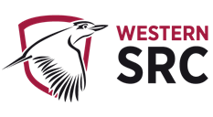
STUDENT REPRESENTATIVE COUNCIL
MONTHLY MEMBER REPORTS

August 2022

Contents
Contents 2
Executives 4
PRESIDENT: RAMEEZ PARKAR 4
VICE-PRESIDENT EDUCATION (UNDERGRADUATE): BAKAR MOHAMAD 5
VICE-PRESIDENT EDUCATION (POST-GRADUATE): SANJAY THAPA 5
Not submitted 5
VICE-PRESIDENT ACTIVITIES: CAMERON CHESTERS 5
GENERAL SECRETARY: SABRINA YOUNG 6
Campus Representatives 13
BANKSTOWN REPRESENTATIVE: JASMINE RICCIARELLI 13
CAMPBELLTOWN REPRESENTATIVE: DHARSHINI SATHYANARAYANAN 14
Not submitted 14
HAWKESBURY CAMPUS REPRESENTATIVE: VACANT 14
Not submitted 14
LIVERPOOL CAMPUS REPRESENTATIVE: ROMONDA EID 14
PARRAMATTA CITY CAMPUS REPRESENTATIVE: ELLYN JOYCE TORTAL 17
PARAMMATTA SOUTH REPRESENTATIVE: RAZIN POLARA 18
NIRIMBA CAMPUS REPRESENTATIVE: SARA MIKHA 19
Not submitted 19
ONLINE STUDENT REPRESENTATIVE: CAITLIN MARLOR 19
KINGSWOOD CAMPUS REPRESENTATIVE: JULIAN GONZALEZ 21
Not submitted 21
SMALL AND REGIONAL CAMPUS REPRESENTATIVE: VACANT 21
Not submitted 21
Equity Collective Representatives 21
DISABILITY REPRESENTATIVE: ROBERT REED 21
ETHNO-CULTURAL REPRESENTATIVE: CRYSTAL RAM 25
ENVIRONMENT REPRESENTATIVE: DANIELLE ALBERTINE 28
FIRST NATIONS REPRESENTATIVE: TIFFANY SHARPE 30
INTERNATIONAL STUDENTS REPRESENTATIVE: ANKANKSHA ANKANKSHA 32
RESIDENTIAL STUDENTS REPRESENTATIVE: JORDAN BRETT 33
WOMEN’S REPRESENTATIVE: JEMMA COOK 35
QUEER REPRESENTATIVE: JACOB MEIN (EMILEE) 36
WELFARE AND WELLBEING REPRESENTATIVE: VICKY-RAE REED 37

Executives

PRESIDENT: RAMEEZ PARKAR

Name: | Rameez Parkar | Role: President
Month: |  | August 2022
Reporting Period |  | Monday 4th July 2022 – Thursday 4th August

Date | Training
Thursday 7 July 2022 | SRC EOI Inductions
Monday 18 July 2022 | SRC Executive Training – Running Effective Meetings

Date | Meeting
Friday 7 July 2022 | July SRC General Meeting
Wednesday 13 July 2022 | SRC Grievances Panel Meeting
Thursday 21 July 2022 | Consultation with Penrith Campus Representative
Friday 22 July 2022 | SRC Grievances Panel Meeting
Friday 22 July 2022 | Consultation with Residential, Ethnocultural and Penrith Representatives
Wednesday 27 July 2022 | SRC Executive Meeting
Friday 29 July 2022 | SRC Grievances Panel Meeting
Sunday 31 July 2022 | Consultation with Residential Campus Representative
Notes:
- Planning is underway for a Cross-campus Facilities and Services Forum a date is yet to be confirmed.

Actions assigned to me at SRC meeting
- I have made initial contact with NUS Representatives and will begin getting a quote for reaffiliation.

VICE-PRESIDENT EDUCATION (UNDERGRADUATE): BAKAR MOHAMAD
SRC report July - August
- 04/07 - Sent summary of Winter Fest discussion to organising team
- 04/07 - Emailed the Student community team about new interns and steps going forward.
- 04/07 - Orientation session with new interns
- 05/07 - initiated plan for VP’s education committee
- 08/07 - attended general SRC meeting
- 09/07 - drafted email to address concerns that arose amongst SRC reps post SRC general meeting
- 18/07 - Attended SRC executive training
- 21/07 - C-stall meeting
  - Finalised plans for campus stall execution. Merch and marketing resources were delegated to reps to order and submit requests.
  - Posters are being finalised by interns
  - Banners are being designed by inters
- 22-23/07 - drafted plans for intern program regarding:
- Marketing reform initiative
- Design reform initiative
- Events planning initiative
- 23/07 - reviewed draft plan for scavenger hunt event
- 27/07 - followed up campus reps to finalise poster designs for their campuses
- 28/07 - online meeting with Teisha to discuss marketing approach
- 29/07 - meeting with interns to plan newsletter, c-stall execution, scavenger hunt across campuses, bankstown campus support, banner designs, canva kit and marketing procedures for the SRC.
- 29/07 - voted for SSAF funding committee
- 29/07 - Made a list of our locations for in-person meetings for the rest of the year
- 29/07 - sent email to SRC reps for Open Day representation
- 29/07 - forwarded zoom invited to new reps

VICE-PRESIDENT EDUCATION (POST-GRADUATE): SANJAY THAPA

Not submitted

VICE-PRESIDENT ACTIVITIES: CAMERON CHESTERS
This month I have attended all meetings including the chairing lesson that the execs attended. I finished work at 5pm while the meeting started at 4:30pm so I joined via Zoom on the train ride home from work. I also spoke to Romonda about the winter wonderland project of the SRC which didn’t go ahead. It had $10,000 allocated to it which we discussed reallocating to the end of year Christmas Party. I advised Romonda to create a new motion to officially reallocate the $10,000. That motion has now been put into the agenda and we expect that to pass easily enough as its not controversial and last year’s Christmas party ran very well. Some of the details still need to be worked out such as catering and presents and set up but with Daniel Janto’s help again it should be sorted easily enough. I emailed the VC’s office and we finally got a meeting scheduled with him. We will have to send them an agenda and list of people coming and their titles. We expect to address finally the parking arrangement and getting it free for after hours parking. This will help bolster the sports participation, on campus food vendors, and the willingness for students to come to campus to study.

GENERAL SECRETARY: SABRINA YOUNG
Events attended
7 July – attended the Out for Australia at WSP’s panel discussion focused on Designing and Creating Safe Spaces
11 July – attended Conversation Convention event to welcome new students to ECG
14 July – attended the ECG Speed friending event
18 July – attended the LEAD Social Impact 2-Day Hackathon event
18 July – attended the ECG Speed friending event
19 July – attended the LEAD Social Impact 2-Day Hackathon event
20 July – attended the 2023 NSW Government Graduate Program Info Session as part of the Winter Employer Sessions & Talks (W.E.S.T.)
21 July – attended the Pride in Diversity GWS Summit sponsored by Woolworths & City of Paramatta held at Parramatta City Campus
26 July – attended Share the Dignity Morning Tea to raise awareness for period poverty with the Parramatta City Provost Committee
30 July – attended the Western Badminton Socials Session
30 July – attended the Book club and Table-Top Guild’s Literary Board Games N’ Pizza Event
Meetings
4 July – attended the SRC Interns orientation meeting
8 July – attended the SRC General Monthly Meeting
15 July – attended the SRC Interns meeting
19 July – arranged a meeting with Hassan (Events Intern) to teach them how to use the Western Life platform and reviewed their event planner
25 July – discussed retail operations on campuses with Office of Estate and Commercial, facilitated by Natalie Bradury
26 July - arranged a meeting with Paige (Design Intern) to provide a tour of the SRC Website and to organise priorities with layout, design and upload of documents
27 July – attended a Mentoring Moments session with Luke Fenech (WSU Alumni) as part of the LEAD program
27 July – attended the Mental Health and Wellbeing team induction meeting
27 July – attended the SRC Executive Meeting
28 July – Attended the NCP Scholarship meeting
28 July – attended an interview with the Whitlam Institute to potentially assist in gallery invigilation
29 July – attended an interview with the WSU Events Team to potentially assist in the running of Open Day on 14 August
29 July – attended the SRC Interns meeting
2 August – attended WSUNS discussion
2 August – facilitated an ECG session
4 August – attended the GoGlobal information session
Trainings
14 July – attended ECG training
18 July - attended the Running Effective Meetings Workshop (exec training)
Concerns
Budget Committee concerns
  - Member improper use of unallocated budget
  - Air hockey table maintenance
  - Jenny Page approval of all budget requests regardless of quoting for items over a certain price
Retail Operation concerns
  - University Merchandise store, which is located next to subway on the Parramatta South campus (similar to Co Op Shop) is only on Parramatta South Campus – seems a bit unfair for students/staff at other campuses
    - Please note that this will be open for the first couple of weeks of semester, and then will reduce to 1 day per week. – also another inconvenience for students who cannot be on campus on that 1 day
  - Vending machines on certain campuses:
Campus | Location | Map
PSQ | Level 1 | 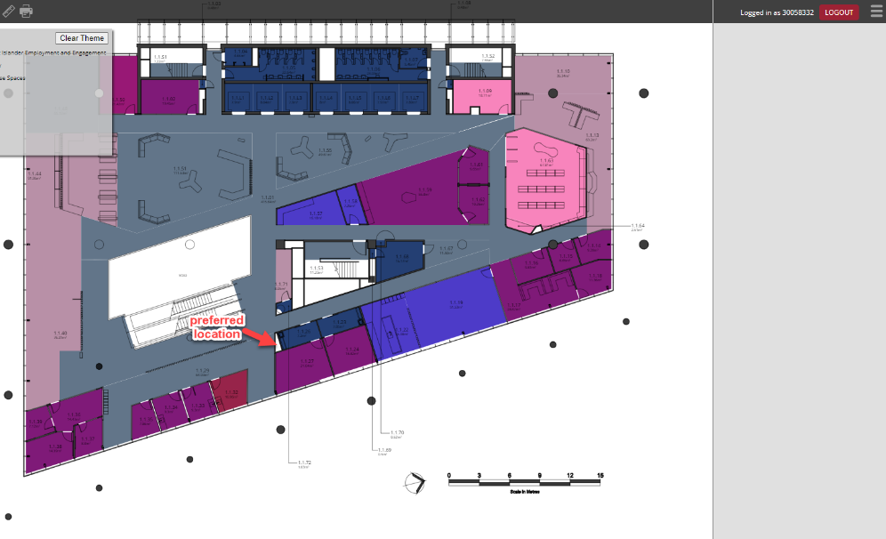
Bankstown |  | 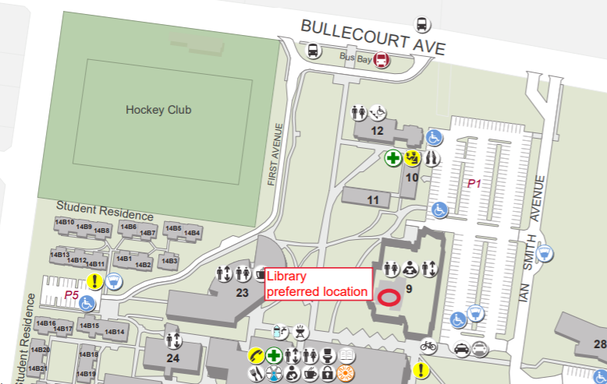
Campbelltown |  | 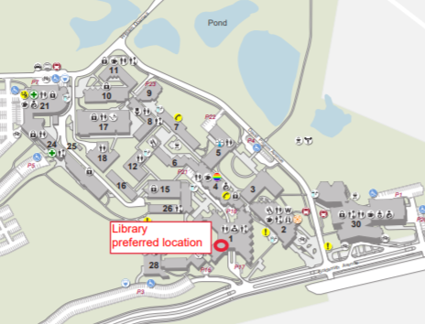
Hassal St | Level 2 | 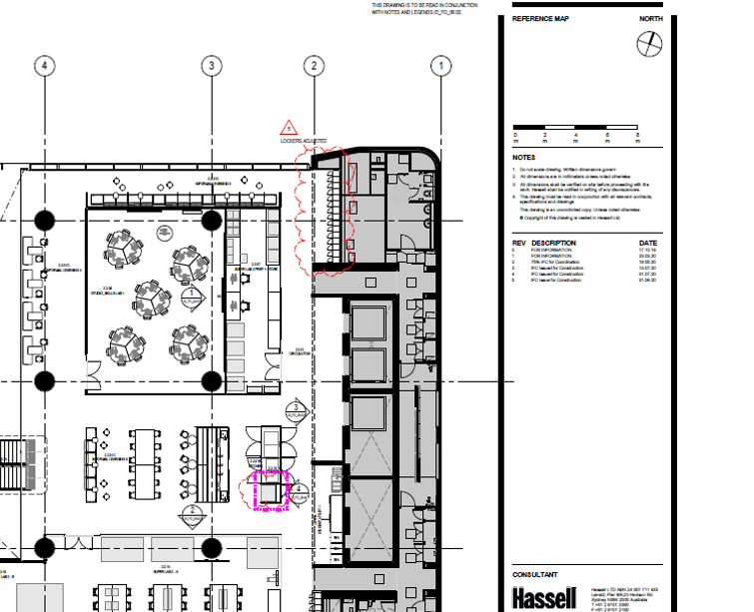
Hawkesbury |  | 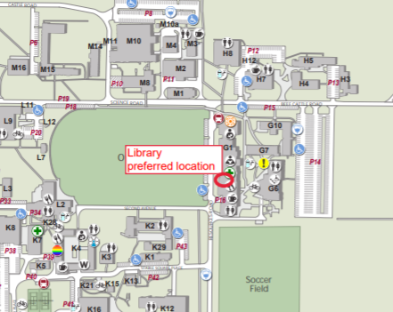
Kingswood |  | 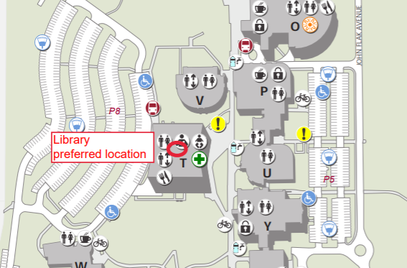
Liverpool |  | 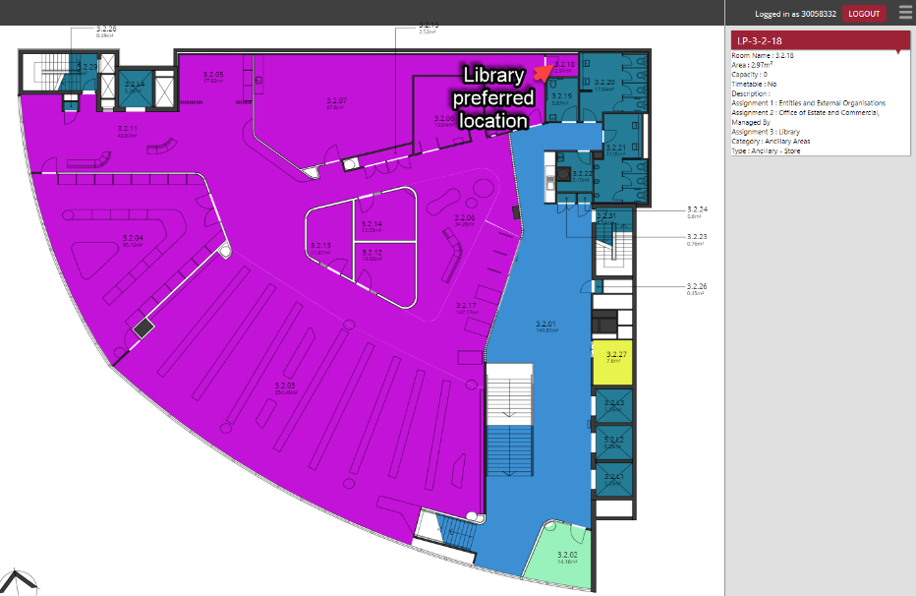
Parra South |  | 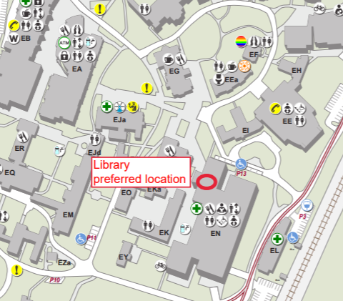
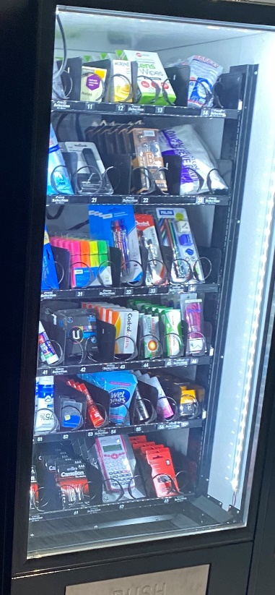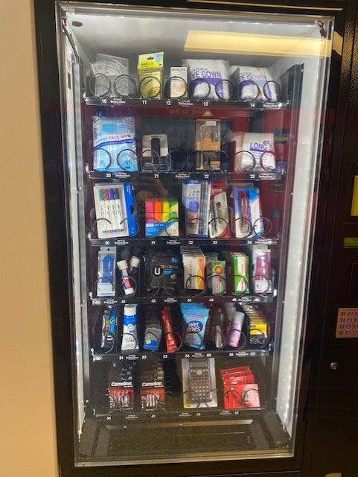Picture 1: Courtesy of Craig from OEC
Picture 2: Courtesy of Natalie Bradbury
  - University branded products completed through https://wsu.sourcesbg.com.au/
    - Issue: not very well known to students/obscure to find
    - Not able to try on sizing
    - Not sure about the return process
Actions
9 July – Reviewed training checklist provided by Grant on Western Life and made recommendations via email
11 July – Organised and held a stall for PADFS welcome week semester 2
12 July – organised and held a stall for PADFS welcome week semester 2
13 July – assisted SRC stall for welcome week semester 2
26 July – participated in VR research at the Westmead MARC’s Institute on the WSU HPRNet Project for Perceptual Learning
27 July – participated in VR research at the Westmead MARC’s Institute on the WSU HPRNet Project for Perceptual Learning
27 July – requested by Student community and Executives to arrange an EOI for SSAF Advisory Group 2023 to be submitted within 2 days
28 July - participated in VR research at the Westmead MARC’s Institute on the WSU HPRNet Project for Perceptual Learning
29 July - participated in VR research at the Westmead MARC’s Institute on the WSU HPRNet Project for Perceptual Learning
29 July – sorted through EOIs and presented recommendations to Richard Martino
1 August – finalised chosen SSAF members and confirmed with SSAF SRC members their new positions
1 August - participated in VR research at the Westmead MARC’s Institute on the WSU HPRNet Project for Perceptual Learning
2 August - participated in VR research at the Westmead MARC’s Institute on the WSU HPRNet Project for Perceptual Learning
3 August - participated in VR research at the Westmead MARC’s Institute on the WSU HPRNet Project for Perceptual Learning
4 August – assisted the Office of People and Success on the Work Integrated Learning and Service-Learning Project
4 August - participated in VR research at the Westmead MARC’s Institute on the WSU HPRNet Project for Perceptual Learning

To do
  - Organize SRC Budget meeting
  - Draft agenda for SRC budget meeting
  - Collate all documents for SRC reporting and monthly meeting
Outcomes
  - New agenda structure roll-out as per discussion of the Executive meeting

Campus Representatives

BANKSTOWN REPRESENTATIVE: JASMINE RICCIARELLI
Monthly Report Bankstown Student Rep (July/August)
30th June 2022- CCEN MONTHLY MEETING
Listened to Environmental Rep talk about budling H at Kingswood campus and their plan to make it a better office space for the src and collectives
5 July 2022- Campus Stalls
Checked over the campus stall event page to see what is left to be done. Emailed Bakar with a list of what is needed to be complete for the event to be submitted including dates from each campus rep, event logo and description. Gave suggestion for a logo draft design waiting to hear back from other reps about time.
6 July 2022- Event Post of Bakar
Posted an event for Bakar on WesternLife to help with promotion of a research project.
6 July 2022- Organisation with Monda for Liverpool and Bankstown stalls
Many messages were sent between us and we came to the agreement that we would hold both our stalls on Wednesday from 9.30- 12pm as a trail.
6 July 2022- Campus Stalls
Completed more editions on the WesternLife event and will be scheduling a reoccurring event promo on Mondays in weeks 2,5,9,13 which quates to once a month.
7 July 2022- Campus Stalls
Started the event WHS form still waiting for some to get back to me with locations for the event. I am hoping for the event to uploaded by Friday 15th July. Email all reps to get their locations and time/date for the event.
10 July 2022-Spring Welcome Week intro meeting
11 July 2022- Campus Stalls
Chased up final signature for the WSH form and asked the intern to make some changes for the event logo
13th July 2022- Welcome Week Stall (Parramatta South)
13th July 2022- Meeting poll for Campus Stalls
14th – 15th July 2022- Emails between Hassan and myself about an event
21th July 2022- Campus Stall meeting
21th July 2022- Meeting with Hassan about events
22nd July 2022- Campus Stall Banners meeting
Proposal and Actions-

CAMPBELLTOWN REPRESENTATIVE: DHARSHINI SATHYANARAYANAN

Not submitted

HAWKESBURY CAMPUS REPRESENTATIVE: VACANT

Not submitted

LIVERPOOL CAMPUS REPRESENTATIVE: ROMONDA EID
SRC REPORT JUNE/JULY
30/6/2022 – Meeting and discussion on Winter Wonderland Fete with Grant Murray, Jenny Page and Jostina Basta
A ½ hour meeting regarding issues with the Winter Wonderland Fete turned into 2 hours of “issues” with the event which was approved then unapproved because of planning and logistic issues. The budget has been allocated however, was not approved. I spent almost 2 weeks altering all the issues which both Grant and Jostina deemed “unfit”, only to be told the event will not go ahead and will be rejected. I’m still awaiting an email response from both Grant and Jostina regarding their lack of support and why I wasn’t just told it would be rejected in the beginning, seeing both parties did not believe in my ability, nor did they offer any support. I am uncertain why I was given a bunch of issues to amend, only to be rejected anyway, seems that I was only ever set up to fail, which is very upsetting and quite unfair.

30/6/22 – CCEN Meeting “KINGSWOOD CAMPUS”
Discussion on moving Building N into Building H for more practical use and spacious room. Collectives to meet and discuss, and having a Working Bee Group, for the big move. Scheduled for July 24th. Unable to attend this working bee group currently. Still in talks about organising a practical garden bed/vegetable patch. Awnings or a shady covering is also discussed.

2/7/22 – Emails went out to stall holders regarding their Covid Safe Plans and their WH&S Plans. Initial email sent out to Jostina from Student Clubs, regarding help and advice - I am still awaiting a response some 5 weeks later!

7/7/22 – NAIDOC week event at Liverpool Campus. Had 3-4 lovely people tag along to a Dreamtime Colouring session at the Liverpool Campus. We acknowledged the Traditional Custodians of the Land, and we enjoyed a chilled colouring session, with beautiful Aboriginal music being played during the 1.5-hour session.

21/7/22 – C-Stall meeting with Bakar and the rest of the group. Further discussions on merchandise, and props for the event. Emails were sent out to Events regarding the use of their tables, and who the point of contact is for future dealings of C-Stalls. Bankstown – “Donna” from Security, and Liverpool” Nick” from Events. Parramatta City, Ellyn-Joyce reached out to the point of contact for clarification on where to access tables and who needs to be notified. Allocation of jumpers and their designs/sizes need to be finalised today for distribution next week.

21/7/22 – Agenda Item lodged for a Secret Santa Christmas Party. I was in touch with Cameron regarding his input and advice on hosting another Secret Santa Christmas Party in December which is to be held at two different Campuses - Parra South and Campbelltown on the 8th and 15th of December. Seeing its success was acknowledged and that I still have the $10k budget which was granted for the Winter Wonderland, Vicky-Rae and I have well in advance submitted the new agenda item giving Clubs and Events more than enough time and notice, which also allows us to be able to plan “peacefully” without anymore disturbances and issues with our event – given the lengthy amount of time to plan for December. Cameron is supportive of this decision and both Vicky-Rae and I will be organising a working group for those members who are interested in helping.

26/7/22 – FACSIAR Lunch ‘n’ Learn “Improving Mental Health Outcomes for Children in Out of Home Care”

27/7/22 – Laugh Therapy. A one-hour session where students are able to feel safe, vent and laugh their stresses away.

28/7/22 – CCEN Meeting cancelled “Kingswood Showcase”
28/7/22 - Registered to be Liverpool Campuses Lifeblood “Champion” – Contacted Amy Phelan and registered to help promote blood donation as I am unfit for personal blood donation giving. Amy referred me to Ronny Maroun from Lifeblood, who has walked me through registering and given me promotional pamphlets to distribute. 134 doners are needed to beat the record for blood and plasma donations. Every donation saves 3 lives! This is a fantastic initiative, and I would appreciate anyone’s support. Get in touch with me if you are interested in donating.
29/7/22 – Checked Liverpool Campuses Pantry. Contacted Vicky regarding restocking.

3/8/22 – C-Stall Meeting at Bankstown Campus. Liverpool C-Stall had to be cancelled last minute due to lack of props being delivered in time. I was very excited to be paired up with Jasmin at the Bankstown Campus, where we not only educated the students on who SRC are, but also had an “open library” of mental health and well-being colouring books and pencils and left-over Aboriginal art works from the NAIDOC week event, to add to the pile of goodies being available for students. This was a hit! Students really do love freebies, and they now know that Jasmin’s office is located upstairs in building one! I also used this opportunity to post our posters “WE ARE YOUR VOICE” around the campus, and I was also lucky enough to print out and post some Lifeblood information. I unfortunately have no access to free printing at the Liverpool Campus, I got in touch with Jenny Page, who replied and cc’d both Grand and Nick regarding who to touch base with. It would make my life a little easier knowing I can do printing at my own campus. I am still awaiting a response.
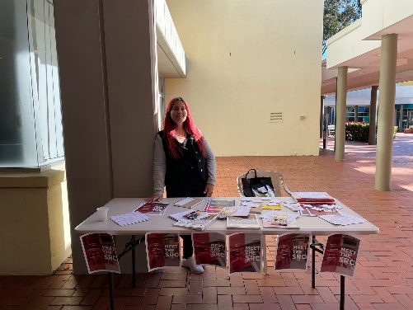
3/8/22 – Had conversations with Bakar regarding tablecloths for the C-Stall tables. We both agreed that the use of table covers will be more professional and appealing to others. I purchased 10x Burgundy coloured table covers from Luna Wedding and Event Supplies, for $143.90 delivered. I will need to be reimbursed for this amount as Bakar is happy to have this amount taken out of his budget, I was happy to purchase until next SRC meeting where Bakar will reimburse me from his budget request.
Written by Romonda Eid SRC Liverpool - 18900864

PARRAMATTA CITY CAMPUS REPRESENTATIVE: ELLYN JOYCE TORTAL
July 8, 2022 – Attended the SRC General Meeting July 10, 2022 – Attended a brief meeting hosted by Sanjay Thapa with the SRC representatives assisting in ‘Welcome Week’ to plan and finalise the upcoming SRC stalls across campuses.
July 13, 2022 – Assisted in the SRC Stall for Welcome Week at Parramatta City Campus, Level 1. The SRC Reps that I worked with on this day was Sanjay Thapa and Caitlin Marlor. I was able to engage with current and future students at the University and informed them of who we are and what we do to represent all students across the different campuses. I also advised them to sign up to Westernlife and follow us on social media, as well as hand out the merchandise that VP Postgrad Sanjay Thapa ordered for the SRC Stalls. July 15, 2022 – I contacted 3 Companies regarding customisation of the merchandise and got 3 quotes from Vistaprint, Custom Gear and Good things. This is for the monthly stalls to be held at each campus.
July 19, 2022 – Had a brief chat with Grant Murray regarding:
· 1PSQ Laptop & Laptop lock + required cables to be installed at Parramatta City Campus
· Gaming TV and stand + required gaming consoles etc to best utilise the technology – Level 1
· Air Hockey table location – Level 1
July 20, 2022 – Following my call with Grant, I reached out to the relevant teams via email, studentservices@westernsydney.edu.au as well as Verity Foley (Campus Safety and Security Operations Manager), to request permission on the Gaming Console, Air Hockey, and Table tennis set up on Campus. July 21, 2022 – Attended the meeting hosted by Bakar Mohamad regarding “Project-C stall” to finalise the merchandise, banners, and planning. This stall is to be hosted at each campus once a month.

PARAMMATTA SOUTH REPRESENTATIVE: RAZIN POLARA
SRC Monthly Member Report – Razin Polara (July, 2022)

Meetings, events or conferences I have attended this month in my capacity as a member of the SRC:

- Meeting with campus life offices and dean of Engineering.
- Meeting with Parramatta provost committee.
- Meeting with Events officer

Communication and engagement, I have been involved this month as a member of the SRC:

- This month have been working majorly on designing the new SRC merch for our upcoming C-stall initiative. Here are the designs we have decided to finalise.
- As a part of cross-campus equity and also the Parramatta south campus representative I will be holding a stall at the south campus every 2nd Friday to promote SRC and spread awareness of what SRC is and what we do.
- I was also involved in the welcome week at both Parramatta's south and city campuses. I helped all 3 days of the welcome week.
- In addition to that, I have collaborated with the Parramatta south provost committee to organise a diversity fest on campus for that I will be contacting clubs and societies to participate in the fest presenting their diverse foods and talent.
- This will not only create awareness but will support clubs to get promoted to a broader amount of students.
- I will also be taking part in the open day as a part of the SRC stall and will be helping out other reps who are interested.

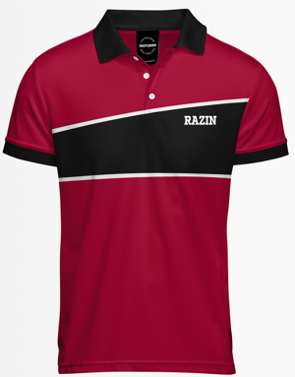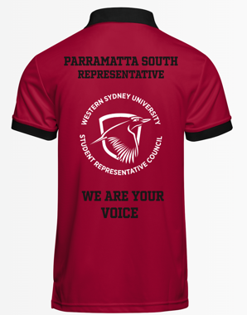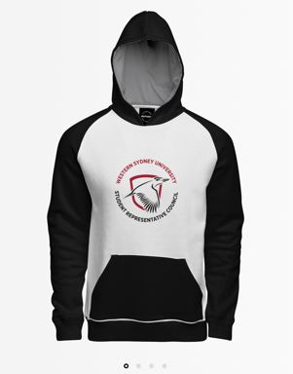

NIRIMBA CAMPUS REPRESENTATIVE: SARA MIKHA

Not submitted

ONLINE STUDENT REPRESENTATIVE: CAITLIN MARLOR
This month I have had to adapt to recent family changes which required me to be overseas for a period of time, which interrupted my capacity from approx.. 17/07 to 03/08. Otherwise I have enjoyed this month and I look to have my C Stall set up early this month.
08/07 – Attended SRC General Meeting
10/07 – Attended Welcome Week Briefing Meeting
Discussion surrounding welcome week and facilitating the SRC stall at Welcome Week
12/07 – Attended Alternative Assessments Working Party Meeting
Attended meeting facilitated by PVC Learning Futures Si Bedford. The group works toward the following principles:
· Develop criteria for online assessments format, delivery models and evaluation.
· Review issues relating to online assessment and develop solutions.
· Recommend processes to ensure appropriate support is in place for staff and students.
· Take a research-informed and data-driven approach to ensure best practice.
I have found attending these meeting a useful insight into the development of online coursework within the university and look forward to using this as an opportunity to encourage positive change, especially once my C-Stall is fully established.
13/07 – Attended Welcome Week Stall at Parramatta City Campus
This was a great opportunity to meet more of the SRC team and get to know the students in person. It was also positive to promote the SRC to students who may not know about the SRC, particularly new students. I remained for the whole day
29/07 – RSVP to Jenny: Meet and Greet
04/08 – Meeting with Residential Representative
04/08 – Event Request Issues flagged with Grant and Jenny
During my attempt to lodge event request for C-Stall I ran into permission issues which are looking to be fixed.

KINGSWOOD CAMPUS REPRESENTATIVE: JULIAN GONZALEZ

Not submitted

SMALL AND REGIONAL CAMPUS REPRESENTATIVE: VACANT

Not submitted

Equity Collective Representatives

DISABILITY REPRESENTATIVE: ROBERT REED
July SRC Report – Robert Reed Disabilities Representative

Report for activities and collaborations for the period inclusive of the last report.

6th July Assistive Technology Catchup w/ Sally Leggo and Natalie McLaughlin.
Special Guest: Dash (Campbelltown Rep) to discuss the shuttle bus application and survey
8th July SRC Monthly Meeting
10th July Ukrainian Fundraiser Soccer Gala Day
Attended as Disabilities rep and participated within my limitations on the day, including organisation and playing. Those that attended had a great time playing against each other, and we now know the staff are superior at soccer to the students, even if they had ringers in their team. Special shout out to Razin Polara and Vicky-Rae Reed for their organising of the day and their commitment to a cause which many of us monitor and wait for the outcomes of the crisis and final resolution.
15th July Mates Corner Discussion Group
19th July Meeting with Tatum Faber on future collaborations with the Disability Collective and role as the student representative for Disabilities for the School of Medicine. During the discussion, it was realised that several students in the School of Medicine were unaware of services that the students can use to assist them in their studies at Western Sydney University. Given that Tatum wants to understand and learn about the services available at Western Sydney University, an invitation was extended to attend the monthly meeting for the Disability Collective, Disability Services and Welfare and Wellbeing on which Tatum attended.
22nd July Mates Corner Discussion Group
26th July Disability Collective, Disability Services and Welfare and Wellbeing Monthly Meeting.
Business arising from the previous meeting was heavily discussed this month, including the limitations of stops for the shuttle bus at Campbelltown. Although the shuttle does stop at what may seem like regular intervals, it has been noted that there are gaps where another stop may be of use especially considering the distance between stops and the impact it may have on students with a disability and parents who may have children in attendance. It was also noted that the gradient of one of the stops might impact students who require mobility aides to commute around the university. Terri and Michell Falconer are to assist with further enquiries about the positioning of current stops and the addition of extra stops that may be of greater convenience to all students. Dash (Campbelltown Rep) also provide information gained from a poll once published regarding shuttle bus tracking and accessibilities. In our following newsletter to the Collective, we will include a poll to assess the accessibility of both the tracker and stops used by our collective students from the various campuses.
At this time, the Disability Policy for the University of Western Sydney is being reviewed in the draft stage; once this step is completed will be forwarded to Disability Advisors for feedback. We eagerly await this outcome and look forward to the proposals outlined in this document.

It was also brought up at this meeting about issues regarding student safety plans, which will be discussed externally at a meeting with Terri Mears. Safety plans are in place to provide for the safety and well-being of students who attend our university, regardless of their status. As such, they must be adhered to by all persons regardless of whether they are staff or students. The fundamental provision is to allow a student or staff member to attend the university and its campuses without fear or negative impact on their well-being and to continue their studies to the best of their abilities.

The general business of the recent meeting involved the upcoming events for both RuOK Day in September and International Day of Disability in December. We hope to form a collaborative effort to ensure that both days are a success and to increase the awareness of mental health and the impact of disability and studies at university. Additional thanks to Richard Martino for comments on the possible planning and strategy for both events.

Note-taking templates were also discussed, and the form they will take when used by note-takers before being given to students once completed after the class the student needs it for. While minor tweaks may be required to allow for interpretation of notes for differing units and degrees, the overall standard of the proposed template would be sufficient to provide the information from the class before being passed on to the student.

Thank you to Dearne Richards for allowing insight into the machinations of Work, Health, Safety and Well-Being at Western Sydney University
27th July Student Q & A with Grant Murray regarding upcoming elections and the role of the SRC for prospective students.
Very insightful and informative, despite the limited attendance.
28th July Cross Campus Equity Monthly Meeting
29th July Mates Corner Discussion Group
1st August Emailed Emilee for a possible collaboration for an event for World Aids Day in December.
I have received an email back from Emilee regarding what can be done for the day to allow for inclusivity of all and the appropriateness of running the event to create a greater understanding and increased knowledge of the issues that are faced by all communities
2nd August NUS roundtable discussion with NUS Disabilities Rep, Georgie McDaid.
Several topics were raised at this meeting. This includes the e impact of AIPs and the use of AIPs by current academics when assisting and, in some cases, lack of assistance due to not understanding the requirements some students need when attending classes to complete their studies to the same standard as other students. This includes the accessibility of classes, especially for students with mobility issues. ProctorU and related invigilation methods were discussed, and a common complaint against its use is the possibility of invading students’ privacy in their home environment. The impact on students who use this platform regarding eye movements and looking away from their screen, the subsequent possibility of academic misconduct. Some students cannot maintain constant eye contact with a computer screen for significant periods. Carers and the role they play outside of the university environment were also discussed. There are instances where their circumstances are not adequately considered due to the many variables associated with their role as carers. It was noted that not all carers perform the same role; whilst one may care for a family member who may require minimal assistance, there are those attending university who also require extensive care for the person they care for. One topic to be highlighted is the possible future collaboration with the Disability Representative from the University of Sydney regarding the creation of Disability specific rooms and how Western Sydney University devised the creation of spoons rooms. I also connected them to Vicky-Rae Reed to discuss this issue as she championed the initial Western Sydney University Spoons Room at Liverpool Campus in 2018.
I look forward to future discussions on this topic and future discussions with my peers from other universities around Australia.
3rd August Assistive Technology Catchup
Monthly discussion regarding the location of accessibility of assistive technology by Sally Leggo. Inclusive upgrading of current systems in specific areas to provide for the use of technology such as speech to word, i.e. Glean, to allow students improved capability when completing assigned class work or assessments. Sally has been in contact with Disability Advisors regarding the location of sensory rooms/safe spaces and will be updated in our following newsletter.
July Welcome Week
I assisted in a limited capacity at both Parramatta City and Parramatta South Campuses. It was great to finally meet SRC members I had only interacted with online before the event. Apologies if I did not recognise some of you in person.

Upcoming
Disability Collective Newsletter to be delivered to students of the Disability Collective.
Discussion with the executive on vacant positions and an invitation to all those in the Collective
who may want to become a general representative with the Disability Collective.

Looking forward to catching up with as many of you as I can soon, and the continued collaboration with current members of the SRC.

ETHNO-CULTURAL REPRESENTATIVE: CRYSTAL RAM
SRC Member Report – August 2022
Meeting Attendance (ETHNO-CULTURAL REPRESENTATIVE):
06/07/2022 Meeting with Student Leaders (Campbelltown/Parramatta campuses)
19/07/2022 Meeting with Grant Murray
22/07/2022 Meeting with SINAG Filipino Student Society of WSU
22/07/2022 Meeting with Student Leaders and SRC President - Rameez Parkar
27/07/2022 Meeting with Taurai Moyo - Student Clubs Team
29/07/2022 Inclusive Communities and Ethnocultural Collective Meeting
01/08/2022 Meeting with SRC President – Rameez Parkar
08/08/2022 Meet & Greet between SRC; Editors & Student Community staff
11/08/2022 Raksha Bandhan Event – Parra City
12/08/2022 SRC Meeting
As the ethnocultural representative, I will continue in my efforts to partake and report the needs of students across all fields on and off campus. As the representative I believe it is anticipated that I strengthen student voice and increase participation in activities which are currently online. I plan to organise regular meetings both face to face and virtual, for students that allow a chance for the students of various communities to grow and develop.
Since being elected I have sustained effort to support and advance networks as well as partnerships with individuals, groups, clubs, and offices which are working towards the same otherwise similar objectives such as the Provost Committees where we will be working alongside with the Inclusive Communities Coordinator, for the upcoming Diversity Fest. This will assist to leverage our capacities and resources, as well as to avoid duplication of activities and meetings, especially with university staff.
Further to this, I have collaborated with multiple student collectives and societies to schedule events for the remainder of the term, acknowledging various days of observance in ethnically diverse communities.
Raksha Bandhan is also known as Rakhi, is a festival that is celebrated on the full moon day according to the Hindu Lunar calendar. On this day sisters and brothers come together to express their love for each other and pray for their wellbeing. The sisters tie a knot of Rakhi on the wrist of her brother, who promises to protect his sister from the evil. Today, this festival is not only celebrated among the siblings, but also between friends and the close ones to whom the people want to spread their message of love and care. I wish those from Hindu community a Happy Raksha Bandhan!
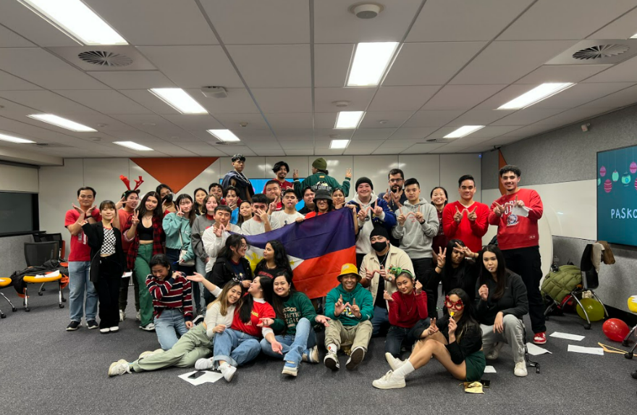
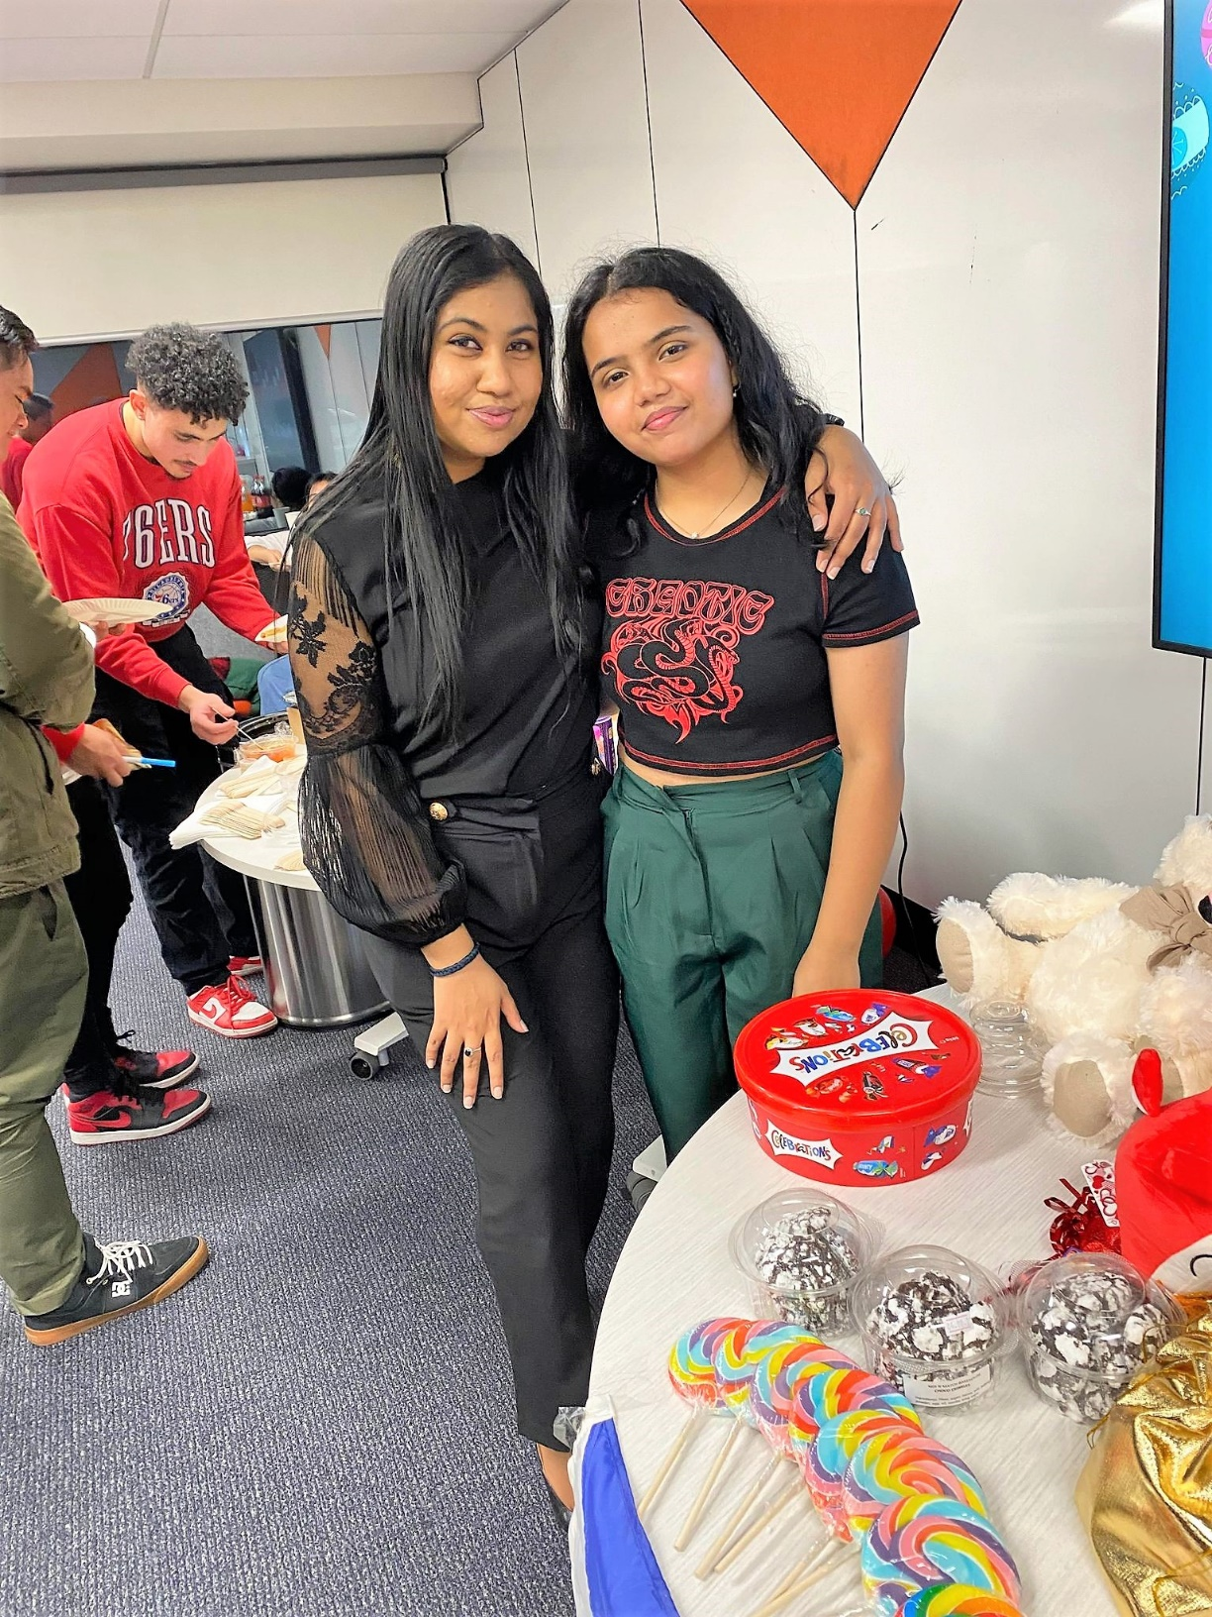
Filipino Student Society of Western Sydney University- Executive Member, Bansari Soni

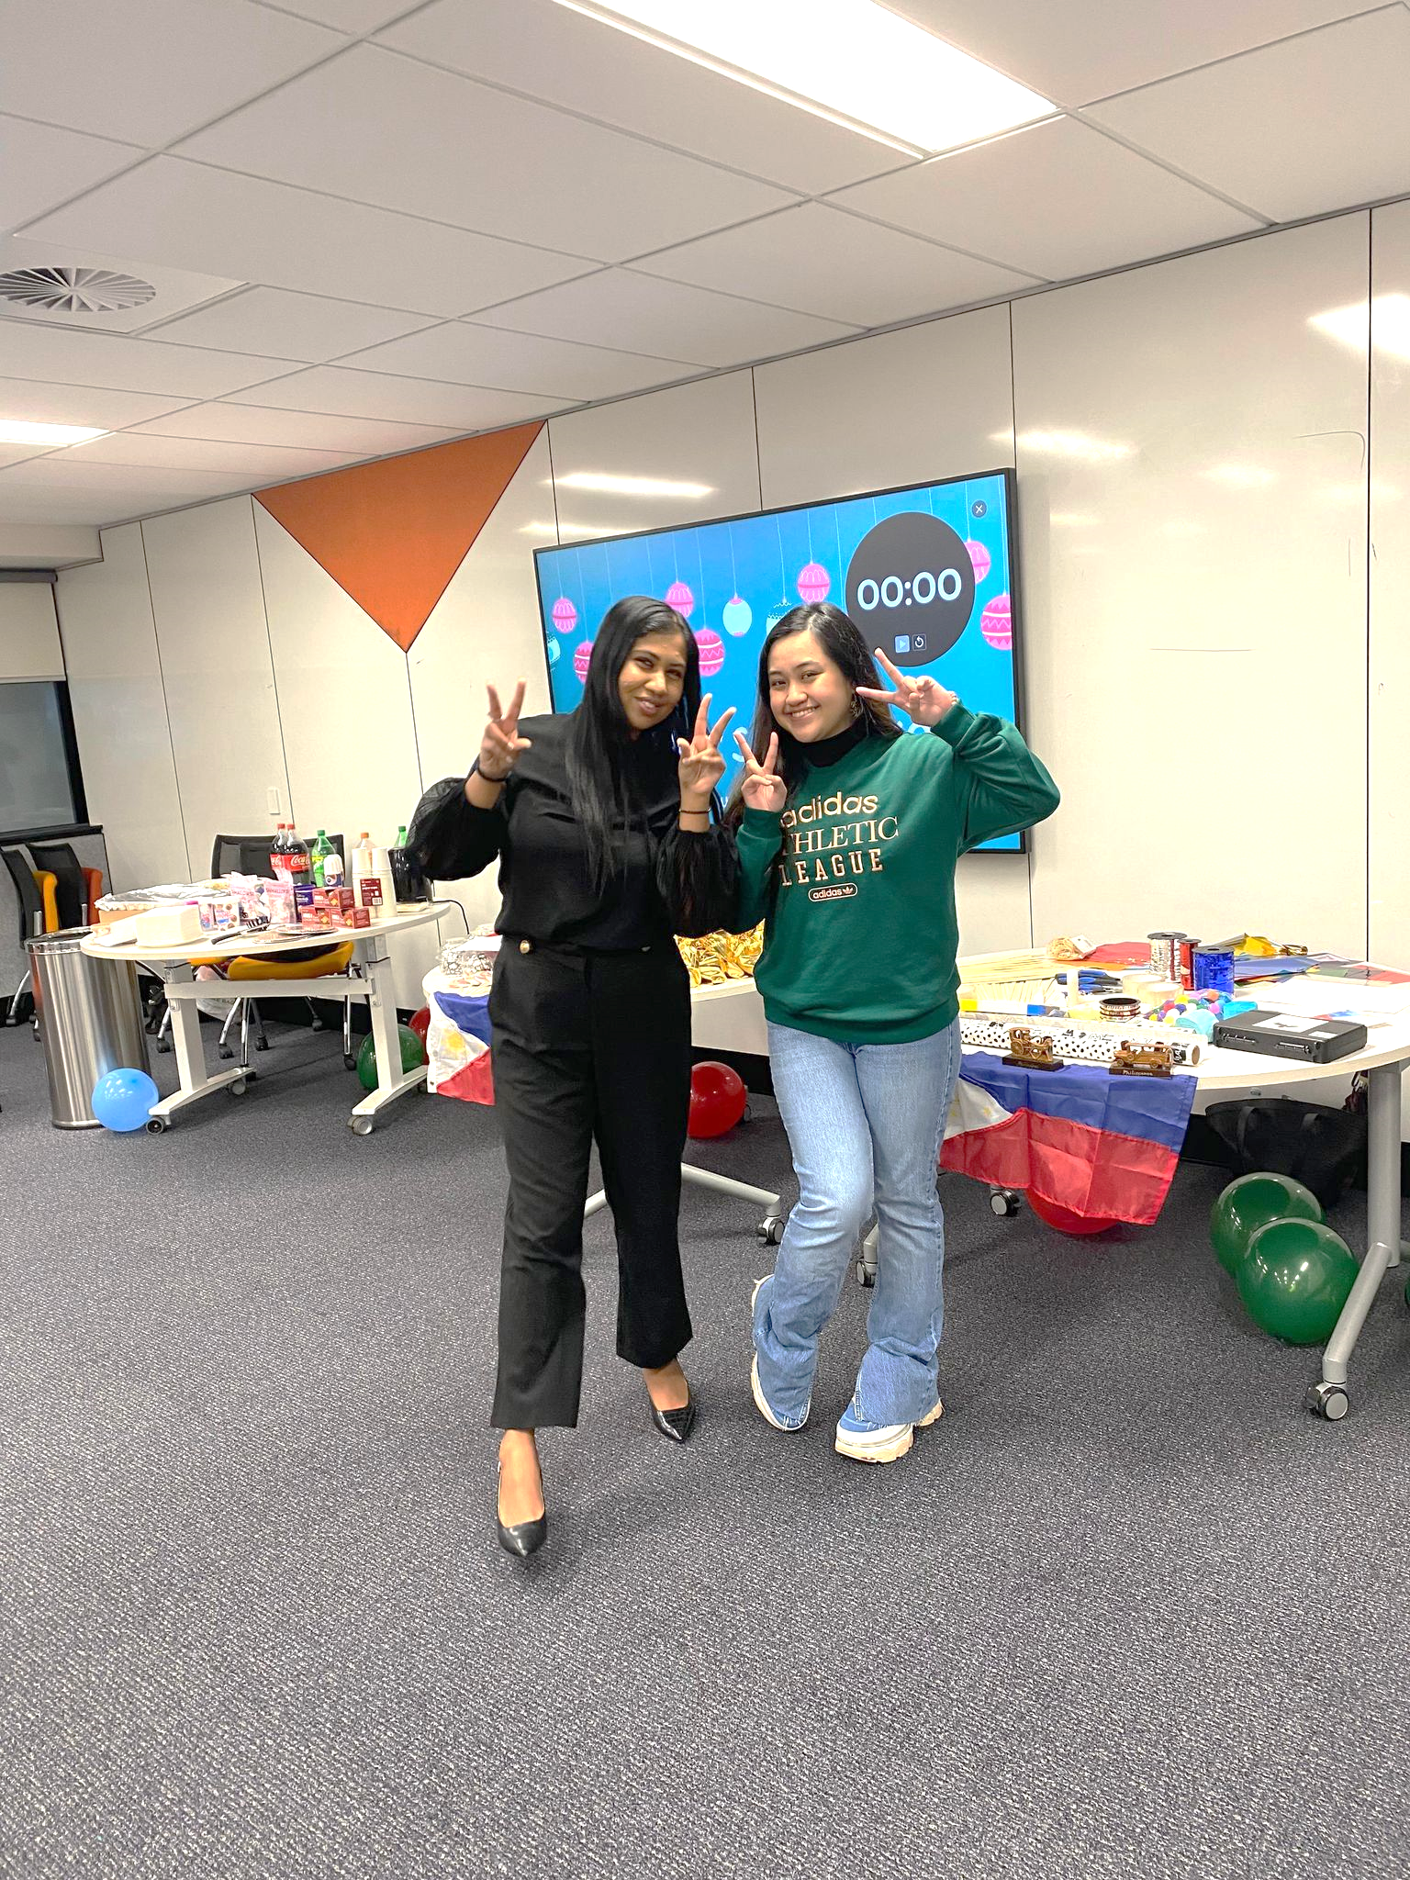
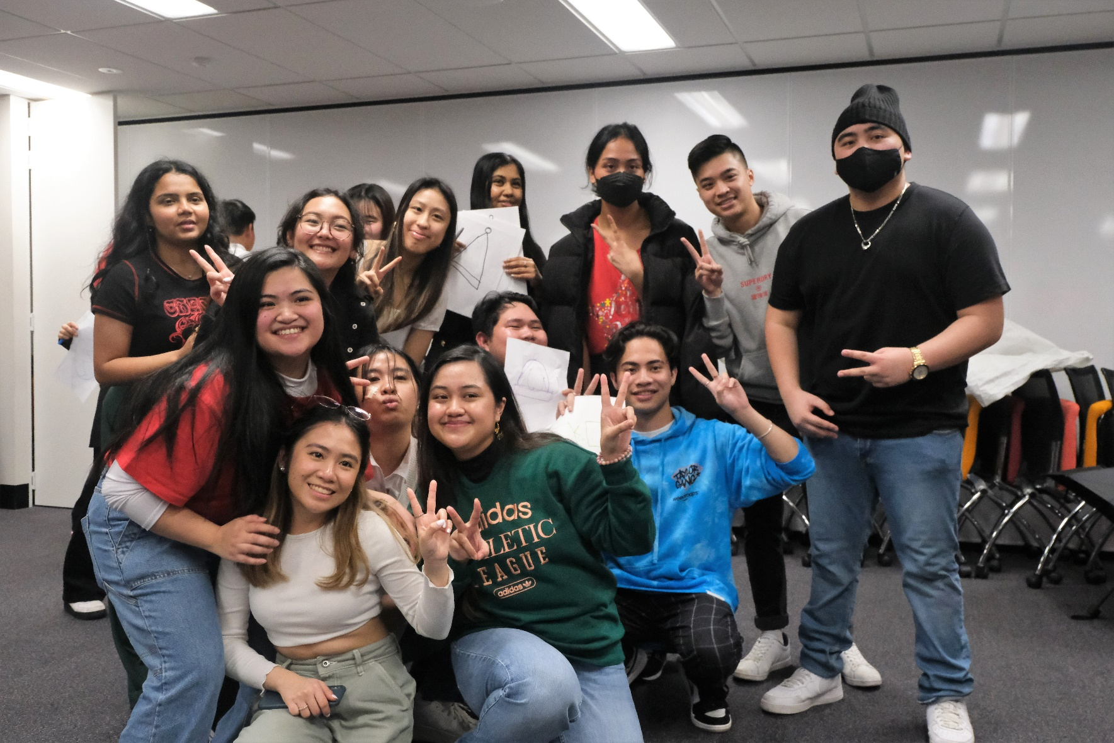
With the President of Filipino Student Society of Western Sydney University, Maria Everdone

ENVIRONMENT REPRESENTATIVE: DANIELLE ALBERTINE
Danielle Albertine – Environment Representative

This month has been epic, with almost every day having a meeting, event, or workshop over the last couple of weeks, with the trend continuing. We have also welcomed a new general officer and general secretary. Aside from our general monthly Collective meeting, we’ve also had 3 planning / debriefing meetings. As part of preparing for the Festival of Action and the Kingswood Showcase, we a lot of time putting together welcome, and workshop, packs, sorting out new merch and preparing our event materials.

The Festival of Action was put together by the Future Thinkers team from the 21C Project, and brought together staff, students, and external organisations. By bringing them together, it encouraged conversation on how to incorporate equity, justice and climate action into curriculum, careers, and a broader future vision. We attended in collaboration with Inclusive Communities, with a particular focus on Interdependence.

The Kingswood Showcase was a great opportunity to engage with other clubs and areas of the Uni, students, and staff. Our new bunting was a hit, and we also had some great conversations, especially with a visiting academic on the merits of the Times Higher Education University Impact Rankings considering Western’s recent no. 1 global rank.

Open Day is fast approaching, and we’ve been approved for a stall which means it will be all hands-on deck! We have a bit of a scramble to make sure we have sufficient merch, materials, and prizes. I’ll also be speaking on the student panel, so think of your questions haha!

Most of you are probably aware that turning Kingswood’s Building H into a purpose-built space for the Collectives, chaplaincy and Inclusive Communities has really taken wings. After having an onsite brainstorming session with Collective reps and officers, Daniel Jantos took our ideas to Richard Martino the other day, and we now have a meeting of the CCEN, Inclusive Communities and Richard to look at how we can move forward.

Meetings:
• Daniel Jantos and Marissa Waddington from Inclusive Communities, Jenna Condie from 21C Curriculum Project and Hareem Abassi from AYCC
• Cross Campus Equity Network meeting at KW Campus Building H
• Andrea Cuestraclaros from Monash to discuss SDGs and the Societal Role of Universities
• Brit Hardiman from Sustainable Futures
• Penrith Provost bi-monthly meeting

Workshops:
• WoCo – We collaborated with WoCo on a Self-Care Sunday - Sustainable face masks workshop online, as well as an a Paint a Pot event at Parramatta South campus.
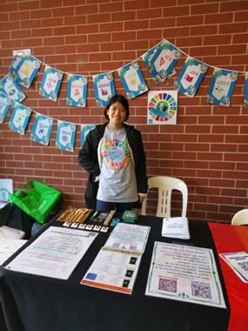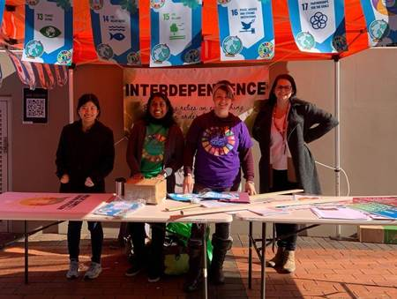

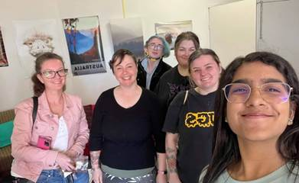

FIRST NATIONS REPRESENTATIVE: TIFFANY SHARPE
FIRST NATIONS REPRESENTATIVE: TIFFANY SHARPE
First Nations Representative – August SRC Report
I continue to be engaged with the student leaders and Indigenous cohort, along with adequately meeting the standards of criteria within the First Nations role and responsibilities stated in the portfolio. I am increasing my opportunities by taking collaborative initiative projects with the Equity Representatives and Western SRC Student Leaders overall.

Meetings:
- 6th July 2022: Assistive Technology
- 7th July 2022: APCAC Meeting
- 8th July 2022: July SRC Meeting
- 11th July 2022: Student Voice Meeting with Grant and Jenny Communication with Student Community regarding to seek assistance to fund an Indigenous student to attend the World Indigenous People Conference on Education (WIPCE), which I successfully was able to fully-fund the student’s opportunity to the conference.
- 27th July 2022: Badanami Yarning Circle Staff and Students CommBank Technology & Operations Indigenous Academy who are offering exciting opportunities for Aboriginal and Torres Strait Islander peoples to kickstart their career in Technology and Operations at CommBank subjectively in the background in STEAM (Science, Technology, Engineering, Analytics & Mathematics).
- 4th August 2022: Parramatta South Provost Meeting Raise up concern of the three flags which
- 4th August 2022: Vice-Chancellor’s Gender Equity Committee – Student Interview

Training/Projects:
- Sustainable Impact Program
- INTERCHANGE

Additional Initiatives:
- Welcome Week
Advocating and promoting for the Western SRC, MATES, and Western Phoenix Spirit at Parramatta City Campus. Also, I supported the new-coming students by welcoming everyone to Western Sydney University and answering their questions plus helping.
- NAIDOC
Participated in online events that Badanami arranged and external opportunities that I could engaged.
- National Aboriginal and Torres Strait Islander Children’s Day
The establishment of the first National Aboriginal and Islander Children’s Day on August 4, 1988, occurred in the context of protests led by Aboriginal and Torres Strait Islander people and their supporters during the bicentennial year. Aboriginal and Torres Strait Islander peoples felt a day was necessary to honour our children, instil them with self-assurance, and make them feel special and included.
The date of August 4 was historically used to commemorate the Stolen Generations, Aboriginal and Torres Strait Islander children who were taken from their families at a young age without their knowledge.
With the support of their families and communities, the majority of Aboriginal and Torres Strait Islander children are thriving and growing up strong in their cultures.
Nonetheless, a substantial number of our children continue to face ongoing challenges as a result of colonisation and its effects. This includes discrimination, poverty, systematic removal, intergenerational trauma, displacement from land and culture, and lack of community empowerment.
To achieve equality, we must approach these challenges holistically, taking into account the health, safety, and development of Aboriginal and Torres Strait Islander children.
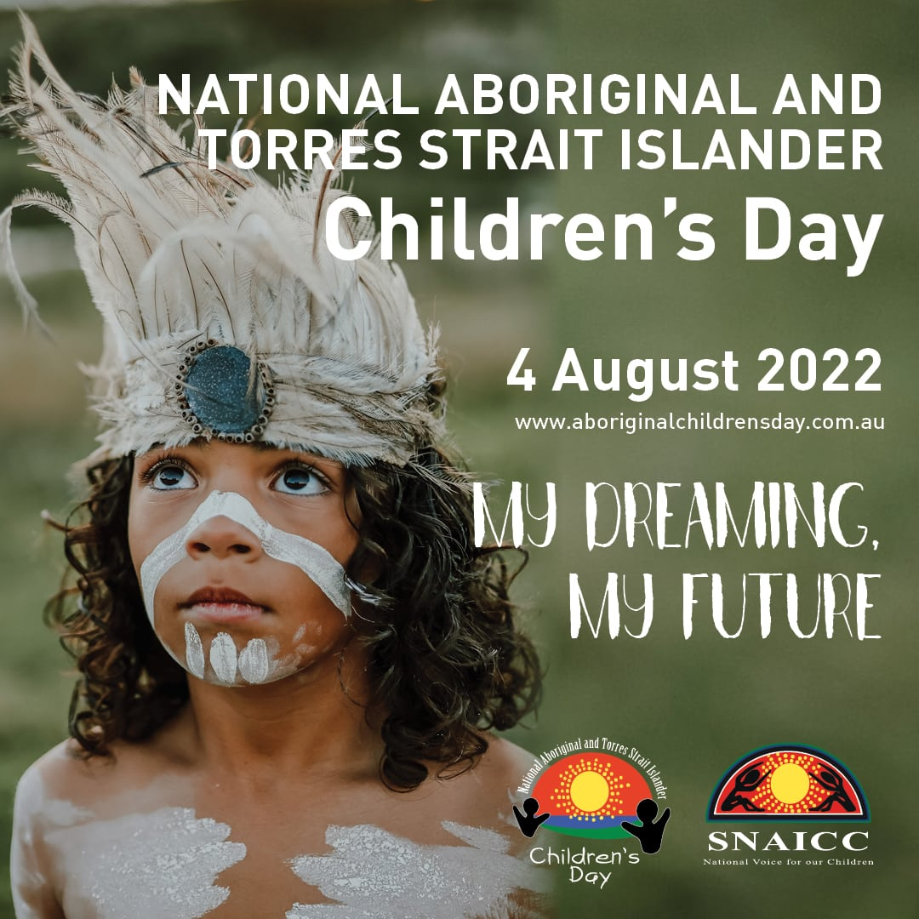

INTERNATIONAL STUDENTS REPRESENTATIVE: ANKANKSHA ANKANKSHA
MONTHLY REPORT
International Representative
4th August, 2022.
Following are the ways in which I carried out my responsibilities as the International Representative:
i) Volunteered during welcome week and promoted the SRC in such a way that more and more students get to know who we are and what we do.
ii) Asked the students during welcome week to provide suggestions regarding what they feel the SRC should pay attention too and got heaps of response.
iii) Met with many international students and solved whatever doubts they had regarding a new whole new life that they are about to start.
iv) Corresponded with the previous members of the international collective to get an idea of the track that they were on so that I can continue that progress.
v) Will be meeting a couple of previous officers of the collective to see if they are still interested in the position.
vi) Will be working on rolling out an election announcement for the vacant positions in the international collective.
vii) Hosted the welcome dinner in week 1 for all the students in association with the inclusive communities.
viii) Keep constant contact with international as well as exchange students to make sure they are feeling comfortable in the new environment and the university as well.

RESIDENTIAL STUDENTS REPRESENTATIVE: JORDAN BRETT
August Members Report
04/07/2022 – Meeting with Student Voice
04/07/2022 – Meeting with Residential Student
04/07/2022 – Meeting with the Kingswood Representative
04/07/2022 – Meeting with the President
05/07/2022 – Meeting with the Online Students Representative
05/07/2022 – Correspondence with CLV Hawkesbury
05/07/2022 – Correspondence with CLV Parramatta
05/07/2022 – Correspondence with CLV Bankstown
05/07/2022 – Correspondence with CLV Nirimba
05/07/2022 – Correspondence with CLV Campbelltown
05/07/2022 – Correspondence with CLV Kingswood
06/07/2022 – Meeting with Residential Students
06/07/2022 – Correspondence with CLV Hawkesbury
07/07/2022 – Correspondence with CLV Campbelltown
07/07/2022 – Meeting with Residential Students
07/07/2022 – Correspondence with Tenants Union NSW
08/07/2022 – General Meeting
08/07/2022 – Meeting with the President
11/07/2022 – Meeting with Residential Student
12/07/2022 – Meeting with Residential Students
12/07/2022 – Meeting with the Online Student’s Representative
13/07/2022 – Correspondence with the President
14/07/2022 – Meeting with CLV Hawkesbury
14/07/2022 – Meeting with CLV Operations Manager
15/07/2022 – Meeting with the Ethno-Cultural Representative
18/07/2022 – Correspondence with the Queer Collective Representative
19/07/2022 – Meeting with the Queer Collective Representative
19/07/2022 – Correspondence with ‘Flagworld’
19/07/2022 – Meeting with Student Community
19/07/2022 – Correspondence with Tenants Union NSW

22/07/2022 – Meeting with multiple Representatives
25/07/2022 – Meeting with Residential Stakeholders
26/07/2022 – Correspondence with ‘Flagworld’
26/07/2022 – Correspondence with CLV Operations Manager
26/07/2022 – Correspondence with Tenants Union NSW
27/07/2022 – Engagement Activities with External Stakeholders
27/07/2022 – Correspondence with the General Secretary
28/07/2022 – Consultation with multiple Representatives
28/07/2022 – Correspondence with Student Community
29/07/2022 – Meeting with multiple Representatives
01/08/2022 – Meeting with the President
01/08/2022 – Meeting with the Kingswood Representative
02/08/2022 – Meeting with the President
02/08/2022 – Meeting with the Kingswood Representative
02/08/2022 – Meeting with the Online Students Representative
03/08/2022 – Meeting with multiple Representatives
04/08/2022 – Meeting with Tenants Union NSW
04/08/2022 – Meeting with internal and external stakeholders
04/08/2022 – Meeting with Residential Student

Personal Report to the Residential Student Body
It has been a very strong month for the Residential Student body, with the body being represented to not only organisations within Western Sydney University, but external as well. I have, with your support, been able to bring your concerns to the Tenant’s Union of New South Wales, an organisation that will stand in solidarity with our fellow residents. In addition, I have been working with members of the SRC to ensure inclusivity within our villages, and to improve our representation within the Student Representative Council. There may be members of the Student Representative Council who are unaware of the difficulties that residential students face, but with your support I am committed to ensuring that your concerns will not be ignored.
There are new members to the SRC, and I welcome our incoming President, Rameez Parkar, and the new Kingswood Representative, Julian Gonzalez, both of whom are incredibly hard-working individuals who have taken great interest in residential student issues. I also welcome the incoming Queer Collective Representative, Emilee Mein, who has already made great strides to represent Queer Collective members within Western Sydney University Villages. I wish all three incoming members the best and look forward to working together to ensure that our respective portfolios are well represented with the Student Representative Council.

As always, I encourage all residential students to reach out to me should I be of any assistance.

Jordan Brett, Residential Student Representative

WOMEN’S REPRESENTATIVE: JEMMA COOK
Women’s Representative – Jemma Cook
Meetings:
- 17th of June, 2022 – meeting with collective officers and reps for correspondence with Building H KWS campus
- WoCo Meeting with collective officers
  - 5th of July, 2022
  - 12th of July, 2022
  - 19th of July, 2022
  - 26th of July, 2022

Events:
- 20th of July – We had the first instalment of the Women’s Wednesday weekly events which we focused around anxieties going back into the semester. This was a great conversation and there was a lot of response that brought up some points which we will utilise as future event topics. We have been discussing collaborating with other collectives about doing some cross-collective networking and opening these conversations to a broader audience.
- 22nd of July – Women’s Collective held our first in-person event which was a movie night held at Kingswood campus. We believe that this event was a success considering it was pre-semester and it was a relatively simple movie as we wanted to ease into these in-person events.
- 24th of July – We held the first Self-Care Sunday event in collaboration with the Environment Collective. It was a DIY Face Mask, and this was held via zoom and packages were sent out to the attendees with the ingredients needed and then a rep from environment collective guided us all through the process of making the masks.
- 26th of July – we held another in-person event which had a great turnout! We ended up having 16 attendees which we were so happy with. We held this event at Parramatta South campus and can see why most events are held there just from the resources and spaces that they had available. We had 6 German exchange students, so I think this was a nice way for students to meet each other in an organised but relaxed environment. The feedback we got was great as well and it seems students really are just trying to reconnect not just with each other but with the university as well.
- We have begun organising the events that we would like to hold in the following month:
  - We will be continuing our Women’s Wednesday series with more poignant topics moving forward
  - We will be holding another instalment of the self-care Sunday series where we will be making bookmarks. It is designed to be very relaxed and just a way for those who come to have easy conversation with those around them.

Main concerns:
- The women’s rooms on campus still need some love, but with the chaos that has been sitting my medical school entrance exam, I haven’t had the capacity to really commit to this yet. We are having a meeting in the following week(s) to get a schedule up of when we can get to each of these rooms.
  - I will be having a meeting with the Parents Union, and the campus reps to get some input and advice into these spaces as well.

Others:
- Have been putting some more thought into cross-collective networking and am in the process of working with my officers to bring some more ideas to the table. (TBC).
- Will be organising an EOI to get a new officer to join the collective as we have sadly lost Amelia (general officer).

QUEER REPRESENTATIVE: JACOB MEIN (EMILEE)
Queer Collective August Report
A lot has been happening July with Queer Collective (QC). Firstly, there has been a new Queer Representative. I’ve been updated on all the goings on in Queer Collective from before I was elected and am now up to date with everything.
QC had a stall at welcome week from Monday to Wednesday, and had approximately 30 new students sign up to Westernlife in that week, with new members still slowly coming in as classes start back up again.
QC has also started a new discord server, which launched during welcome week. The old discord server has been archived and is no longer used. This new discord has a new verification system, which ensures that people joining are indeed students of WSU, as well as making it easier for the officers to reprimand people should they act inappropriately or unprofessionally. Fortunately this hasn’t happened yet. The new discord currently has 95 members, both new and returning from the old discord.
QC has also been making a second zine, a small magazine featuring artwork and poetry of the queer students. Students have been able to submit pieces throughout the month, and it will be completed early August.
Some QC officers have been able to go to meetings on behalf of the collective while I haven’t been able to. This includes a meeting with the Cross-Campus Equity Network, helping organise room changes and planning spaces for future events.
We’ve also started collaborating with the Pride and Diversity Network about Mardi Gras 2023. We’ve asked for suggestions from the members of qc for what music they would like to be played on the float. We are still hearing back from them.
We have been collaborating with Ycollab in order to promote their focus group, which is about the creation of a new safe space in south-west Sydney. Various members of qc also attended the focus group itself.
QC also did a movie night, in collaboration with the Campus Representative for Kingswood. It was a hybrid event, both online and in person, watching Mamma Mia and The Owl House.
Lastly, the queer rooms for Campbelltown campus and Parramatta south campus have been cleaned out a bit more, with updated resources, posters, and a suggestions box.

WELFARE AND WELLBEING REPRESENTATIVE: VICKY-RAE REED
WELFARE AND WELLBEING REPRESENTATIVE: VICKY-RAE REED
I FEEL THAT I HAVE ADEQUATELY UNDERTAKEN THE ROLES AND RESPONSIBILITIES OF MY ROLE FOR THE JULY-AUGUST PERIOD OF 2022 BY ENGAGING WITH THE FOLLOWING:
· Assistance with planning and approval for two delegates to the Australasian Diabetes Conference on behalf of the Disability Collective – July 10th
· Assisted First Nations Representative Tiffany Sharpe with arrangements for her delegate to the World Indigenous Peoples Conference.
· Restocking of the Little Free Pantry on Level 1 Liverpool Campus in preparation for Welcome Week.
· Distribution of First Aid Certificates to attendees – July 11th
· Welcome Week at Parramatta City Campus
· Assistance with Disability Services Intake for female Parramatta Student – July 14th
· SDSN Regional Committee Meeting - July 15th
· Meeting with Liverpool Representative, Romonda Eid, to discuss the change of the Winter Wonderland Event to 2022 Secret Santa Christmas Picnic – July 16th
· Reached out to Zuzia Buzewicz of the Tenants Union “ Make Renting Fair” Campaign- July 19th
· Promotion of the Open Door Visiting Lecture surrounding the experiences of UK Military Service Women and veterans and responding to their needs and complex issues – July 18th
· Bankstown City Campus Communications & Change Committee Meeting – July 20th
· Assistance with Welfare and Counselling Referral for Reduced Study Load for male Online student- July 19th
· Promotion of Student Veteran Mentorship program – July 19th
· Referral to NUS Disabilities Representative to include Disability Collective in their upcoming roundtable discussion – July 19th
· Conversations with Angelo Kourtis re: Student Safety Plans- July 19th
· WSU Penrith Showcase meeting with Simon Preuss-Kearney, Danielle Albertine and Julian Gonzalez – July 19th
· Creation of WSU Penrith Showcase Planning Document – July 21st
· Response to the email from Shaista Khan re: student engagement and awareness campaign on foreign influence – July 21st
· Contacted Sydney Fun Faces concerning the cancellation of Winter Wonderland – July 21st
· Contacted Bowen Fucile of Engineers Without Borders re: the cancellation of Winter Wonderland – July 21st
· Wear it Purple Panel Planning – July 21st
· Open Door Visiting Lecture at Westmead Campus – July 22nd
· 2022 Humanitarian Innovation Awards Hackathon (FIRST PLACE WINNER) – Jul 21-23rd
· Cross Campus Equity Network Planning for Building H, Kingswood – July 24th
· Assistance and referral for International Student affected by c19 unable to attend on-campus classes – July 25th
· Disability Collective, Equity & Diversity, Mental Health & Wellbeing Monthly Meeting – July 26th
· Email conversations with Nikhil Autar re: Accessibility app for students with disability (Ongoing) – July 26th
· Forwarding of 2022 Secret Santa Agenda Brief to Student Events, Jostina Basta for consideration – July 28th
· Conversation with Kellie Burke, Manager, Future Student Engagement re: Student Veterans Program for Open Day – August 1st
· Communications with Alicia Garling, Village Manager – August 2nd
· Email Communications with USyd Disabilities team re: Spoons Rooms – August 3rd
· NSW Council for Pacific Communities Meeting – August 1st
· Make Renting Fair Meeting – August 4th
· Wear It Purple Panel Planning – August 4th
Upcoming
· SDSN Regional Advisory Group Meeting – August 9th
· International Day of the World’s Indigenous Peoples Roundtable: The Mana Wahine Report – August 9th
· Zoom Meeting to discuss Building H, Kingswood – August 11th
NOTE: September is expected to be a quieter month for me as my double mastectomy with reconstruction for breast cancer has been booked for September 14th, 2022.

