STUDENT REPRESENTATIVE COUNCIL
MONTHLY MEMBER REPORTS

October 2022

Contents
Contents 2
Executives 4
PRESIDENT: RAMEEZ PARKAR 4
VICE-PRESIDENT EDUCATION (UNDERGRADUATE): VACANT 5
Not submitted 5
VICE-PRESIDENT EDUCATION (POST-GRADUATE): SANJAY THAPA 5
VICE-PRESIDENT ACTIVITIES: CAMERON CHESTERS 6
Not submitted 6
GENERAL SECRETARY: SABRINA YOUNG 6
Campus Representatives 7
BANKSTOWN REPRESENTATIVE: JASMINE RICCIARELLI 7
CAMPBELLTOWN REPRESENTATIVE: DHARSHINI SATHYANARAYANAN 8
HAWKESBURY CAMPUS REPRESENTATIVE: VACANT 9
Not submitted 9
LIVERPOOL CAMPUS REPRESENTATIVE: ROMONDA EID 9
PARRAMATTA CITY CAMPUS REPRESENTATIVE: VACANT 12
Not submitted 12
PARAMMATTA SOUTH REPRESENTATIVE: RAZIN POLARA 12
Not submitted 12
NIRIMBA CAMPUS REPRESENTATIVE: SARA MIKHA 12
Not submitted 12
ONLINE STUDENT REPRESENTATIVE: VACANT 12
Not submitted 12
KINGSWOOD CAMPUS REPRESENTATIVE: JULIAN GONZALEZ 12
Not submitted 12
SMALL AND REGIONAL CAMPUS REPRESENTATIVE: VACANT 12
Not submitted 12
Equity Collective Representatives 12
DISABILITY REPRESENTATIVE: ROBERT REED 12
ETHNO-CULTURAL REPRESENTATIVE: CRYSTAL RAM 15
ENVIRONMENT REPRESENTATIVE: VACANT 18
Not submitted 18
FIRST NATIONS REPRESENTATIVE: TIFFANY SHARPE 18
INTERNATIONAL STUDENTS REPRESENTATIVE: ANKANKSHA ANKANKSHA 19
RESIDENTIAL STUDENTS REPRESENTATIVE: JORDAN BRETT 20
WOMEN’S REPRESENTATIVE: VACANT 21
Not submitted 21
QUEER REPRESENTATIVE: JACOB MEIN (EMILEE) 21
WELFARE AND WELLBEING REPRESENTATIVE: VACANT 22
Not submitted 22

Executives

PRESIDENT: RAMEEZ PARKAR

Name: | Rameez Parkar | Role: President
Month: |  | October 2022
Reporting Period |  | Friday 2nd September 2022 – Thursday 6th October 2022

Date | Training

Date | Meeting
Friday 9th September 2022 | SRC September General Meeting
Thursday 23rd September 2022 | SRC Executive Meeting
Sunday 29th August 2022 | Consultation with Residential Campus Representative
Notes:
- Planning is underway for a Cross-campus Facilities and Services Forum in the week of 17th October

Actions assigned to me at SRC meeting
- Negotiations of NUS reaffiliation fees is ongoing.

The last month has been relatively quiet for the SRC especially with mid semester break, assessment blocks and especially the SRC general election period. I have continued with my agenda of ensuring the effective functioning of the Student Representative Council. I have drafted substantial changes to Schedule 2 of the Student Representation and Participation Procedures which will be considered at the next SRC meeting. These changes have been designed to address some of the shortcomings of the current process. Planning is underway for a Cross-campus Facilities and Services Forum in the week commencing 17th October. Negotiations of NUS regarding reaffiliation fees is ongoing. Great process has been made in ensuring the resolution of ongoing complaints to the Grievances Panel and in making sure the SRC is a safer place for representatives, staff and students.

VICE-PRESIDENT EDUCATION (UNDERGRADUATE): VACANT

Not submitted

VICE-PRESIDENT EDUCATION (POST-GRADUATE): SANJAY THAPA
September 2022 Member Report
Meetings and events attended
- September SRC Executive Meeting
- September SRC General Meeting
- Liasioned with the parramatta city campus provost committee
- Planning and organising the SRC stall for the welcome week
- Assisted the SRC budget committee to assess the financial process of the SRC monetary
- Represented the president for the Disciplinary committee
- Collecting information and represented before the Honorarium/Remuneration committee
Work in Progress
- Preparation of the post graduate networking event for the coming quarter
Tasks completed.
- Updated SRC website with the current member's list and new positions available
- Prepared summary report for the quarter 3 (July to September, 2022) based on matrix system and presented to the Remuneration Committee
Plans for the next month
- Effectively execute my role as VPP
- Create events, workshops, and activities to encourage collaboration among postgraduate students. This can be an excellent platform for students to network and share their student and industry experience, potentially leading to job opportunities during and after university. This can also provide insight into how the university can offer opportunities and pathways to achieve sustainability and a smooth transition from university to industry employment.
- Engage with students and student leaders in a discussion around issues with education at the university and maintain networks with Academic Committee Student Representatives, other relevant university staff units and networks

VICE-PRESIDENT ACTIVITIES: CAMERON CHESTERS

Not submitted

GENERAL SECRETARY: SABRINA YOUNG
Events attended
Tuesday 6 September – Launch Pad social event
Thursday 8 September – volunteering with the Mental Health and Wellbeing Team for R U OK Day at Hawkesbury campus
Thursday 15 September – Venture Makers event with Launch Pad
Wednesday 28 September – Event volunteer for Peer Programs End of Programs Celebration
Thursday 29 September – Student Events Team Diversity Fest Drag Bingo Volunteer
Meetings
Thursday 1 September – Vote of Formal Notice meeting
Tuesday 6 September – facilitated ECG session
Friday 9 September – SRC general meeting
Friday 16 September – 21C PX Student Partnership program with staff on curriculum development program induction
Tuesday 20 September – LEAD Communiteer – Mentoring and Community Volunteering Workshop
Wednesday 21 September – Cultural Wellbeing Rapid Session
Wednesday 21 September - Mental Health and Wellbeing Team meeting
Friday 23 September – SRC Executive Meeting
Monday 26 September – Peer programs celebration briefing
Tuesday 27 September – LEAD Communiteer – Mentoring and Community Volunteering Workshop 2
Not-for-Profit Meet & Greet
Friday 30 September - 21C PX Student Partnership program with staff on curriculum development project meeting
Trainings
n/a
Concerns
n/a
Actions
Compiled Budget Committee report for general meeting agenda as additional Business Document G
Organised gift cards for interns
Intern wrap-up and handovers
Navigation system for agenda update
To do
SSAF preparation for motions
SSAF new advisory members now that Jemma and Caitlyn are no longer part of SRC
Navigation system for agenda update – to inform SRC members upon next email of agenda for October

Outcomes

Campus Representatives

BANKSTOWN REPRESENTATIVE: JASMINE RICCIARELLI
Monthly Report Bankstown Student Rep (September/October)
1st September 2022- Special meeting
7th September 2022- Complaint: College not getting free student breakfast in week 8
Email the team about the issue and Vick said she will pass the issue on to student events.
7th September 2022- c-stall
Planning and organising art packs with Monda for the campus stalls. As well as giving her a couple of tips to help her collect campus data for your forum.
9th September 2022- SRC monthly meeting
28th September 2022 c-stall
Let Monda take an extra 10 art packs from Bankstown stash as she need them to complete her stall and let her know that I’m planning on completing my stall in week 12.
Proposal and Actions-
Although this month has been a slow and quite month in my role as SRC campus rep I have been able to help out and guide another rep to gain campus feedback. I plan for my month of October/November to also be slow as we are coming closer to the end of the semester and heading into exams. I also plan to complete 1 more c-stall to gain final Bankstown campus feedback and attend the good bye Bankstown event that maybe held in week 13 for students before they move into the new city campus.

CAMPBELLTOWN REPRESENTATIVE: DHARSHINI SATHYANARAYANAN
SRC MEMBERS REPORT – OCTOBER
DHARSHINI SATHYANARAYANAN – CAMPBELLTOWN CAMPUS REPRESENTATIVE
The past month has been quite slow. I don’t think I have done as much as I wanted to as a Campbelltown Campus Representative. Due to some personal issues, I couldn’t focus on my duties as a SRC rep. Hence, why I made the tough decision in stepping down from my role as a Campbelltown Campus Representative.
SRC has taught me so many values, that are not just vital for my career, but also my personal life. I was able to connect with people who inspired me in so many ways. I was granted opportunities to speak out on behalf of students in my home campus in Campbelltown. The main take away for me from this beautiful journey is to not hesitate to speak your thoughts. As a person who tends to become an introvert when surrounded by new people, it was quite difficult for me to share my views. This was one of many reasons for me to join SRC – to get out of my comfort-zone. Seeing so many talented people share their honest opinions for the welfare of WSU students, I was inspired to become like them. I am so grateful for this beautiful journey, and I am sure that the future Campbelltown Campus Rep would be able to support students even more. All the very best!

HAWKESBURY CAMPUS REPRESENTATIVE: VACANT

Not submitted

LIVERPOOL CAMPUS REPRESENTATIVE: ROMONDA EID
SRC REPORT – September/October

2/9 – Submitted SRC Report
3/9 – Emailed Nick D and Daniel J regarding idea for “Liverpool Lunches”, an initiative for Liverpool Campus Students to have healthy and easy to follow meals to eat and learn to prepare for themselves. It is important that the students know that good food doesn’t have to be extravagant.
3/9 - Facebook Poll on what students prefer “if you were offered a free meal, would you prefer lunch or dinner?” – Lunch wins
7/9 – C-Stall Bankstown and Liverpool Stalls I spoke to many students and had a “feedback” box for the students to leave their feedback, ideas and what ever they wanted to share with me. A few of the students were asking for more social aspects to the University life experience, as well as free food and more amenities for Level 1. One student wanted to thank the Campus for giving her a Parents Room, which she said she would not have been able to manage without this room.
Jasmine and I prepared “care packs” for our students to giveaway. We decided that the students wanted a more relaxed and “chill” experience, especially during exam period so Jas has gone to buy adult colouring books and textas/pencils for the students. I have been fortunate enough to be sharing Jasmin’s budget, meaning she has bought extras for me for my campus C-Stall. The students absolutely love these, and I will need to go back to Parramatta to get more stock to give out to the students. This is something I intend on continuing in the New Year.
8/9 – DCJ Child Protection Caseworker Information Session Webinar
9/9 – SRC Meeting for September. My Agenda Item 11.3 was pushed back again for the 2nd month in a row. Not happy about this. Emailed Sabrina and asked for a possibly “Flying Minutes” vote. A formal email was sent through to President Rameez Parker, asking for FM consideration.
9/9 – Nick D referred a student to me regarding posting flyers for a research project. I have found out all the relevant information, and have agreed to meet with the student on the 14th, the student research is on ‘understanding the campus climate for gender and sexuality diverse students and staff at WSU’.
13/9 – Who Bleeds Wins LIFEBLOOD meeting – invite from Ronny Maroun. Catch up on the current tally and the new advice around blood donation. Have invited Megan Green from Lifeblood Liverpool for a catch up and a combined C-Stall and Lifeblood promoting hour, on the 21st of September. Security has been notified of the visitor attending.
14/9 – Caught up with research students. We posted her research posters around the campus, we asked at the library for permission (just in case), which was fine. The student was very pleased to have had her research paper posted around the campus. I was more than happy to help.
16/9 – Received email correspondence from Marissa Waddington and Daniel Jantos in support of the “Liverpool Lunches’ – known as the Community Lunches. I have been asked to present 4 recipes as Daniel and Marissa want to try for the month of October, a Thursday lunch run. I am excited to have their support and more importantly, the students get to have a home cooked meal for free.
19/9 – Did the shopping for the ‘Free Little Pantry’ located on Level 1 at Liverpool. I had Vicky-Rae do my reimbursement for me as I have not yet been shown how to do this and I am not confident enough to try on my own. This came out of Vicky’s budget. I still have a Provost Budget which I need clarification on from Diana. The Panty is being used quite regularly, which is good and troubling at the same time. It troubles me knowing students are coming to campus without food and I’m wondering what their living/life arrangements are like. It is good that we found something which the students can turn to in their time of need. I have seen the pantry stocked and emptied in a matter of days... this needs some love.
21/9 - Held a combined C-Stall and Lifeblood registration hour. I am pleased to say, we got 6 new registrations for blood donations in one hour! We just saved 18 lives! <3
25/9 – Flying Minutes motion results 11.3 – 7 votes (6 for, 1 against. Did NOT meet Quorum) Under Rameez’s instruction the Secret Santa Christmas Party won’t be passed and will not be discussed again at the next meeting. Despite the results not meeting quorum and the initial delay of voting not even being explained for starters, this I find to be an unfair decision however, I have not got it in me for petty games and factions. The students miss out, and this is the sad realisation.
27/9 – Creative Cultures Liverpool Campus. Unfortunately, I was unable to attend the workshop on a last-minute emergency however, I filled out all the surveys.
28/9 – C-Stall at Liverpool Campus. Dropped by at Bankstown Campus to pick up more goodie bags thanks to Jasmin. I have also combined a Lifeblood registration into this C-Stall today, another 5 new registrations in 1 hour!
Quite offended that the head of Campus Safety and Security is causing unwanted and unnecessary drama, with respects that I asked someone for a hand to pick up a table which took 2 minutes, and I get told off about it because I should be using SRC hands, and not security... pathetic if you ask me! I don’t see the point in emailing or calling someone from the SRC to help me carry a table… that is a waste of resources and time.
28/9 – Laugh Therapy. One attendee – a safe space for a chat and a laugh.
29/9 – CCEN monthly meeting CANCELLED
30/9 – Agenda Item deadline. Submitted three agenda items for next months meeting.
30/9 – Catch up with Megan Green from Lifeblood at Liverpool. I was humbled with her generosity. Megan attended Liverpool Campus with 4 bags of groceries which she donated to the “Free Little Pantry” , along with some pasta, rice and sauces for the Community Lunches. When asked why she had done this? Megan said – “I wanted to thank you for all your hard work and efforts that you’re doing for the Uni, with the Pantry and the Lunches and for all your help and support with Lifeblood” … I’m very humbled and grateful that someone appreciates the good I am trying to achieve at this campus. Megan has asked to volunteer at the next C-Stall and Lifeblood registration hour, which will be held on the 19th of October. Thank you, Megan! Stacked up the Pantry with the goodies that Megan has kindly donated.
3/10 – IM ALERT food handling safety, online course from EHA – Environmental Health Australia.
4/10 – Lifeblood Who Bleeds Wins Challenge Meeting.
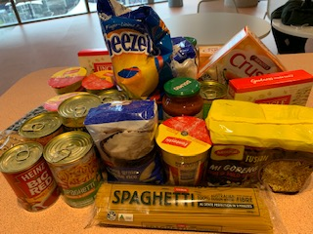 Donated Food Items from Lifeblood Liverpool
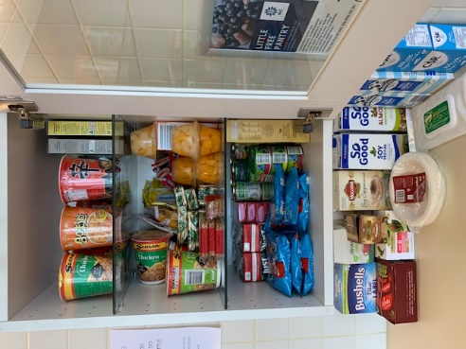 Free Little Pantry Stocked up after a $150 shop
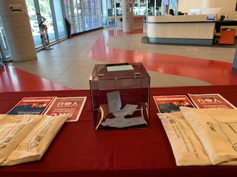 Feedback in the feedback box at the Liverpool Campus C-Stall

Written by Romonda Eid – 18900864 – SRC Liverpool

PARRAMATTA CITY CAMPUS REPRESENTATIVE: VACANT

Not submitted

PARAMMATTA SOUTH REPRESENTATIVE: RAZIN POLARA

Not submitted

NIRIMBA CAMPUS REPRESENTATIVE: SARA MIKHA

Not submitted

ONLINE STUDENT REPRESENTATIVE: VACANT

Not submitted

KINGSWOOD CAMPUS REPRESENTATIVE: JULIAN GONZALEZ

Not submitted

SMALL AND REGIONAL CAMPUS REPRESENTATIVE: VACANT

Not submitted

Equity Collective Representatives

DISABILITY REPRESENTATIVE: ROBERT REED
September Monthly SRC Report – Disabilities
07/09/2022 Assistive Technology Catch-Up Meeting
07/09/2022 Space Utilisation Workshop - Workshop 2
Second workshop of a two series workshop. This allowed for greater insight into the machinations and working of OEC and their role within Western Sydney University. Throughout the sessions many ideas were pitched by the various groups inclusive of both staff and students on how to increase not only participation of all those in this community, but to increase awareness of functionality of services provided, current amenities at the campuses and how to better utilise existing infrastructure and incorporation of new infrastructure and programs with existing collaborations and partnerships.
09/09/2022 Monthly SRC Meeting – unable to attend due to illness
16/09/2022 Mates Corner Men’s Discussion Group
Weekly discussion group for student attending Western Sydney University,
Due to midsemester break and assessments that are undertaken by students at this time turnout will be low, however expected.
21/09/2022 Campbelltown Provost Meeting
23/09/2022 Western Sydney University App – Discussion
Discussion regarding the apps used by Western Sydney University and
overall accessibility for students. On note some features would be of benefit for those with visual acuity issues to allow for better use by all students. One example that has been noted is the colour scheme due to visual field spectrum effect, and some students are unable to properly utilise the app due to inability to read wording due to this. Discussions ongoing.
23/09/2022 Mates Corner Men’s Discussion Group
27/09/2022 Disability Collective, Diversity, Equity and Well-Being Meeting – postponed
Postponed due to insufficient number of agenda items. However, the next meeting will include discussions for the upcoming Movember events, and International Day of Disability .
30/09/2022 Mates Corner Men’s Discussion Group
05/10/2022 Assistive Technology Catch-Up Meeting
Monthly catch-up with Sally Leggo and Natalie McLoughlin. Discussions surrounding the use of assistive technology in the School of Midwifery and for use on Case Studies and case notes. This will be interesting to see how this progresses as if it can be implemented and proves viable, will open discussions with both Natalie and Sally about its incorporation into other areas, including Health Science programs. Diversity week allowed for the introduction of the Assistive Technology Team to the student community, this allows for all students to understand that there are services available to greatly enhance their studies and academic progression whilst studying at Western Sydney University. As noted to both Sally and Natalie at this meeting my tenure as SRC Disability Representative comes to an end in December however will still play an active role in this monthly catch-up This meeting also provided for discussion on visual spectrum issues regarding apps and programs that are currently used by Western Sydney University. This will likely remain a contentious topic, however it can be understood that this does affect a small number of students. Further discussions regarding Gleam as the replacement for Sonocet, Read and Write programs and upcoming changes including to the hierarchy of IT Services

Upcoming Events / Miscellaneous Items
November is once again coming upon us and as everyone knows it’s the one time of year to grow that moustache you have always wanted to make a difference for Men’s Health. This year we will be looking at creating events for both our Mo Bros and Mo Sistas to tackle the issues that affect men and surrounding loved ones. Initial planning for a Movember Luncheon in collaboration with Western Phoenix Spirit, with guest speakers from Talk2MeBro and NSW Council for Pacifika Community. More information to be provided once all details have been completed.

Guest Speaker Event with Dr Dinesh Palipana OAM, an award-winning doctor, co-founder of Doctors with Disabilities Australia, disability advocate, researcher, and lawyer. This will be a fantastic opportunity to listen and meet an amazing individual who overcame great odds to achieve great success. Special mention to Stephanie Hannah who was able to facilitate this event and to the Disability Collective Executive. Registration details via the Disability Collective on WesternLife.

I will also use this opportunity to thank both Stephanie Hannah and Shobha Venkatachalam for their efforts and dedication that they have brought to their roles within the Disability Collective Executive. I will be forever grateful that I have been able to work with two students who have done an exemplary job since they have joined the executive.

ETHNO-CULTURAL REPRESENTATIVE: CRYSTAL RAM
SRC Member Report – October 2022
Meeting Attendance (ETHNO-CULTURAL REPRESENTATIVE):
13/09/2022 Meeting with Ethnocultural Students – Parramatta City
14/09/2022 Meeting with Ethnocultural Students – Parramatta City
15/09/2022 Meeting with Western Sydney University Boxing Society – President
15/09/ 2022 Meeting with Taurai Moyo - Student Clubs Team
26/09/2022 Hawkesbury Placemaking Strategy - Student Workshop
28/09/2022 Meeting with Grant Murray - Student Voice
28/09/2022 Luncheon with Dr Maminza - University of Mpumalanga
14/10/2022 SRC Meeting
As the elected ethnocultural representative, I will continue in my efforts to partake and report the needs of students across all fields on and off campus. I plan to organise regular meetings both face to face and virtual, for students that allow a chance for the students of various communities to grow and develop. I thank those who have sincerely supported me in becoming the Vice President Education (Undergraduate) for 2023.
Since being elected I have sustained effort to support and advance networks as well as partnerships with individuals, groups, clubs, and offices which are working towards the same otherwise similar objectives such as the Provost Committees where we will be working alongside with the Inclusive Communities Coordinator, for the upcoming Diversity Fest. This will assist to leverage our capacities and resources, as well as to avoid duplication of activities and meetings, especially with university staff.
Further to this, I have collaborated with multiple student collectives and societies to schedule events for the remainder of the term, acknowledging various days of observance in ethnically diverse communities.
In this report I would like to wish students of the Hindu faith a Happy Diwali (The Festival of Lights). Diwali celebrations are held across Australia on the 25th October to celebrate and recognise the celebrates the triumph of light over darkness, good over evil, and knowledge over ignorance.
While different communities observe Diwali in different ways, we can all embrace its ideals of friendship and belonging. In Australia, Diwali also provides an opportunity to reflect on how our diversity has enriched our society.
Nearly 700,000 people of Indian ancestry call Australia home. Last year alone, more than 24,000 permanent skilled visas were granted to Indian citizens, making the Indian Australian community one of the fastest-growing in Australia. Indian Australians have made a tremendous contribution to building modern Australia, succeeding in many fields of achievement – including medicine and law, education and academia, the arts, sport, business; to name a few. Thank you to all our wonderful domestic and international students for their scholastic contributions to WSU. 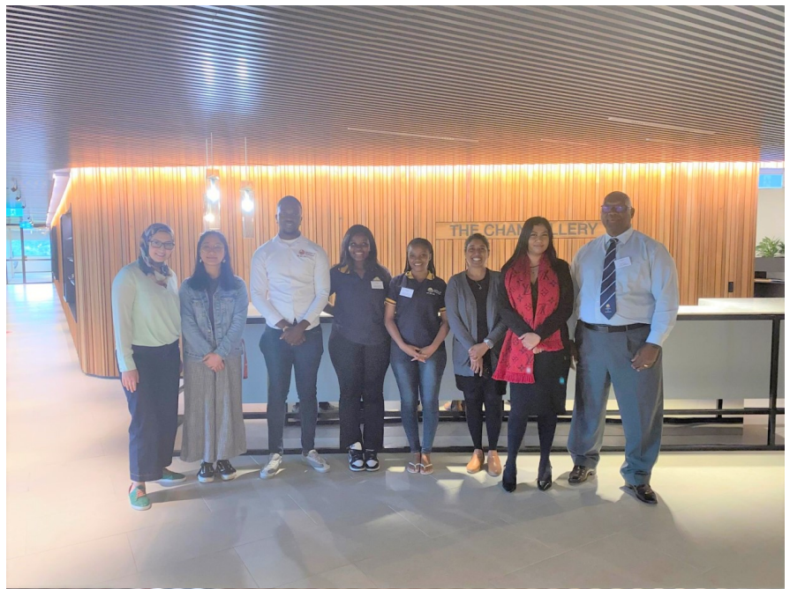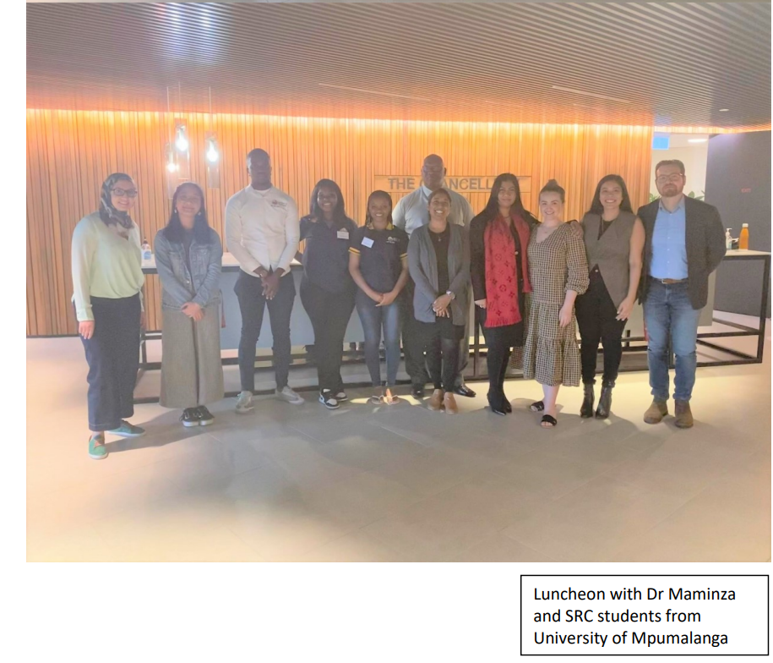

ENVIRONMENT REPRESENTATIVE: VACANT

Not submitted

FIRST NATIONS REPRESENTATIVE: TIFFANY SHARPE
FIRST NATIONS REPRESENTATIVE: TIFFANY SHARPE
First Nations Representative – October SRC Report
I continue to be engaged with the student leaders and Indigenous cohort, along with adequately meeting the standards of criteria within the First Nations role and responsibilities stated in the portfolio. Also, I want to mention the increasingly expansion of engagement and promoting more about what is the SRC and what we do for the student? I am increasing my opportunities by collaborative initiative projects with Equity Representatives and Western SRC Student Leaders overall.

Meetings:
- 9th September 2022: September SRC Meeting via Zoom
- 13th September 2022: Senate Assessment Committee Meeting held at Kingswood Campus
- 26th September 2022: Hawkesbury Placemaking Strategy Student Workshop – followed up via email
- 28th September 2022: School of Science – School Academic Committee Meeting via Zoom
- 6th October 2022: Academic Planning and Curriculum Approvals Committee Meeting via Zoom
- 14th October 2022: Academic Senate Meeting

Events:
- 7th September 2022: Badanami Meeting Tea – Indigenous Literacy Day held at Liverpool Campus
- 7th September 2022: Indigenous Professoriate Lecture – Professor Susan Page
- 27th September 2022: Communiteer: Not-for-Profit Meet and Greet via Zoom
- 12th October 2022: Student to Startup – Interuniversity Event (WSU x UTS x UNSW x Catalysr

Collaborative and Individual Initiatives:
- SRC Merchandise Project
Parramatta South Campus Representative, Razin was unable to continue with the SRC Merchandise Project due to clinical placements and additional responsibilities that I opted to take over the Initiative Project on behalf Razin. I will commence communication with resigned Vice-President (Undergraduate), Bakar the creation of the project idea to get his envision and expectations. As I am taking over of the project that you’ll be informed with updates via email.

INTERNATIONAL STUDENTS REPRESENTATIVE: ANKANKSHA ANKANKSHA
MEMBER REPORT
I believe that I have fulfilled my duties as the International representative in the following ways:
1) Regularly attended the SRC meetings.
2) Working further on the end-of-year event and am in regular talks with the events officer.
3) Joined the Parramatta city provost as a member and attend events hosted my other international students.
4) Using the knowledge gained from the Mental Health and Well-being meetings to help out the international students in need.
5) Hosting community dinners with Inclusive communities for international as well as local students to promote a feeling of belongingness among the students and make them feel at home in a completely new country.
6) Participated in the Diversity Fest and hosted a dinner in liaison with Inclusive communities to promote inclusiveness and friendship.
7) Preparing to host an election for the international collective so that the collective is better represented.
8) Will be holding another meeting with the events officer to break down the steps needed to hold the end of year event and decide what is needed, in what quantity and from where.
9) Planning to attend a meeting of the Parramatta South Provost to request for extra funding required for the end of year event since it will be a big event and will require more funds than the ones allotted to me.

RESIDENTIAL STUDENTS REPRESENTATIVE: JORDAN BRETT
October Members Report
01/09/2022 – Meeting of Vote of Formal Notice
02/09/2022 – Meeting with Student Media
03/09/2022 – Meeting with Residential Students
03/09/2022 – Meeting with the President
05/09/2022 – Meeting with Indigenous Residential Students
07/09/2022 – Correspondence with student re. complaint
11/09/2022 – Meeting with students
12/09/2022 – Meeting with students
13/09/2022 – Forum with Indigenous Community Leaders re. Housing and Student Representation
14/09/2022 – Meeting with Student Media
15/09/2022 – Meeting with Indigenous Community Leaders re. Housing and Student Representation
19/09/2022 – Meeting with Student Media
21/09/2022 – Meeting with Indigenous Residential Students
25/09/2022 – Forum with Students
28/09/2022 – Meeting with Office of Minister for Indigenous Australians
28/09/2022 - Meeting with Office of Prime Minister and Cabinet
31/09/2022 – Meeting with the President
03/10/2022 – Meeting with Indigenous Community Leaders re. Housing and Student Representation
05/10/2022 – Correspondence with the President
06/10/2022 – Meeting with Incoming Residential Student Representative

Personal Report to the Residential Student Body
As the election dwindles down, I am sad to say that I decided not to recontest the position of Residential Student Representative. It has been a great privilege to serve residential students, however you have all been left in great hands.
I have recently met with the incoming Residential Student Representative Belle Cheung, and have great confidence in their ability to continue holding the university and related organisations to account. Belle is a current Occupational Therapy student with a strong passion for protecting our interests, and I wish her well in her term as one of the most important representatives managing one of the most vital portfolios.
In the meantime, my team and I on the SRC will continue to hold members to account. We have been pushing an agenda of honesty, transparency, and accountability; because students know the strength the SRC has when members are united.
Jordan Brett, Residential Student Representative

WOMEN’S REPRESENTATIVE: VACANT

Not submitted

QUEER REPRESENTATIVE: JACOB MEIN (EMILEE)
Queer Collective October Report

This month, Queer Collective put up a stall during Diversity Fest where we made custom badges. The main purpose was for students to be able to put their preferred pronouns on a badge, as well as having a background of their chosen pride flag. We also had stickers and textas to customise them a bit more. It was a big success, with many students both within and outside of queer collective making their own badges.
We have also been planning a number of events for queer collective members. The first of which being an open mic night, which has been approved to happen during the first week of October. The event will have a poetry workshop where students can learn to make their own poems, then after we will have a microphone for any students who wish to share their poems, sing a song, or anything else. The idea is that we are giving students the opportunity to express themselves in an artistic way, when many don’t often have an opportunity to do so.
Lastly, we have just finished planning and gotten approved another art event, this time for the next queer collective zine. We’ve done two creative zines in the past, but for this one we had the idea to make it live, where students can make their poetry or drawings in a group environment. In this format, students are also able to have more of an input in how the zine will have its prompts, layout, and design. This event is to happen in late October.

WELFARE AND WELLBEING REPRESENTATIVE: VACANT

Not submitted

