STUDENT REPRESENTATIVE COUNCIL
MONTHLY MEMBER REPORTS

January 2023

Contents
Contents 2
Executives 3
PRESIDENT: BAYAN SOHAILEE 3
VICE-PRESIDENT EDUCATION (UNDERGRADUATE): CRYSTAL RAM 4
VICE-PRESIDENT EDUCATION (POST-GRADUATE): AFROZ ABID 7
Not submitted 7
VICE-PRESIDENT ACTIVITIES: SABRINA YOUNG 8
Not submitted 8
GENERAL SECRETARY: BOWEN FUCILE 9
Campus Representative 10
BANKSTOWN REPRESENTATIVE: JASMINE RICCIARELLI 10
CAMPBELLTOWN REPRESENTATIVE: ROBERT REED 11
HAWKESBURY CAMPUS REPRESENTATIVE: VACANT 13
Not submitted 13
LIVERPOOL CAMPUS REPRESENTATIVE: ROMONDA EID 14
PARRAMATTA CITY CAMPUS REPRESENTATIVE: LAINE FOX 15
PARAMMATTA SOUTH REPRESENTATIVE: KAITLYN SEYMOUR 16
NIRIMBA CAMPUS REPRESENTATIVE: ISAAC ADAMS 17
Not submitted 17
ONLINE STUDENT REPRESENTATIVE: CAITLIN MARLOR 18
KINGSWOOD CAMPUS REPRESENTATIVE: VACANT 20
Not submitted 20
SMALL AND REGIONAL CAMPUS REPRESENTATIVE: UMAMAH TASNIM 21
Not submitted 21
Equity Collective Representatives 22
DISABILITY REPRESENTATIVE: VLAD FOCAS 22
Not submitted 22
ETHNO-CULTURAL REPRESENTATIVE: LOUIS AUSSUDRE 23
ENVIRONMENT REPRESENTATIVE: MICHAEL TUNG 24
FIRST NATIONS REPRESENTATIVE: TIFFANY SHARPE 25
INTERNATIONAL STUDENTS REPRESENTATIVE: ANKANKSHA ANKANKSHA 26
RESIDENTIAL STUDENTS REPRESENTATIVE: BELLE CHEUNG 27
WOMEN’S REPRESENTATIVE: SANDY LINDSAY 28
QUEER REPRESENTATIVE: JACOB MEIN (EMILEE) 30
Not submitted 30
WELFARE AND WELLBEING REPRESENTATIVE: HEIDI HODDER 31

Executives

PRESIDENT: BAYAN SOHAILEE
Name and Position:  Bayan Sohailee – SRC President | Report Period:  January-February
Members report: | Monthly Summary:  During January, I spent a majority of my time trying to find my feet and provide as much guidance to the SRC as possible:  - I helped to create a new member reporting system so that members had a point of referenced to what a good and bad example of an SRC members report looks like.  - I helped to create a more efficient SRC agenda and minutes template, which will be used during the first SRC meeting in January.  - Due to a vacancy existing in the General Secretary position, I helped with both as the General Secretary and as the SRC president so that operations and meetings could be scheduled and ran smoothly.
Events/Meetings Attended:

- - SRC General Meeting
- - Meeting with Grant
- - Meeting with SRC/MYAN
- - Meeting with VP-P
- - Meeting with SRC Executive team
- - Attended the Special SRC meeting
- - Attended Standing Orders meeting
 | Training Sessions:
 | - - Attended half of SRC Induction
Special Notes | Need to Know Information:  - - I plan on catching up with as many SRC representatives that I can in the January/February

VICE-PRESIDENT EDUCATION (UNDERGRADUATE): CRYSTAL RAM
SRC Member Report – January 2023

Meeting Attendance (Vice-President Education - Undergraduate): 11/11/2023 Student Leadership Meeting with WSU undergraduate students 16/01/2023 Meeting with Multicultural Youth Affairs Network NSW 19/01/2023 SRC Executive Meeting
19/01/2023 Forum: SRC Sessional Orders 23/01/2023 SRC Meeting
A very Happy New Year, to you all!

As the incoming vice-president (education) for undergraduate students I will plan in my efforts to partake and report the needs of students across all fields on and off campus. As the representative I believe it is anticipated that I strengthen student voice and increase participation in activities which are currently online.

I plan to organise regular inclusive meetings both face to face and virtual, for students that allow a chance for the students of various communities to grow and develop.

Since being elected I have sustained effort to support and advance networks as well as partnerships with individuals, groups, clubs, and offices which are working towards the same otherwise similar objectives such as the Provost Committees where we will be working alongside with the Inclusive Communities Coordinator, for the upcoming Diversity Fest. This will assist to leverage our capacities and resources, as well as to avoid duplication of activities and meetings, especially with university staff.

Further to this, I have collaborated with multiple student collectives, external organisations, and societies to schedule events for the remainder of the term, acknowledging various days of observance in our diverse student communities.

In this member’s report I would like to wish those from the Hindu community a Happy Pongal!! Pongal is a multi-day Hindu harvest festival celebrated by Tamils in India and all over the world. It was observed on 15 January, this year.

I would like to thank all those who have supported me in this journey, I look forward to representing you again this year and delivering a plan for the future :)
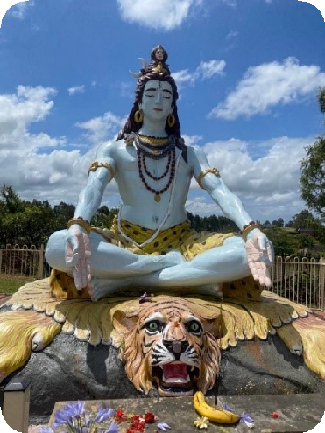
Paying my respects. Meeting with local leaders; to represent and embrace our multicultural student community at WESTERN

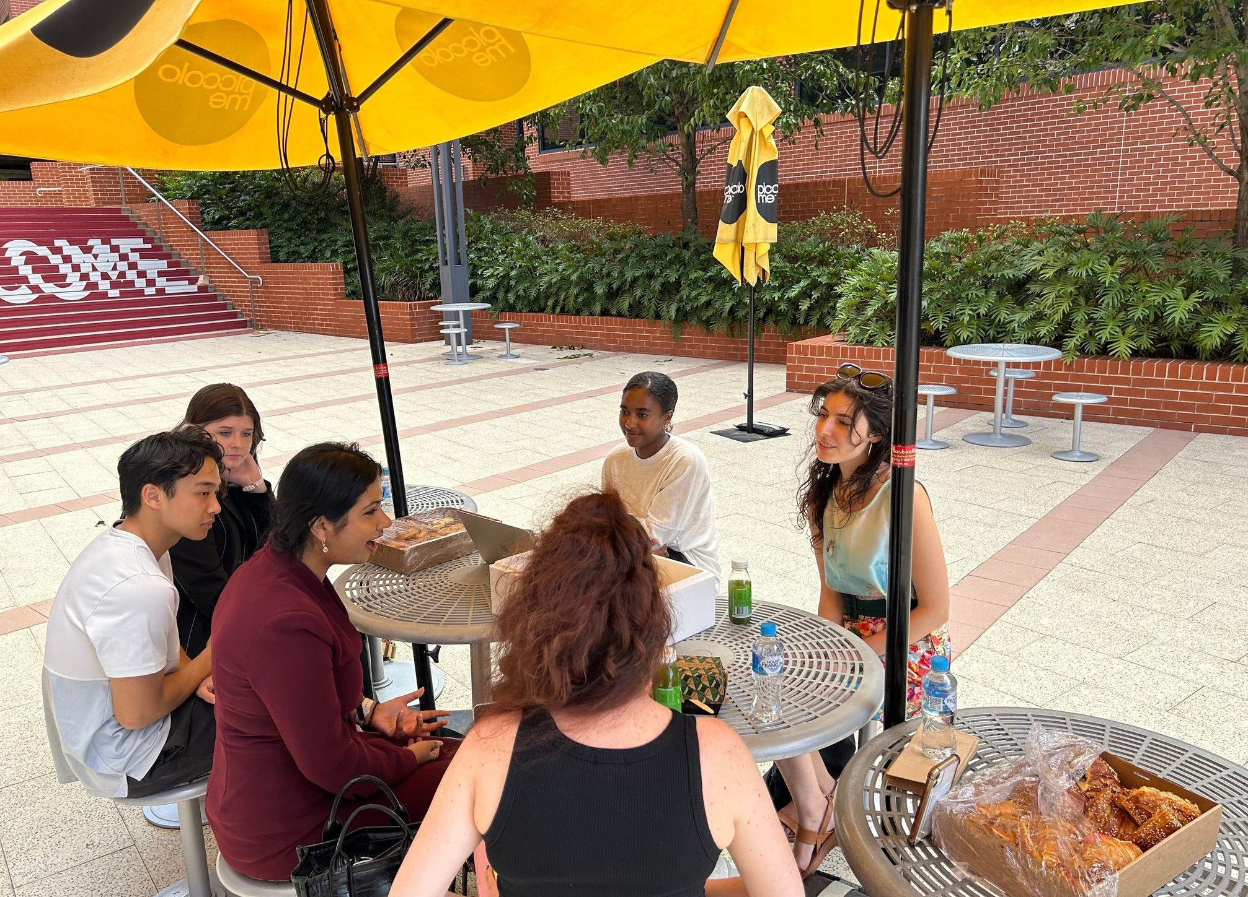
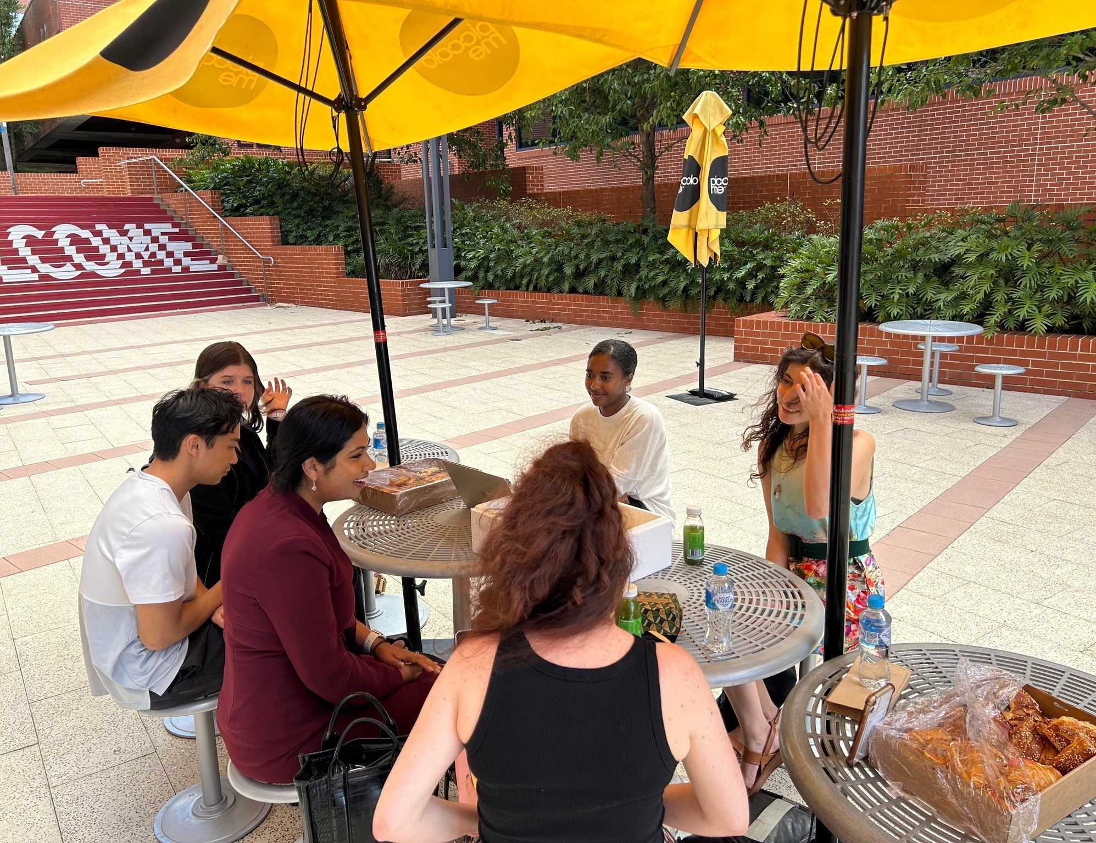
Multicultural Youth Affairs Network Hybrid Meeting, with guests Aisha

VICE-PRESIDENT EDUCATION (POST-GRADUATE): AFROZ ABID

Not submitted

VICE-PRESIDENT ACTIVITIES: SABRINA YOUNG

Not submitted

GENERAL SECRETARY: BOWEN FUCILE
Name and Position:  Bowen Fucile - SRC General Secretary | Report Period:  January - February
Members report: | Monthly Summary:
Midway this month I was elected the SRC General Secretary. I worked on meeting with my fellow representatives and establishing working relationships with the other members of the SRC:

- Discussed with Student Representative Officer the General Secretary role and the dynamic workings of the SRC team
- Discussed with the Student Representative Officer initiatives in creating more accessibility to engagement events and clubs/societies.
- Discussed with Online Representative documents to be used as the General Secretary.
- Discussed with SRC President the expectations and responsibilities of the General Secretary position. Documents to be used were also provided.
- Discussed SRC KPI’s with the SRC Executive Team and increasing activities, events, campaigns and engagement in general.
- Reviewed and questioned the proposed SRC Sessional Orders within the forum.

Events/Meetings Attended:

- Meeting with Student Representative Officer Grant
- Meeting with SRC President Bayan
- Meeting with SRC Executive Team
- Forum: SRC Sessional Orders
 | Training Sessions:
 | - SRC Induction
Special Notes | Need to Know Information:  - Handover of logins from previous General Secretary has not yet been completed.  - 11/2 - Attending SRC and Student Leaders Retreat – 2023  - 30/1 - Attending Student Clubs Executives Training: Processes and Governance

Campus Representative

BANKSTOWN REPRESENTATIVE: JASMINE RICCIARELLI
Name and Position:  Jasmine Ricciarelli - Bankstown Rep | Period: January
Members report: | Monthly Summary:
This month I focused on getting back into the swing of things after the university shut down period. In this coming month of January and February I plan to have a look around the new Bankstown city campus inside I feel seeing the campus layout will help with my planning for the coming year. I also placed an agender term in to receive a budget for the term and I have been in touch with Romonda to discuss some ideas for both our city campus in regard to forums and other activities.

Events/Meetings Attended:
- 13/1/23 Special meeting
- 17/1/23 MYAN meeting
- 19/1/23 Sessional orders meeting
 | Training Sessions:
 | - Training has not been conducted during the January session.
Special Notes | Need to Know Information:  - 16/1/23 Responded to Dr Duffy about free period items. I will give Dr Duffy an idea about the best place to put the items once I have mapped out the new campus.  - 18/1/23 Read through the SRC sessional orders for 2023 which was sent out my Caitlin Marlor  - Upcoming training: I will be attending is the student leader retreat on the 10-11th of February.  - Upcoming training: Student clubs executives training: processes and governance zoom

CAMPBELLTOWN REPRESENTATIVE: ROBERT REED
Name and Position: Robert Reed – Campbelltown Rep | Report Period: January 2023
Members report: | - Completed inventory management for the kitchenette in Campbelltown, including the rotation of new and used products.  - Budget development for the first half of the fiscal year 2023 has been tabled for the January meeting.  - Will schedule a meeting with Daniel Jantos and Inclusive Communities to discuss how to increase the variety of food served to students at Campbelltown Campus community dinners.  - We have had early discussions about free breakfast at Campbelltown Campus with Daniel Jantos. These are now accessible to students enrolled in semester sessions and whose classes begin at 9:00am. The earlier start timings for clinical sessions mean that many students might lose out on this opportunity. Due of the logistics, this will require careful planning.  - Will be developing a survey to collate data from Campbelltown-based students to understand their challenges in comparison to the 2020 Satisfaction Survey. Early input from individuals already participating in 1H sessions may be possible with further data forthcoming in Autumn Session.  - Mate’s Corner (Men’s Discusssion Groups) to reconvene from the 1st of February
Events/Meetings Attended:
Jan 13 - Special meeting regarding sessional orders for implementation into the SRC procedures
Jan 27 – Upcoming SRC January Meeting
Feb 1 – Upcoming Assistive Technology meeting
Feb 6 – Upcoming meeting with NUS, discussions on Hybrid learning and its impact on students

 | Training Sessions:
 | - No formal arrangements have been made for any upcoming training sessions. The DEI and Management training offered by LinkedIn Learning, however, is something I'll be looking at soon.
Special Notes | Need to Know Information:  - Withstanding orders from Angelo Kourtis, a meeting with the new disabilities representative will be scheduled when deemed appropriate.

HAWKESBURY CAMPUS REPRESENTATIVE: VACANT

Not submitted

LIVERPOOL CAMPUS REPRESENTATIVE: ROMONDA EID
Name and Position:  Romonda Eid – SRC Liverpool Campus | Report Period:  December – January
Members Report: | Monthly Summary:  - During the end of December, I was fortunate enough to host a Christmas Party on the 15th of December alongside BSCC President Vicky-Rae. On the 16th of December I attended the final SRC meeting for 2022.  - January brought forth a mixture of ideas, and plans for Liverpool Campus, including those around food shortages, cost of living and student pantry. I have been in talks with Campbelltown Rep Robert Reed, regarding “Free Little Pantry”, and how we can work together to ensure students are able to have food items made available at their Campus. Wellness and mindfulness have also been discussed with Jasmine – Bankstown Rep, and planning will commence in early February.  - I am pleased to announce my motion for a new arcade game has been met, with, Liverpool Campus now in receipt of an Air-Hockey table and water fountain. With thanks to the Liverpool Provost team.
Events/Meetings:
- - Special meeting will be attended on the 13th January 7pm, organized by VPA Crystal

- - Budget request submitted on the 13th of January for yearly events

- - Emails sent out to Inclusive Communities (Daniel Jantos and Marissa Waddington) regarding their support and/or help with the budget around Liverpool Lunches.
 | Training Sessions: N/A
Special Notes | Need to Know Information:  - - Planning on working with fellow Representatives Robert Reed and Jasmine Ricciarelli across the Liverpool and Bankstown City Campus

PARRAMATTA CITY CAMPUS REPRESENTATIVE: LAINE FOX
Name and Position:  Laine Fox - Parramatta City Representative | Report Period:  December - January
Members report: | Monthly Summary:
This month I focused on adjusting and getting back to work. I have also been having preliminary discussions with other SRC members about our plans for 2023.

- I had discussions with VP-U and Online Representative about a solid plan for the first few months of 2023.

- I along with other members of the SRC have drafted new motions to be presented at the next meeting of the SRC.

Events/Meetings Attended:
- Meeting with VP-U and Online student representative

 | Training Sessions:
 | - Attended SRC Induction session
Special Notes | Need to Know Information:  - I have planned meetings to discuss policy and procedure in the coming weeks with other representatives.  - Also intend to complete my Mental health first aid certificate to complement my existing First aids Cert.

PARAMMATTA SOUTH REPRESENTATIVE: KAITLYN SEYMOUR
Name and Position:  Kaitlyn Seymour  Parramatta South Campus Rep | Report Period: December-January
Members report: | Monthly Summary:
- - Spent time further familiarizing myself with resources provided at the induction sessions and doing events training module and quiz.

- - Reviewed Sessional Orders Document provided by Online Rep and VP-E

- - Correspondence with Dr Sarah Duffy and other student reps re SSAF funded period products on campus – expressed interest in initiating process at Parra South, awaiting further reply

Events/Meetings Attended:
- - Apologies sent for being unable to attend Special Meeting called by VP-E re Sessional Orders document. Still reviewed document – had no further feedback to provide.
 | Training Sessions_
 | - - Induction attended in Dec 2022 – have reviewed resources and info from this
Special Notes | Need to Know Information:  - - Monthly meeting on 27 Jan – will be in attendance

NIRIMBA CAMPUS REPRESENTATIVE: ISAAC ADAMS

Not submitted

ONLINE STUDENT REPRESENTATIVE: CAITLIN MARLOR
Name and Position:  Caitlin Marlor – SRC Online Representative | Report Period:  January 2023
Members report: | Monthly Summary:
This month, I am very excited to be taking back on the position of Online Representative, after taking a period of leave last year due to personal circumstances.
I would like to extend my congratulations to my fellow representatives, many of whom were successfully elected last year, and those who were elected during this round of EOIs; I look forward to meeting with and working with you all over this coming year.
Due to my recent appointment to this position, I have limited achievements, but I have big plans for 2023!
- - I am having ongoing conversations with the VP-U regarding Online Students, and what can be achieved within this portfolio.

- - I have spent some time reaching out to my fellow representatives, introducing myself and offering support where possible.

Events/Meetings Attended:
- - Meeting via zoom with VP-U
- - Meeting via zoom with Parramatta City Representative
- - Meeting via phone call with President
- - Meeting with First Nations' Representative
- - Meeting via phone call with General Secretary
- - Meeting via phone call with Disability Representative
- - Meeting with W'SUP Student Editor
- - Meeting with NUS NSW Branch President
- - Meeting via phone call with Student Community
- - Attended SRC Induction Meet and Greet with Senior Staff
- - Meeting with MYAN
- - January Special Meeting
- - January General Meeting
- - Meeting with Women's Representative - Social Media
- - Convened Sessional Orders Forum
 | Training Sessions:
 | - - No training sessions attended this month – although I will be looking to upskill myself over the coming months
Special Notes | Need to Know Information:  - - I will be organizing an email to be sent to all Online students, in order to introduce myself to the portfolio and pencil in the first Online Facilities and Services Forum.

KINGSWOOD CAMPUS REPRESENTATIVE: VACANT

Not submitted

SMALL AND REGIONAL CAMPUS REPRESENTATIVE: UMAMAH TASNIM

Not submitted

Equity Collective Representatives

DISABILITY REPRESENTATIVE: VLAD FOCAS

Not submitted

ETHNO-CULTURAL REPRESENTATIVE: LOUIS AUSSUDRE
Name and Position:  Louis Aussudre - SRC  Ethno-Cultural Representative | Report Period:  January 2023
Members report: | Monthly Summary
- I was elected to this position on Monday 16 January. I look forward to working with the SRC team and the Ethno-cultural collective to make Western Sydney University more culturally diverse.

- I wish to thank my new and continuing SRC reps for their warm welcome, and I look forward to working with them in the coming year.

- This year I am planning to achieve:
  - Promote diversity in the university.
  - Host events with the collective for our community.
  - Continue the great work achieved by my predecessor.

- So far, this is what I am doing to achieve these goals:
  - Planning a handover meet with my predecessor.
  - Assisting in the EOI for the collective's officer.
  - Working with the Multicultural Youth Affairs Network (MYAN).

Events/Meetings Attended
- - Attended MYAN Meeting

Training Sessions (Dot Points):
 | - - As my election was only four days ago and I am currently overseas, I have not had the opportunity to attend any training sessions as of yet, but intend to do so as soon as I return to Sydney, in early February.
Special Notes | Need to Know Information:  - - No special note as of yet.

ENVIRONMENT REPRESENTATIVE: MICHAEL TUNG
Name and Position:  Michael Tung - SRC  Environmental Representative | Report Period:  January-February 2023
Members report: | Monthly Summary
This month, I am very excited to be taking the position of Environmental Representative. I am so grateful to be a part of the SRC.

I am looking forward to meeting with and working with my fellow representatives.

This year I am planning to achieve:
- call on the university to reach net-zero carbon emissions by 2035.
- Initiative to create native green spaces’ on our campuses, as well as call on the University to protect the local flora and fauna.
- Continue to grow the Community Garden initiatives on our campuses.

Events/Meetings Attended:
- Meeting with Online Students’ Representative
- Meeting with Vice-President Undergraduate
- Meeting with Parramatta City Campus Representative
- Meeting with Environmental Collective.
- Attended Special Meeting of the SRC
 | Training Sessions:
 | - No training sessions attended this month due to placement. I will be looking to upskill myself over the coming months!
Special Notes | Need to Know Information:  - A founding member from Environmental Collective, Kathy Nguyen has reached out and held an initial meet and greet with the team  - Environmental Collective election will be coming up  - I am currently overseas, therefore, all correspondence can be directed straight to my email.

FIRST NATIONS REPRESENTATIVE: TIFFANY SHARPE
Name and Position: Tiffany Sharpe - SRC First Nations | Report Period:  December – January
Members Report: | Monthly Summary:  This month I focused on building interpersonal connections with representatives of the SRC and continuing to acquire leadership through professional development:  - Attended NUS NatCon as an elected NUS delegate and built professional relationship with elected NUS First Nations Representative. There has been discussion of ways in assisting campaigns and advocacy in New South Wales.  - I discussed the idea of updating the Indigenous Student Council logo with the Director of the Badanami Centre for Indigenous Education, Fiona Towney.  Events/Meetings Attended:  - APCAC Meeting  - Academic Senate Meeting  - SRC Administrative Committee Meeting  - National Union of Students 2022 National Conference (NatCon)  - Special Meeting of the SRC: January 2023 [SRC RESOLUTION]  - MYAN NSW: Kairos program  Training Sessions:  - Conflict Resolution for Beginners  - Time Management Fundamentals  - Negotiation Skills  - Diversity, Inclusion, and Belonging for Leaders and Managers
Special Notes | Need to Know Information:  - I intend to build professional relationships among the Badanami Centre for Indigenous Education Student Success Officers by scheduling on-campus meetings before Autumn 2023 commences.

INTERNATIONAL STUDENTS REPRESENTATIVE: ANKANKSHA ANKANKSHA

Aakanksha Aakanksha – SRC International Representative
Period – January to February

Summary:
- This month I looked into the formation of the International collective. I sent the updated list of members to Jenny Page and will soon be arranging a meeting with the new members.
- I will be returning to Australia next week but have maintained contact with international students throughout the break.
- I look forward to meeting the new members of the SRC and building collaborations and connections with them to work for creating a better and more inclusive environment for all the students.
- I am also eager to curate new and interesting events which will make life more fun here at Western.

Events attended:

As the session just started there haven’t been many events and as I am still overseas, I could not attend the events that took place, but I look forward to hearing about the experience of all the members who attended the events and learning through it.

Training session

Since I was re-elected for the same position, I did not attend the induction training this time.

RESIDENTIAL STUDENTS REPRESENTATIVE: BELLE CHEUNG
Name and Position:  Belle Cheung – SRC Residential Representative | Report Period:  January-February
Members report: | Monthly Summary:
This month I focused on building relationships with residents in WSU village Campbelltown, working relationships with other SRC member and familiarising myself with the flow of SRC meetings and forums.
- I had a discussion with students living in Campbelltown campus village enquring the needs for facilities around the accommodation. Students raised issues in shuttle bus services, rental cost and lack of social engagement through sporting events.
- I also attended meetings with other representatives through Zoom and had brief introduction of the role from Jordan Brett, former Residential Representative in 2022.
- I also offered assistance to expanding free period products around campus villages.

Events/Meetings Attended:
- Meeting with VP-U, Parramatta City Representative, Online Representative
- Special meeting held on 13/1/2023
- Forum held on 19/1/2023
- WSU Village Campbelltown events
- Meeting with Multicultural Youth Affairs Meeting - PARRA SOUTH
- Meeting with Hong Kong Cultural Society’s executive members
Training Sessions:
 | - Will attend tudent Clubs Executives Training: Processes and Governance on 30th January
Special Notes | Need to Know Information:  - There is a casual meeting with resident assistants in the Campbelltown campus village on the 24th of February – regarding residential students’ concerns. I will provide an update on next months member report.

WOMEN’S REPRESENTATIVE: SANDY LINDSAY
Name and Position: Sandy Lindsay Womens’ Rep | Report Period:  Jan 1-Jan 19, 2023
Members Report: | Monthly Summary:  This month has been a lot about finding my feet and trying to tackle the administrative load of moving into the role, particularly gaining access to digital assets.  - I have started to create material on Canva to post on social media, encouraging new students to join WoCo, and to advertise EOI for officer roles.  - Email communications and phone call with Gemma Cook regarding ongoing projects and 2022 reflection  - Email communication with Laura Beatty regarding access to WoCo social media accounts and email inboxes  - Requested assistance from other SRC reps to unravel the business social media set up. Accepted offer of help from Online Rep- Caitlin Marlor.  - Email communication with Dr Sarah Duffy and Dr Michelle O’Shea regarding free period products on campus, and other project opportunities.  Events/Meetings Attended  - Attendance at special meeting  - Lengthy zoom call with previous Environment Collective officers and incoming representative for the purpose of handover  - Attendance at face-to-face meeting with MYAN to discuss their current projects and where this may intersect with our cohorts  - Attendance at sessional orders zoom forum  Training Sessions  - N/A
Special Notes | Need to Know Information:  - I have identified two email addresses used by Woco which I do not have access to. womenscollective@student.westernsydney.edu.au is listed on WesternLife as the primary contact, and Womens.collective@yahoo.com was used to create the WoCo social accounts.  - EOI for officer roles cannot be advertised/opened until I have confirmed I can access responses.  - Meeting to be planned for late Feb with Sarah Duffy and Michelle O’Shea regarding collaboration on projects for 2023. Further information will be provided in next members report.

QUEER REPRESENTATIVE: JACOB MEIN (EMILEE)

Not submitted

WELFARE AND WELLBEING REPRESENTATIVE: HEIDI HODDER
Name and Position:  Heidi Hodder -Welfare & Wellbeing rep | Report Period: Jan 2023
Members report: | Monthly Summary:
- - got Amy to get in contact with other nominees for Welfare & Wellbeing rep position to see if they have ideas, Sandy got back to me with some

- - got introduced by Amy to Terri Mears, disability officer

- - emailed Grant last year then Richard 10/1 to try to find out last name of Emma, who Ellen Brackenburg suggested I speak to when I spoke to her at the induction drinks meet & greet, haven’t heard back from them so I guess I’ll contact Ellen (have looked in staff directory at welfare staff but not sure who it is)

- - Been in contact with Lucinda Barlow, manager of the welfare service, to organise a meeting

- - brainstorming with other students ways to consult with the student body

Events/Meetings Attended:
- - SRC induction last year and meet & greet
 | Training Sessions:
 | - - SRC induction last year and meet & greet
Special Notes | Need to Know Information:

