STUDENT REPRESENTATIVE COUNCIL
OCTOBER MONTHLY MEETING MINUTES

- Procedural Matters

  - Welcome, Introduction, and Apologies

Attendees:
Sarah Cupitt
Tiffany Sharpe
Sharmin Saba
Alannah Hader
Danielle Albertine
Razin Polara
Rosina Armstrong
Cameron Chesters
Johnathan Espinas
Robert Reed
Sara Mikha
Vicky-Rae Reed
Muhammad Abbas
Dharshini Sathyanarayanan
Loore Muravu
Simon Preuss-Kearney
Rannie Singh
Crystal Ram
Jasmine Ricciarelli

Student Observers/Staff:
Grant Murray
Richard Martino
Vidushi Sethi
Rimsha Khan

Apologies:
Sara Mikha
Muhammad Abbas (late)

  - Acknowledgement of Traditional Custodians of the Land

Tiffany pays respect to campus and community Elders, past present and future and acknowledges any First Nations peoples present.

  - Declarations of Interest

The Chair invites the committee to declare any new conflict of interests in relation to any matters on the agenda or their role on the committee more generally. No members declare any conflict of interest.

  - Starring of Items

Alannah suggested to star all items.
Seconded by Sarah.

  - Order of Business

Order of Business is to be conducted as per the agenda.

  - Confirmation of Previous Minutes

September minutes confirmed as a true and accurate record.
Moved by Alannah. Seconded by Jasmine.

  - Confirmation of Member Reports

August and September reports moved by Alannah. Seconded by Tiffany.

  - Action Sheet from Previous Meeting

Sarah updated the September action sheet items at the bottom of the agenda (6.4).
Quick run through of ongoing actions for August and September and updates.
Sarah has removed completed and altered tasks prior to the August action list.

- General Business of the Council

  - Report from the Chair

"I'd like to open today's meeting by making some remarks around observations of behaviours presented by some members of the SRC. We as the peak representative body of students at Western Sydney University are obligated to adhere to our code of conduct which specifies that as student reps we:
- Contribute to and share responsibility for collective decisions and represent the council's policies on appropriate public occasions; respect the views of others and listen to what they have to say; and adhere to the collective decisions of the meetings. Any council member unwilling to so do should resign
- Ensure their actions do not cause a nuisance or harassment to others. Never use language that is likely to offend the reasonable person, such as racist or sexist terms. Avoid any language or behaviour likely to cause offence to others
- Must treat other members with courtesy and respect
- AND MOST IMPORTANTLY IN CONTEXT OF THE BEHAVIOURS PRESENTED IN ONLINE GROUP CHATS AND DURING MEETINGS Should not engage in inappropriate behaviour that might be seen as threatening or confrontational
  - I have found it disappointing to see that not every SRC rep has been offered the same respect as others and are left feeling uncomfortable and doubting their abilities. Repeated behaviours will be seen and noted as bullying and as such, will not be tolerated.
  - I also note that the code of conduct also stipulates that all members are obligated to adhere to all of their responsibilities including those decided by a motion at a meeting, but also importantly those responsibilities the procedures lay out such as attendance, presence, participation and submission of reports in a timely manner providing overall coherence and productivity to ensure we as a council best represent the views of our fellow students." As of late, a few of these responsibilities have slipped, with some reps not allocating sufficient time slots to fulfil their responsibilities. The procedures do make it very clear as to how reps are to act and the expectations of your roles. I do not want to have to see any reps go however, this body was built to represent all students and if there is a rep who is not doing an adequate job, I think we all can agree it should be given to someone who will.

I don't want these comments to sound harsh and like I am having a go at you all, because it is not everyone. I want these comments to be heard and to sit in the back of your mind so we can avoid any complications for the rest of the year."

  - Report from Student Community

Grant is yet to send a monthly update via email, the draft is nearly complete. Hopes everyone saw his communication about process mapping that's underway (a large piece of work). EOIs have been a topic of conflict and he appreciates everyone has had strong opinions and thoughts – SRC now have a document to review regarding the management of EOIs for further feedback. The document is not finished and Grant will be getting some screenshots and process map, step breakdown etc., for the sections to be stored on Teams. Grant mentions for Rosina to have a chat with him about NOWSA. What's important for everyone to remember and consider is that these documents become quite impermanent quite quickly, and have to be updated constantly (and so have avoided doing that because of the workload associated with maintaining the currency of the knowledge). Grant is happy to do this; however, it means they won't be updated as often as we may like.

Vicky asks if we can just update the documents from the previous student rep structure, e.g. conferences. Grant mentioned it would be a matter of uploading to Teams and copying and pasting, however, Grant has a million priorities and it's not as simple as it sounds.

Grant is pleased to see many reps attend the strategy planning with Michael and thanks those who have taken the time out of their schedules. Grant reminds everyone that set training is mandatory and there shouldn't be questions about that. If you can't attend it, you need to justify why you can not. (Grant wanted this specifically minuted).

There's not too much to update on, however if reps have expenditure, we need to get those conversations happening ASAP so Grant can plan his month accordingly. Limited options for spending after November, which he's mentioned on several occasions. Purchase orders will take longer for vendors we've never heard of (so just avoid invoices and look at businesses that offer credit card payment). Grant would appreciate reps running him through purchases rather than dropping a link and asking him to pay for things. Very happy to problem solve and collaborate with reps.

Jasmine asked about reasonable justification and Grant responded with hospitalisation, a particular urgent need to get away from your computer or campus, obviously on a case by case basis. If you have class then obviously, that's a clash Grant could've avoided and therefore it's justifiable. In regards to work, Grant encourages reps to prioritise the SRC where possible and reschedule shifts. For reps that can't commit to that should leave their SRC role to someone who can do it.

Sarah asks a question relevant to Grant's former points on budget and urgency. Quickly flags to the team her disappointment as we allocated the budget in August and reps have left it a few months to actually get onto their projects, but in terms of the budget itself, she points out Grant has mentioned in the past few meetings the limits on the corporate card for purchases of 10k per month. She notes (based on former team discussion) that if our budget for this semester was around 100k it means we would've only been able to spend 60k of our budget. She asks if this is something that should've been looked at the SRC team that received the new budget in January to plan the 10k spending per month, but even then the budget is over 120k – so what happens to the leftover funds?

Grant responds that there's a couple of avenues he can explore, like Richard to assist with payments, and other team members in student community for credit card payments. Also, if reps want to make their own purchases and seek reimbursements (but not hundreds and hundreds of dollars, as if it's not SSAF compliant reps cannot be reimbursed). If invoices are dire, reach out to grant and Richard, they will avoid invoices where they can but in terms of reminders, he mentioned he took the Jan team through a strategic planning session regarding the new budget, in which reps provided feedback that they weren't comfortable allocating or spending funds until we returned to campus. He notes it's an ongoing conversation and he will not bear any responsibility for that – plain and simple. The prior SRC were not making purchases at the beginning of the year for personal reasons and he appreciates that.

Danielle understands how it's important to avoid the end of year rush and reiterates Sarah's question. She then asks if our overall budget is over 160k if we're sure there are enough avenues to process SRC budget requests.

Richard notes with particularly with large purchases anything over 5k is processed through an invoice. So there are other avenues to pay for big ticket items, corporate cards are used for purchases under 5k and while there are other team members in student community, SRC isn't the only team that is spending their budget.

Danielle thanks Richard for his help.

Grant notes he doesn't want reps to be disappointed in December.

Alannah asks Richard if he has anything to add, Richard opens questions.

Simon asks where he can access the new procedures; Grant said it's on Teams.

  - Report from Collectives

Robert provides updates for Movember (Disability Collective) which started 3 days ago, background on Movember and the importance for cancer amongst men. Hoping to get more people on board, running until November 11th.

Vic asks Rob if he wants to mention the ladies for the physical challenge. Rob mentions any non-binary or female folks can partake in a 60km challenge

Robert and Vicky provide further updates on Mates Corner with MHWB and mentions a few people on board e.g. mentors, Ingrid, Emma Taylor, Steve Lee etc. Aiming for further updates by the 27th of November.

Rannie provides update for Diversity fest and the planning around a virtual Halloween party for the Queer Collective, and ongoing movie nights and zooms.

Loore provides update that she has emailed the student officer hub regarding international students and received positive feedback – for what the uni has put in place for returning international students on campus.

Crystal gives a quick update that she's sent an email to the team for campus set ups and thanks everyone for their support.

  - Report on SRC Budget

Sarah provides updates to the SRC budget for the rest of the year and that all budget requests have been uploaded to Western Life. The leftover costs for Mehwish and Daniel as well as funds allocated to CAPA and CISA (which were already paid) need to be reallocated and has been discussed amongst the team to allocate extra funds to the VPA portfolio so that we can use that for ongoing events for all reps.

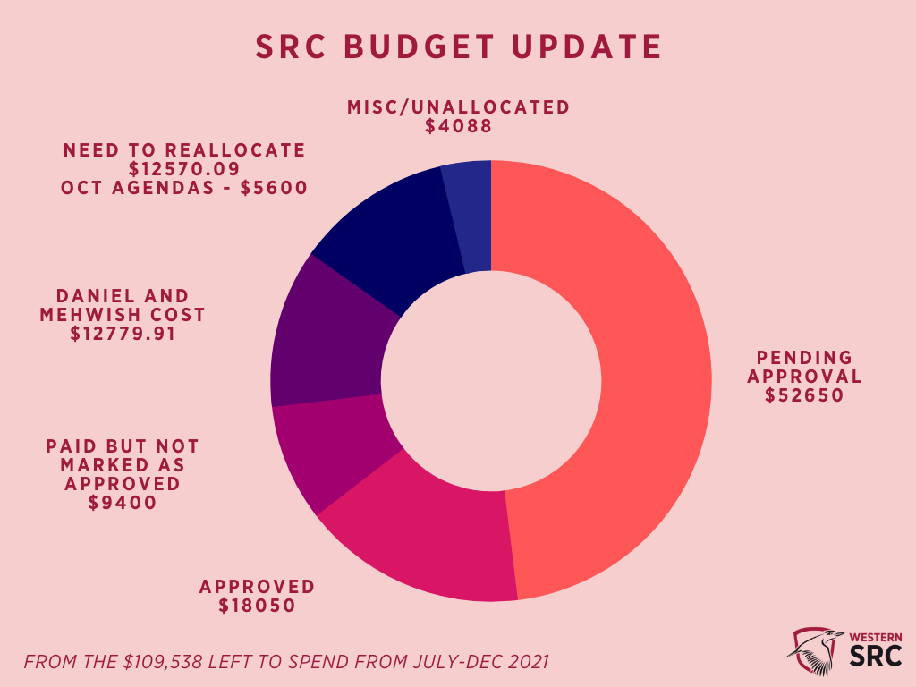
(Updated SRC budget chart distributed and discussed with reps prior to the meeting)

  - Reports and Recommendations from SRC Committees

Vicky mentions the idea of a SRC newsletter to go out fortnightly and asking about updates for this since from Alannah since there hasn't been any real comms through emails since the new team got elected. She also highlights the inclusion calendar and any events that the SRC is putting forward to the wider audience.

Alannah notes she has spoken to Grant however might need to talk to him again to see if that's something that will go ahead and if so what it will look like.

Vicky notes she doesn't have access to any platforms she needs to do her role. And that everything is down for her to send comms to Alannah and Sarah. Alannah says she'll have a chat with Sarah and Grant later on in the week.

Sharmin notes that since it's her first meeting she wasn't sure if she should speak out. She understands there hasn't been a res rep in the past few months; she is planning to visit other community tables at other campuses to travel there and introduce herself so they know there's a student to support them and host events. She feels that there is a lot of CLV campuses to cover and would obviously love to attend all of them but doesn't think it would be possible, and so encourages the campus reps to visit their respective campus CLV resident campuses so students can meet reps.

Muhammad apologises for showing up late but provides a quick update about his recent event for his mental health day baking class – which was famous and popular and all the tickets sold out within two days, and good attendance and feedback. Mehwish has suggested possible fortnightly or monthly ongoing events. He is happy to collaborate with other reps for similar future events. Muhammad notes communication with Grant and is happy to pick up Anushka's action items.
- New Business of the Council

3.1 Live Study Stream with Peers

Issue | Study Stream
Date | 26th September 2021
Mover | Dharshini Sathyanarayanan
Seconder | Jasmine

Issue Description:
Inspired by the study stream website, this is an event where students can come together during STUVAC and study. This is just an attempt to bring back the productive vibes we get in our university libraries. Students will not have microphone control, but will be able to chat in the chat box – a way for them to ask any course-related questions, which could also help them revise.

Portfolios/Students Impacted:
This is for those students who are not motivated to study at home.

Recommendation:
It would be much appreciated if the SRC reps and editors could promote this event as much as we can, like gifting the first 30 students a $20 Officeworks Gift card.

Justification/Reason for Recommendation:
I don't think any universities has ever conducted an event like this before. I am hoping we have this event and see whether students find it useful. If so, then we could do events like this more often.

Budget Impact:
Items | Quotes/Cost
30 $20 Officeworks Gift cards | $20 x 30 = $600

Dash introduces herself as the Campbelltown Rep and notes she got the idea from Tiktok for the study stream event, chat through the chat box, no inappropriate language etc. Cameron was very encouraging about this event and wanted to increase the funding for the event.

New Budget Impact:
Items | Quotes/Cost
First 100 get $30 Officeworks Gift cards | 100 x $30 = $3000

Dash also mentioned she's happy to re-run the event during stuvac two or three times.

Event is already on Western Life. Budget allocation is from Cam's portfolio.

Dash to provide feedback of the first event next meeting.

3.2 Engagement Strategies

Issue | Lack of engagement from reps
Date | 30.09.2021
Mover | Sarah Cupitt
Seconder | Alannah Hader

Issue Description:
At the September exec meeting, I raised the question of how reps performed in their quarterly review; this discussion then led to the group finding the main issue with SRC is internal engagement, leading to this agenda item. Ultimately reps don't understand their role because they haven't read about their position requirements in the procedures.

Portfolios/Students Impacted:
All reps.

Recommendation:
- Start developing strategies around engagement
- Perhaps discuss this during the SRC Strategy Session 2 or 3
- People can raise their concerns, ask for advice etc.
Justification/Reason for Recommendation:
Lack of engagement from specific reps, lack of meeting attendance, lack of member reports, lack of action towards mandatory responsibilities of being a student rep.

Proposed Action:

All reps to attend mandatory strategy sessions and prioritise developing strategies to engage the entire SRC team.

Rimsha Khan (student observer) asks if there are any SRC positions available. Sarah notes EOIs open for vacancies in Dec and notes where you can find vacancies on the SRC website.

Alannah and Vicky are keen to get involved.

SRC team to collaborate on strategy building in sessions with Michael.

Passed unanimously.

3.3 Working group to assist with the formation of the Collective officers for international students.

Issue | Assist with organising events and engage with the international student at a wider range.
Date | Ongoing
Mover | Loore
Seconder | Tiffany

Issue Description:
Creation of a working group to assist the international student Rep with organising events and engaging international students both onshore and offshore. This group will keep running until the election of Collective officers to work with the SRC International Rep.

Students impacted:
International students

Recommendation:
I am inviting all the SRC rep who are willing to be part of the initiative to kindly email me with their earliest available date so we can organise a zoom meeting including International Students Association executives and get the group to start working.

Justification /Reason for Recommendation:
It's a follow up to the raised concerned from the student community that there is not enough representation of the international students within our university.

Notes she was meant to work on this with Natasha but as she resigned Loore is on her own. Vicky said she's happy to help if required. Danielle adds that this is more of an update than a motion since the agenda in the last meeting was to start a working group.

Host ongoing discussions with international students and SRC reps. First meeting 25th Oct.

3.4 Title: Ceramic Craft Night

Issue | Additional funding for VPA role
Date | 14th October
Mover | Cameron Chesters
Seconder | Vicky-Rae Reed

Motion Description:
The funding for VPA role has been used for multiple big Kahoot events and also as a way to very quickly and easily provide funding to initiatives and events by other SRC reps who thinking of events between meetings. The additional funding of $5,000 or as close to that figure depending on what funding is left will be of great help in ensuring SRC reps can quickly carry out their event ideas and students therefore have the best uni experience possible.

Portfolios/Students Impacted:
All

Budget Impact:
Items | Quotes/ cost
Additional funding for VPA role | $5,000

Proposed Action:
I propose that the SRC commits to allocating this funding to the VPA role for the benefit of all SRC reps and WSU students.

New Budget Impact:
Items | Quotes/ cost
Additional funding for VPA role | $15,000

Proposed Action:
I propose that the SRC commits to allocating $15,000 to the VPA role for the benefit of all SRC reps and WSU students.

Unanimously passed.

- Other Business

Grant discusses summer sessions and SRC event planning and possible collaboration.

Rosina briefly discusses NOWSA and funding tickets for students. Sarah clarified the budget request exsitsts already this is just an update as the conference approaches.

- Next Meeting and Close

November 19th https://au.cglink.me/2ih/r35840
December 10th https://au.cglink.me/2ih/r35841

- Additional Documents

  - June Action Sheet
June Action Sheet
Action | Responsibility | Completion
Submit a budget request for postgraduate committee working group | Alannah to reassign/check WL | TBA
Get in touch with the relevant department regarding WHS/food for Penrith BBQ | Simon | Pending discussion with Provost
Organise Postgrad/HDR get together | Reassign VPP task to Muhammad? | TBA

  - July Action Sheet
July Action Sheet
Action | Responsibility | Completion
Razin to follow up on Intersession Day Out after COVID-19 and get more info from Rameez. | Razin | Planning for post COVID
Crystal to initiate a plan to advocate for Nirimba and Bankstown Campuses. | Crystal | Ongoing
Start an action group to enquire about residential student issues. | Alannah | Ongoing
Alannah to start a working group with all reps for the 'Happy Hour' initiative | Alannah | Ongoing

  - August Action Sheet
August Action Sheet
Action | Responsibility | Completion
Student Monthly Wellbeing Rug and Mug Group – to be held in the next month | Jasmine | Completed
Let Sarah know how much to take out of the SRC budget for Daniel and Mehwish since their contracts started in June | Grant | Completed
Work on budget requests through WesternLife for NUS and other items that reps want to start working on, as one budget item or individually. | Sarah & Reps with budget portfolios | Completed
Collective Officer Honorariums - Danielle to send a blanket email and organise a zoom meeting to discuss further. | Danielle, Richard, Simon, Sarah | Ongoing (readdress at Dec meeting)

  - September Action Sheet
September Action Sheet
Action | Responsibility | Completion
Craft Event working group and contact Events Team for student delivery | Sara | Completed – Event: Nov 30th
International Student Collective – working group and meeting | Loore | Ongoing

  - October Action Sheet
October Action Sheet
Action | Responsibility | Completion
SRC newsletter – Alannah to discuss with Grant and Sarah | Alannah
Muhammad is happy to pick up Anushka's action items. | Muhammad
Dash to provide feedback of the first study event next meeting. | Dash
SRC team to collaborate on strategy building in sessions with Michael. | Sarah, Alannah & Vic
Host ongoing discussions with international students and SRC reps. First meeting 25th Oct. | Loore

