STUDENT REPRESENTATIVE COUNCIL
DATE: 26th of August 2021
TIME: 4.30 pm to 6.00 pm

Agenda
- Procedural Matters

  - Welcome, Introduction, and Apologies
  - Acknowledgement of Traditional Custodians of the Land
  - Declarations of Interest
  - Starring of Items
  - Order of Business
  - Confirmation of Previous Minutes
  - Confirmation of Member Reports
  - Action Sheet from Previous Meeting

- General Business of the Council

  - Report from the Chair
  - Report from Student Representation & Participation
  - Report from Collectives
  - Report on SRC Budget
  - Reports and Recommendations from SRC Committees
- New Business of the Council

  - Student Monthly Wellbeing Rug and Mug Group

Issue | Promoting positive students mental health and wellbeing during online study
Date | 17 July 2021
Mover | Jasmine Ricciarelli
Seconder | Cameron Chesters

Issue Description:
Creating a monthly wellbeing chat for all WSU students during the second NSW lockdown. Where students are able to discuss issues that have been impacting them during their studies on a monthly basis this casual monthly group will help promote student engagement in a non-judgmental safe place to help promote strategies on student wellbeing and raise issues that have been affecting students. As student have mentioned that online study in 2020 had impacted them negatively.

Portfolios/Students Impacted:
All students

Recommendation:
I recommend having both male and female SRC reps attending a monthly meeting so that students can feel comfortable during the group.

Justification/Reason for Recommendation:
As this group is for everyone having both male and female runner can help promote inclusion for student wellbeing during this tough time

Proposed Action:
The SRC can create and promote positive student and community wellbeing though meeting and helping other students during the times of lockdown where many students feel isolated.

  - SRC Budget Proposal Aug-Dec 2021

Issue | Proposing a blanket budget item to save ongoing agenda items
Date | 09/08/2021
Mover | Sarah Cupitt
Seconder | Alannah Hader

Issue Description:
Historically the SRC budget is never entirely spent. On top of that, most SRC agenda items are requests for funding events and initiatives that usually result in meetings running overtime. Therefore, having a budget proposal for the rest of the year’s expenditure would provide SRC and students with information on how much we assign to student initiatives, events, affiliation with NUS and CAPA, and so forth.

My proposed blanket proposal is as follows, after several discussions with SRC reps, exec, Richard, and the budget committee (pie chart below, see table for a breakdown of the budget impact)

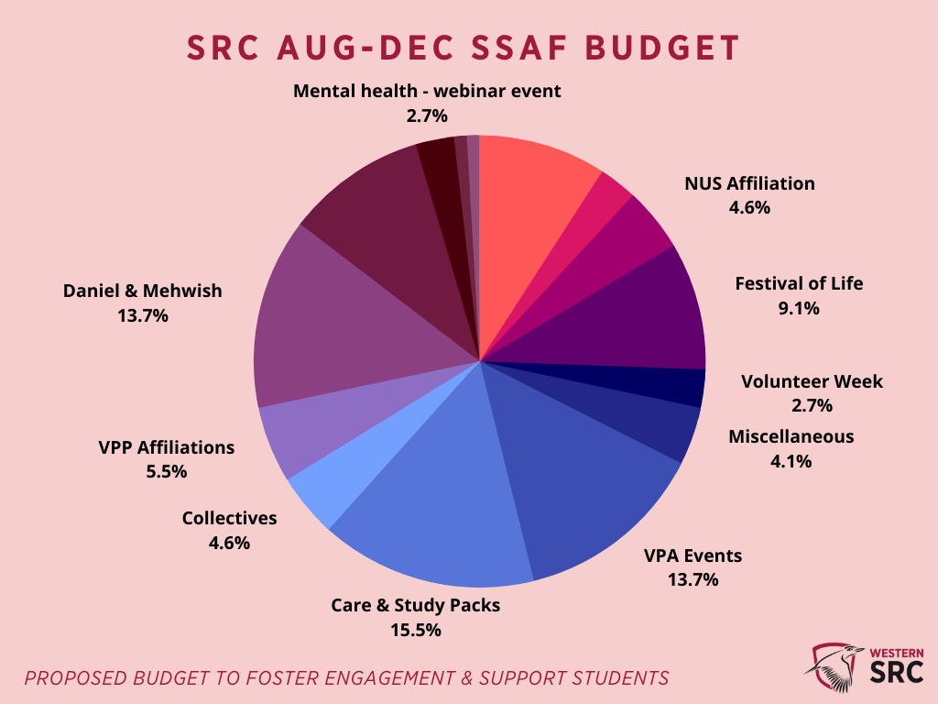

Portfolios/Students Impacted:
All portfolios.

Recommendation:
To have a short final discussion about how the remaining $109,538 for the year should be allocated and then vote on a motion to assign those funds to their relevant portfolios. Note: the amount of funds to be spent also includes the funding passed in the July meeting as those funds have not yet been spent, though they have formally been assigned to those portfolios and so cannot be amended.

Justification/Reason for Recommendation:
This proposal intends to prevent any confusion regarding how much funding we have for the year and provide transparency for students about how our budget will be spent. It will also save time in future meetings by removing the need to submit agenda items for ongoing funding purposes, especially in need of last-minute events or student initiatives.

Budget Impact (passed funding from July meeting and flying minutes):
Items | Quotes/Cost
Simon’s Portfolio - Gift cards | $1000
Muhammad’s Portfolio – EID initiative | $1000
Danielle’s Portfolio – Garden & Collective | Up to $10,000
Tiffany’s Portfolio – Student Volunteer Week | $3000
Cameron’s Portfolio – Online events | $3000

Budget Impact (new items to be passed):
Items | Quotes/Cost
NUS Affiliation | $5000 (ready to process)
Mental health – external webinar or panel event (could be organised internally with WSU mental health and well-being, no updates yet) | $3000
Data packs for students (a former initiative of mine as VPU in 2020) | Up to $11,000
Care and study lockdown packs for students | Up to $17,000
Up to 15k for Daniel and Mehwish (pending work they have contributed so far, could be reduced further or give to the Student Community office) | Up to $15,000
CAPA and CISA Affiliation to be organised by VPP (funding estimate based on 2020 receipts) | $6000
Collective funding for events, initiatives, forums (however, collectives may return to club funding) | $5000
Crystal - Festival of life and similar cultural events to engage with students | $10,000
Cameron VPA events (likely to be online until the return to campus, Alannah’s ‘Happy Hour’ would also be included in this and campus forums | $15,000
Miscellaneous leftover for future agenda items, website, Hootsuite etc. | $4,538

Proposed Action: For the SRC to vote on the budget proposal to lock in the budget expenditure till Dec 2021, to use our allocated funds to assist the roles of reps in supporting WSU students.

  - Budget Request Process for Reps

Issue | Explaining how budget requests work
Date | 11/08/2021
Mover | Grant Murray
Seconder | Sarah Cupitt

Issue Description:
Grant to explain the process of budget requests for the SRC team through the Western Life portal.

Portfolios/Students Impacted:
It concerns all reps seeking funding for their events or initiatives.

  - Women’s Collective Engagement

Issue | Engaging and supporting students
Date | 14th August 2021
Mover | Rosina Armstrong-M
Seconder

Issue Description:
As the women’s collective tries to grow we plan to send out a pack to our members especially during this time of lockdown. We will be running activities for engagement to have a chat with our members and stay connected.

Portfolios/Students Impacted:
Women’s collective members and students who are willing to get involve in the plan activities and send out pack.

Recommendation:
I recommend that the SRC support the collective to reach out to western women student.

Justification/Reason for Recommendation:
To bring inclusive and do what students will benefit.

Budget Impact:
Items | Quotes/Cost
Send out pack & online engagement prizes | $1,000

Proposed Action:
I propose that SRC allocate $1,000 for women’s collective engagement and activities.

  - Women’s Collective Diversity Fest

Issue | WoCo Panel Discussion
Date | 14th August 2021
Mover | Rosina Armstrong-M
Seconder

Issue Description:
The women’s collective will be hosting a panel discussion on the 23rd September 2021. We are hoping to have a maximum of three panellist for the event and will like to appreciate their time and input on the day with a present. We also want to have three lucky draw winners on the day for student participation.

Portfolios/Students Impacted:
Staff panellist and students at the event.

Recommendation:
I recommend that the SRC will get involve and the amount proposed will support the women’s collective in this event.

Justification/Reason for Recommendation:
As we aim to improve awareness and connect with students, we are putting this up for student to understand how they can build confidence and stand for themselves as well as others when things are not going in the appropriate way.

Budget Impact:
Items | Quotes/Cost
Panel present | $450
Student lucky draw | $50 x 3

Proposed Action:
I propose that the SRC allocate a fund of $600 for Women’s Collective diversity fest panel discussion.

  - Men’s Mental Health Project

Issue | Men’s Mental Health
Date | 15th August 2021
Mover | Robert Reed
Seconder

Issue Description:
Some conversations that have been circulating as of late as the Sydney lockdown intensifies surrounding the issue of Men's mental health. This is an issue that both my wife. Vicky-Rae and myself in addition to the Disability Collective executive deem extremely important especially as statistics from BeyondBlue in 2019 show that 7 men per day complete suicide. We believe that the statistics today would be much higher.
It has been identified as a long-standing issue on our campuses that men tend to not be able to access a male-identified counsellor or welfare officer in their time of need. We also understand that there are many cultural sensitivities and considerations that also come into play when men are requesting help. Compound these two issues with the overarching issue that the mental health stigma is challenging for men (despite 33% of men having a diagnosed mental health issue according to mental health organisation, Stride) especially when they are often seen as the glue that holds the family together.

We believe in a three-pronged approach, and this is the part where all of you can be further involved:

- Increased support and counselling for men, by men. Whilst we have no doubt that our women in counselling and welfare are fantastic with what they do for our student community. There are issues that men only feel comfortable speaking to other men about. We also identify that some male-identifying students may not have a male role model in the home or could do with some male mentorship. We have had some fantastic male Campus Life officers previously who had afforded this to our students in an informal capacity through camaraderie and friendship.
- Support men supporting men. There is a genuine need to offer men's only support groups. Men need encouragement to speak freely about their challenges and their emotions. They are much more likely to speak uncensored about their struggles in a group of their peers. This can be facilitated in the online/virtual mode during the current lockdown affording men an outlet for discussion with other men. There are MULTIPLE platforms for this type of discourse for women in the University sphere via the Women's Collective and other University platforms and programs and whilst this has merit it leaves no identified space for our men. It is not simply ok to assume that they can sort it out for themselves.
- Ensuring culturally appropriate services are readily available to men. It is not enough to potentially say that services are available for men. That's great! But are they culturally sensitive? Our brothers of the Indigenous and Pacifica communities, to name two, have vastly different cultural and spiritual expectations to the Australian populace when it comes to discussing matters of mental health. We believe by actively promoting access to male-identifying culturally appropriate counselling and welfare services this may create a more inclusive environment that will foster more men reaching out in times of crisis.
We wonder if you would join us in being able to improve service provision for our men. We are intrigued to discover what already exists within Western Sydney University and what we could possibly do to facilitate this alongside our community partners to ensure the provision of services for our men are adequately met. We understand that this is hard but much-needed work and early intervention in this space is a far better measure than wondering what we could have done when one of our men falls through the gaps of life.
Will you help us?

Portfolios/Students Impacted:
Male identifying students of all portfolios

Recommendation:
Male identifying members of the SRC form a working group to work alongside the Disability Collective executive to facilitate spaces for men to speak openly about their issues. Female identifying members who wish to assist are welcome to assist with advocating for these spaces and accommodations for our men. Please note the spaces for men to speak are designed to be for men by men.

Justification/Reason for Recommendation:
This has not been afforded to male identifying students in recent times and we don’t believe it helpful for this not to be afforded to male identifying students.

Proposed Action:
Male identifying members of the SRC form a working group to work alongside the Disability Collective executive to facilitate spaces for men to speak openly about their issues. Female identifying members who wish to assist are welcome to assist with advocating for these spaces and accommodations for our men. Please note the spaces for men to speak are designed to be for men by men.
All interested parties can reach out to us at disabilitycollective@student.westernsydney.edu.au.

- Other Business

- Next Meeting and Close

- Additional Documents
  - June Action Sheet
June Action Sheet
Action | Responsibility | Completion
Submit budget request for postgraduate committee working group | Daniel to pass on to Anushka as new VPP | TBA
Get in touch with the relevant department regarding WHS/food for Penrith BBQ | Simon | (on hold due to COVID 19 lockdown)
Coordinate NUS reaffiliation | Rameez (negotiated new fee – invoiced 5k) | Moved to July as a new item as Rameez is no longer in SRC
Organise Postgrad get together | Daniel to pass on to Anushka as new VPP | TBA
Organise HDR get together | Daniel to pass on to Anushka as new VPP | TBA
Pay CAPA fee | Daniel to pass on to Anushka as new VPP | TBA
Organise CISA conference details | Daniel to pass on to Anushka as new VPP | TBA

  - July Action Sheet
July Action Sheet
Action | Responsibility | Completion
Alannah to follow up with Anushka regarding June action items that now sit under her portfolio as the new VPP. | Alannah/Anushka
For Danielle to follow that up as she has emails that say differently (regarding collective officer honorariums). | Danielle
Sarah to form a working group to discuss the budget proposal and present the results at the next budget committee meeting and the August SRC Meeting. | Sarah | Completed
Razin to follow up on Intersession Day Out after COVID-19 and get more info from Rameez. | Razin
Sarah will form a working group with a mix of exec and reps to discuss plans for the SRC website further and decide if we want to pursue the project externally or internally. | Sarah | Completed
Crystal to initiate a plan to advocate for Nirimba and Bankstown Campuses. | Crystal
Sarah to discuss with NUS reps next week and follow up with a new agenda item for discussion for the August SRC meeting regarding affiliation cost. | Sarah | Completed
Start an action group to enquire about residential student issues. | Alannah
Muhammad to work with Daniel Jantos regarding Eid initiative with funds from Simon's approved portfolio. | Muhammad
Alannah to start a working group with all reps for the 'Happy Hour' initiative | Alannah
Sarah to send tentative dates for the remainder of the year and send an availability poll for August. Pearl asked Sarah to organise the next Team day as well for the same day. | Sarah | Completed

