Student Representative Council Meeting #3 2020 Agenda Item List
Wednesday the 18th of March 2020, 15:00 –17:00
Parramatta South EHa.1.30 - Parramatta City: 8.10 - Bankstown: 01.1.060 - Zoom: 203141091

Opening and procedural matters
1. Welcome
2. Acknowledgement of Country
3. Apologies
4. Declarations of material interests
5. Confirmation and acceptance of Minutes and Member Reports
6. Action sheet from previous meetings
7. Starring of items
8. Arrangement of Business

9. Report from Student Representation & Participation
10. Report from the President of the SRC

New business of the Council
11. Installation of Breastfeeding Privacy Screens in Women’s Spaces and dedicated breastfeeding space in Building 1, Bankstown Campus - Sumegha Sehgal, seconded Vicky-Rae Renier-Clark
12. Merchandise Order – Frederick W. Bekker
13. Privacy curtains for women's rooms – Sumegha Sehgal
14. The Westmead Strategy – Frederick W. Bekker
15. To update the code of ethics to 'version two' in order to ensure it remains consistent with the procedures of the SRC – Matthew Bojanic
16. Untitled – Josh Newton

17. General business
18. Next meeting and closure

1. Welcome
The Chair officially opens the meeting and welcomes members and those in attendance.

2. Acknowledgement of Country
The cultural protocol of the acknowledgment of the traditional custodians of the land on which this meeting is held on.

3. Apologies
Any Apologies received are noted by the Committee. Apologies have been received from;
- Danielle Wolf – Environment Representative
- Vicky-Rae Renier-Clarke - Disabilities Rep
- Phil Craig – Vice President Events

4. Declarations of Material Interests
The Chair invited members to declare any new material interests in relation to any matters on the agenda or their role on the Council more generally.

5. Confirmation of Previous Meetings Minutes and member reports
Following amendments received from Charbel Korkmaz, and Matthew Bojanic the minutes from the previous meeting and member reports are required to be confirmed as a true and accurate record.

Following additional information submitted by Vicky-Rae Renier-Clark, regarding mischaracterisation of her motion, the minutes from SRC meeting #1 2020 are required to be re-confirmed as a true and accurate record

6. Action Sheets from Previous Meetings
The Committee notes the actions taken on items listed.

7. Starring of items
The Starring of items for discussion is to take place, with all unstarred items as having been considered and noted, and their respective recommendations as adopted.

8. Arrangement of Business
Discussion whether a change to the arrangement of business is required.

9. Report from Student Representation & Participation
The Student Representation & Participation provides their report and allows for queries

10. Report from the President of the SRC
The President of the SRC provides their report and allows for queries
NEW BUSINESS OF THE COUNCIL

11. Installation of Breastfeeding Privacy Screens in Women’s Spaces and dedicated breastfeeding space in Building 1, Bankstown Campus - Sumegha Sehgal, seconded Vicky-Rae Renier-Clark

Description:
It has been identified that Western Campuses do not have enough dedicated breastfeeding spaces within the University Network, these are often coupled with accessible bathrooms that often do not make these areas a viable and comfortable space for women to nourish their children from their own bodies.
Vicky-Rae identifies that previously Women’s Officers across campuses were not consulted prior to the installation of privacy screen for breastfeeding. As such previous Women’s Officers emailed Capital works on the 10th Oct 2018 requesting consultation for any future changes to student spaces, and to alter the screens, as they were not fit for purpose.
We are proposing the installation of such screens in the women’s spaces with the consultation of the Women’s officers and the proposal of the former Women’s Room in Building 1 on the Bankstown Campus being reutilised as a “Mother’s Room” dedicated for women to have a dedicated space where they can breastfeed their children without having to do so in an accessible bathroom which do not believe is firstly sanitary nor fit for the purpose intended,

Discussion:
It is not appropriate for university departments to alter an equity space without consulting, or at least informing the collective that manages the student space.
We believe that through holistic consultation with the appropriate equity collective that these spaces may be altered to be fit for the purpose intended.
Recommendations:
The SRC contact Office of Estate and Commercial and any other applicable departments, to reiterate
- that these are student-run spaces for students
- as users of these spaces we have valuable insight into what promotes/inhibits the functionality of the space
- modifications to these spaces should involve consultation with the officers of that space
- the contact details for each collective
- the combination of breastfeeding spaces and unisex accessible bathrooms is not acceptable as these spaces are intended for two completely opposite purposes.

Motion moved: That a representative of the SRC write and submit an email, on behalf of ALL collectives, requesting the university and its departments seek consultation with an appropriate collective representative prior to implementing changes to any student/collective space.
Motion moved: That the SRC gives full endorsement to the creation of a dedicated breastfeeding space on the Bankstown Campus separate to that of the accessible bathroom.
Motion moved: The SRC will fully endorse and promote the implementation of breastfeeding spaces within the Women’s equity spaces.

12. Merchandise Order – Frederick W. Bekker

The purpose of this purchase is to provide the students of WSU with environmentally sustainable re-usable items that will assist them in their journey throughout university. This product is bulk bought and thus passes on savings to the student body. These products shall further the message of the SRC as a platform for students to have a voice and encourage more involvement in campus life.

The merchandise has been chosen by the students as per the democratic poll advertised on the WSU SRC and various collective Facebook Page’s, with the results attached.

This merchandise shall be distributed to all campuses equitably for fair distribution to all students. The items purchased have been ensured to be sourced from environmentally sustainable sources, from companies with strong ethical values ethos. In order to ensure a competitive pricing, the cheapest of three quotes found rule has been utilised and this has been made available previously via email, upon request, and additionally uploaded to: https://1drv.ms/u/s!Al9WnbfmIEDAn1l9OX7Y2InWCbKy?e=9YEhsX.
Following the working group conducted by Allan Feng, the custom logo’s to be utilised in each item is to be a combination of the current SRC and Collective logos, to ensure uniform and equitable distribution.

Following the working group conducted by Danielle Wolf with Vicky-Rae Renier Clarke in attendance, it has been determined that there is a total $19,000 left of the SRC budget that can be safely considered funding that shall be left unspent and rather than letting our funding go to waste would be prudent to use our funding to help assist and reach out to students to the best of our abilities.

It has been additionally been discussed that due to already existing stock of keep-cups, and the redundancy with the provided metal bottles which were found to be more popular, that the keep cup order to not be followed through with.

Thus, there shall be a total 1,000 assortment with custom logo sets purchased containing;
- A reusable Metal Bottle
- A wooden 32GB USB
- A Metal Straw
- Straw cleaning kit
- Bamboo Lined Note-book
- Recyclable Bamboo Fibre/Corn-starch Pen, and
- A sticky pad

The price for this purchase per student shall be $16.38, with the total purchase for 1,000 students to benefit being $16,380.

Motion moved:
The SRC shall make the purchase of x1000 custom logo environmentally conscious 1L metal bottles for equitable student distribution. At $4.85 per unit, the total price of this purchase is $4,850

Motion moved:
The SRC shall make the purchase of x1000 custom logo environmentally conscious recycled 32GB USB’s for equitable student distribution. At $4.99 per unit, the total price of this purchase is $4,990

Motion moved:
The SRC shall make the purchase of x1000 custom logo environmentally conscious metal straw + straw cleaning kit for equitable student distribution. At $1.85 per unit, the total price of this purchase is $1,750

Motion moved:
The SRC shall make the purchase of x1000 custom logo environmentally conscious Bamboo lined notebook, corn-starch/bamboo-fibre pen, and sticky pad for equitable student distribution. At $4.69 per unit, the total price of this purchase is $4,690

13. Privacy curtains for women's rooms – Sumegha Sehgal

Objective - To provide women's rooms with privacy curtains for breastfeeding on campus in a safe and secluded place.

Proposed Solution - Women's rep to source prices of curtains and installation fee for campus rooms, especially Bankstown. To provide options to SRC for quotes and pricing for the items.

Motion for Budget request - Need to see the campuses to get a better idea and then quote amount.

14. The Westmead strategy – Frederick W. Bekker (on behalf of Mandii Carr)

·

·
·
Getting to Campus
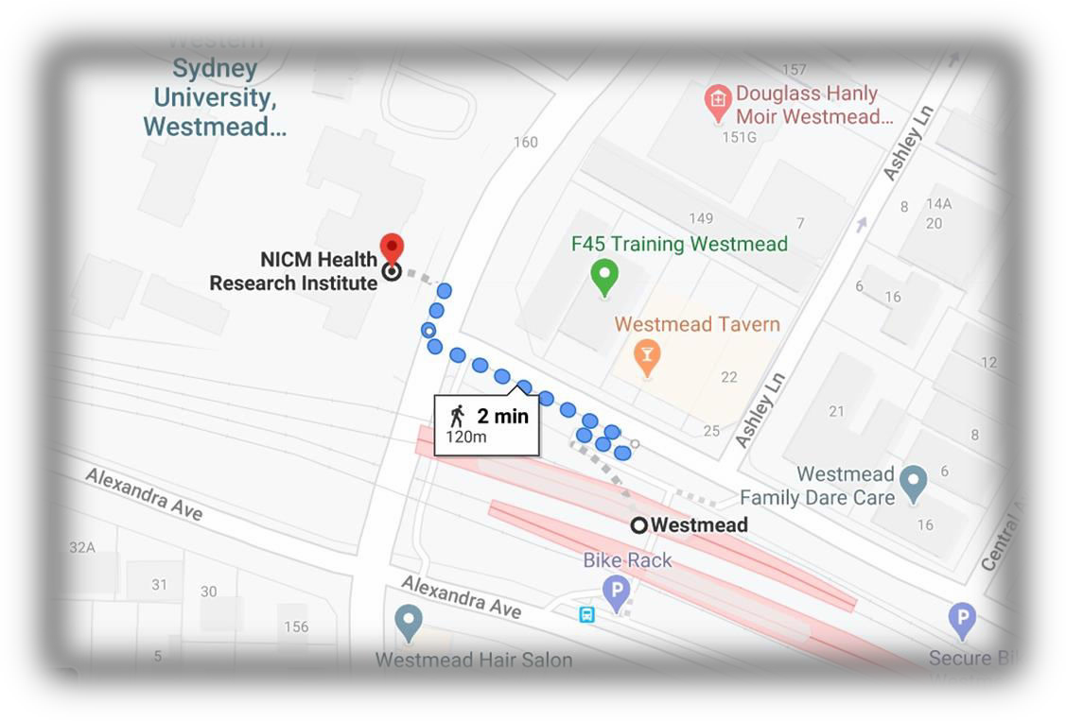

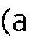
Motion Moved:

15. To update the code of ethics to 'version two' in order to ensure it remains consistent with the procedures of the SRC – Matthew Bojanic

I will be proposing a modification to the Code of Ethics after holding a conversation with Allan and Richard (as well as getting some legal advice from OGC). I have attached the document Allan sent me to this email however, the discussion will be presented to the council itself.

16. Untitled - Josh Newton

Motion Moved: I move that the SRC creates a task force to look into the logistics of co-oping the current student villages. I also move that this task force creates a model, detailing how we would like the co-op to function, in order to present it to the university.

Motion Moved: I move that the SRC creates a task force to look into the issue of crisis housing/ homelessness affecting students. I also move that this task force looks into ways of alleviating this issue.

17. General business
Any General Business of the Council is to be discussed here;
- Upcoming special meeting #4 regarding Updating Student representation and procedures – date to be decided via doodle poll – Frederick W. Bekker

18. Next meeting and closure
The next scheduled meeting of the SRC is to be decided via Doodle Poll.

Student Representative Council Action Sheet
Action | Responsibility | Completion
Frederick W. Bekker to organise a shared platform for representatives to share about their upcoming project timelines. | Frederick W. Bekker | Completed
Matthew Bojanic to reach out to Bill Parasas regarding the formation of the student advisory committee relating to food and beverage options available on campus | Matthew Bojanic | Pending
Matthew Bojanic and Vageesh Jha to reach out to the CLV regarding the formation of the student advisory committee relating to student accommodation | Matthew Bojanic and Vageesh Jha | Pending
Danielle Wolf and Allan Fang shall be co-ordinating working how much money the council is prepared to allocate, and working out where that money is to be allocated for merchandise. This meeting shall be open to all members for discussion. | Danielle Wolf | Completed
Frederick W. Bekker to organise a doodle poll gauging member availability for the next meeting | Frederick W. Bekker | Completed
Frederick W. Bekker to send through the Action Item List as soon as possible to the Council. | Frederick W. Bekker | Completed

