STUDENT REPRESENTATIVE COUNCIL
MONTHLY MEMBER REPORTS

January 2022

TABLE OF CONTENTS

PRESIDENT: ALANNAH HADER 3

VICE-PRESIDENT EDUCATION (UNDER-GRADUTE): BAKAR MOHAMAD 4

VICE-PRESIDENT EDUCATION (POST-GRADUATE): SANJAY THAPA 5

VICE-PRESIDENT ACTIVITIES: CAMERON CHESTERS 6

GENERAL SECRETARY: SARAH CUPITT 7

RESIDENTIAL STUDENTS REPRESENTATIVE: SHARMIN SABA 10

INTERNATIONAL STUDENTS REPRESENTATIVE: LOORE MURAVU 12

WOMEN’S REPRESENTATIVE: ROSINA ARMSTRONG-MENSAH 13

QUEER REPRESENTATIVE: RANNIE SINGH 14

FIRST NATIONS REPRESENTATIVE: TIFFANY SHARPE 15

DISABILITY REPRESENTATIVE: ROBERT REED 16

ETHNO-CULTURAL REPRESENTATIVE: CRYSTAL RAM 17

ENVIRONMENT REPRESENTATIVE: DANIELLE ALBERTINE 18

ONLINE STUDENT REPRESENTATIVE: ALLANA OFEE 19

PARRAMATTA CITY CAMPUS REPRESENTATIVE: MUHAMMAD ABBAS 20

PARAMMATTA SOUTH REPRESENTATIVE: RAZIN POLARA 21

NIRIMBA CAMPUS REPRESENTATIVE: SARA MIKHA 22

KINGSWOOD CAMPUS REPRESENTATIVE: SIMON PREUSS-KEARNEY 23

BANKSTOWN REPRESENTATIVE: JASMINE RICCIARELLI 24

CAMPBELLTOWN REPRESENTATIVE: DHARSHINI SATHYANARAYANAN 25

HAWKESBURY CAMPUS REPRESENTATIVE: JONATHAN ESPINAS 26

LIVERPOOL CAMPUS REPRESENTATIVE: ROMONDA EID 27

WELFARE AND WELLBEING REPRESENTATIVE: VICKY-RAE REED 28

SMALL AND REGIONAL CAMPUS REPRESENTATIVE: ROMIT SAHARAN 29

PRESIDENT: ALANNAH HADER

29/11/2021- Coordinator Catch up- student retention and success meeting
10/11/2021- SRC December Meeting
13/11/2021- Coordinator Catch up- student retention and success meeting

Over the course of summer break, I have done a lot of personal planning and goal setting for the year up ahead. I have planned for a newsletter to be released once semester is underway and we will be able to reach out to the max number of students when they become more engaged with university life.

After our budget committee meeting this upcoming Friday (14/1/22), my hope is that our team have a plan to stay on track with our budget for the following year. Our aim is to not underspend again this year so we are able to maximise the impact we have on student life and experience at western Sydney.

We have a few campaigns such as orientation events, parking and food and beverage choices on campus that will be worked on this year with commitment and assistance from various members of the SRC.

In December we welcomed five new members onto the SRC; Bakar Mohamad, Sanjay Thapa, Romonda Eid and Allana Ofee. I look forward to working with them all and continuing work with the rest of the SRC for 2022. I envision that our full team will now be at maximum efficiency and be able to work as a collective force to enact change for good this year.

VICE-PRESIDENT EDUCATION (UNDERGRADUATE): BAKAR MOHAMAD

December - January

Contributions:

- Developed discussion about data collection on systemic issues from students – initiated from discussion with Grant in November
  - Currently in consultation phase
- 02/12 – A podcast with the WSU welfare team (to be released).
- 02/12 – Organised a meeting with academic reps to discuss collaboration
- 10/12 – Attended academic senate meeting
  - Provided an update to senate pertaining to current student collaboration and its progress
- 10/12 – Attended SRC meeting
- 14/12 – Collaborated with Lucinda Keating (student welfare) to reach international students and sharing their experience about living and studying in Australia
- Had a meeting with Office of Governance regarding student rep collaboration and forming a standardised student complaint form
- Attended and assisted at the SRC Christmas Party – PS
- Wrote a small piece about the SRC Christmas Party and submitted to Sarah.
- Emailed the unit coordinator of ‘Human Learning’ pertaining to student complaints brought to the SRC.
- 11/01 - Attended SRC induction meeting
- 11/01 – Attended ‘Discussion for student involvement’ with Grant
- Initiated consultation and execution phase of a psychology conference being organised within the university.

Coming up:

- Release SRC podcast with Sarah and Richard
- 14/01 – SRC budget meeting
- 19/01 - Have a meeting with NUS Ed Officer to discuss representation
- 21/01 – SRC meeting
- 27/01 - Follow up meeting with student services hub and office of governance services pertaining to standardised student complaint form
- 27/01 - SRC executive meet

VICE-PRESIDENT EDUCATION (POST-GRADUATE): SANJAY THAPA

Not submitted

VICE-PRESIDENT ACTIVITIES: CAMERON CHESTERS
SECRET SANTA EVENT 2021 DECEMBER

The inspiration for the event was just that I wasn’t aware of any other Christmas events happening at the uni, there was support for it from other SRC members and also WSU staff and so we all went with the idea, organised and then ran it

Tiffany, Rob, Vicky, myself were probably the biggest contributors from the SRC to the event I would say. But we have at least 6 SRC members contributing to the event at various stages

It cost about $10,000 for all the gifts and food catering.

We gave away about 200 presents to students including putting some aside for the international students arriving on Christmas Eve which was a very nice initiative brought to us by Michelle from Daniel Jantos’ team

The two Christmas picnic events were massive successes and doing them again next year would be very good ideas

Other than that, the holidays were very relaxing and a good re-charge, I plan on getting the taste tour up and running again ASAP during semester 1, they were so much fun and everyone loved them. I hope to secure some extra funding too for the VPA budget so that we can plan and run events without needing to wait for the next meeting. It makes everything much faster.

GENERAL SECRETARY: SARAH CUPITT

- Collated and circulate December member reports and agenda as well as looping in Hollie Hammond to the calendar invite which also included all relevant documents and minutes of the last SRC meeting
- Emailed the team the revised December member reports (one late submission) and updated November minutes (with minor adjustments) - also updated calendar invite with relevant documents and the SRC workspace on Teams
- Asked reps who have plans for events/campaigns for next year so I can start planning the budget proposal for the January meeting - especially how much we want to allocate to care and data packs if we still want this to carry over to next years initiatives
- Corresponded with Dianne Smith who was enquiring about the Student Diary for 2022 for when the PDF copy will be released and if it’ll be printed for next year
- Secured a position in Western Sydney University’s exclusive High-Flyers Program
- Drafted meeting graphics for next years first four monthly meetings:
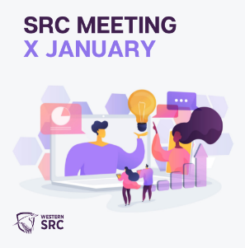 | 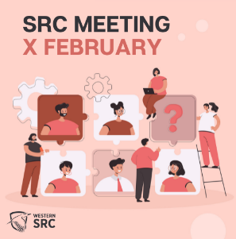 | 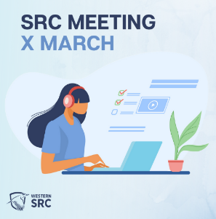 | 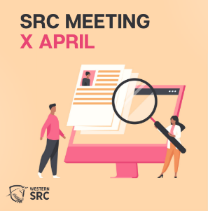

- Sent an availability poll 5/12 with the due date of the 19/12 to organise the best time reps can meet on the 14/01 for the SRC Budget Committee Meeting - and for reps that can not attend to let me know if they wish a budget proposal put forward for their student group.
- Shared the Christmas and new year closedown dates for Western with the team
- Posted about the expected delays on the selected bus and train routes on Monday 6 and Tuesday 7 December due to industrial action on SRC socials
- 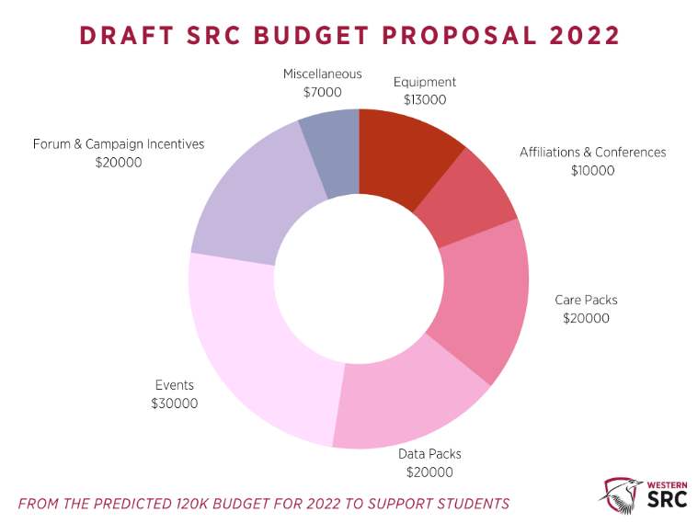
- Revised budget after discussion with reps before the budget committee meeting:
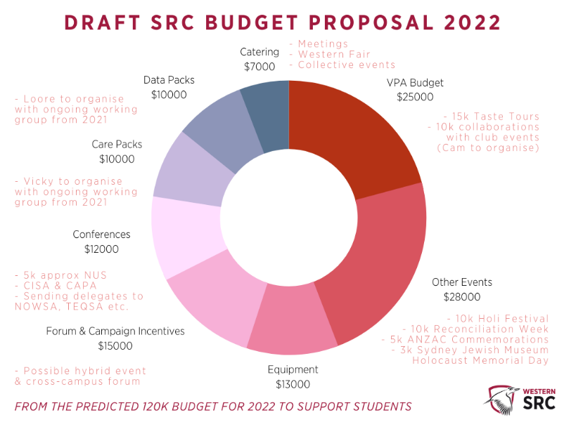
- Corresponded with student reps from usyd and uts to book a location for the Natcon state hub situation. We're in the process of booking: 1. A Lecture hall in the UTS Tower with a capacity for 72 people, booked through UTS 2. A conference room in Manning Bar at Usyd with a capacity for 100, booked through the USU. From attending two discussions Alannah was then asked to put through a flying minute for WSU to chip into the booking costs alongside usyd, uts, unsw and uow.
- Western SRC website is updated with the newly elected reps, and Mehwish has reached out to the new VPU and VPP for photos for the exec team
- Corresponded with Grant and Tileah re: returning Lav Mics to Kingswood campus
- Created Western Life events for the next four SRC monthly meetings for January [https://au.cglink.me/2ih/r38020], February [https://au.cglink.me/2ih/r38021], March [https://au.cglink.me/2ih/r38023] and April [https://au.cglink.me/2ih/r38022]
- Scheduled posts on SRC socials and western life to promote future SRC meetings for Jan-April (two weeks before each meeting) based on the graphics I drafted in early Dec with the dates I announced at the Dec meeting and have circulated to the SRC team
- Sent outlook calendar invites for the next 4 SRC monthly meetings sent to the team
- Corresponded with Dianne Smith with an update on student diaries for 2022. Verity Mcintosh was the contact at the beginning of the year for the 2021 Diaries. Student Central don't have much information for the 2022 Diaries yet. I’ve advised Dianne to reach out to Verity Mcintosh as she is in the same role via v.mcintosh@westernsydney.edu.au and to cc me if needed.
- After my call with Raveen, I spoke to the exec to approve my graphic and post promoting the ABC news story call out on SRC socials and western. ABC 7.30 putting together a TV story about the recovery of the western Sydney economy after lockdowns. Raveen is looking to connect with young soon-to-be grads or recent grads who are open to sharing their job search journey and personal and professional experience.
- Sent the names and emails of all NUS delegates to the NUS General Secretary
- Posted Rosina’s info about free tickets to the riverside theatre event on SRC socials
- Circulated the December unconfirmed minutes for the team’s perusal alongside the zoom recording and uploading both to teams. I also sent the important dates for next year's meetings and report deadlines up until April as I will likely leave at the end of March (with western life event registration links). Furthermore, I reminded reps to vote for the time of the 1.5-hour budget committee meeting on January 14th with voting closing on the 19th of December. And finally, a reminder to email myself or Alannah formal apologies if reps can not attend.
- Sent out a calendar invite for the Budget Committee Meeting to take place 2.30 to 4.00 pm 14th of January with the time having the most votes (15 votes)
- Expressed interest to join the working group for the pride football event
- Worked with Tiffany on the SRC new year’s post for the student community, approved by exec team and shared on all SRC socials and western life
- Spoke to Lindy Priestman regarding online student experience videos

Meetings:

- Market Research discussion with WSU students - 06/12/2021
- NSW Ombudsman Training | SRC & Editors - 10/12/2021
- SRC December Monthly Meeting - 10/12/2021
- Cross-campus forum - 17/12/2021
- SRC Catch Up with the new VPP - 03/01/2022
- Student Rep Discussion For Involvement Lobbying Src & Other Mechanisms To Stay Involved - 11/01/2022

Ongoing plans for January:

- 14/01/2022 - Budget Committee Meeting
- 21/01/2022 - SRC January Monthly Meeting
- Send Jenny agenda for exec meeting #1 2022
- SRC Jan Exec Meeting - 27/01/2021
- Work with Ingrid on WHMB article about WSU’s mental health campaign, champions, strategy etc. Pending more information on the strategy, interviews are completed.
- Start planning Gen Sec handover and look into promoting next round of EOIs
- Upload Dec agenda, reports and minutes to the SRC website once approved
- Upload reports, agenda and minutes to Teams
- MHWB Champions Meeting - various dates

RESIDENTIAL STUDENTS REPRESENTATIVE: SHARMIN SABA
Meetings
10/12/21 – Attended SRC December meeting
- Presented the agenda item regarding the issue of spelling and format errors in exam paper, as well as heavily westernized concepts that create barriers of understanding for International Students - BEHV2005 (Spring 2021) Human Learning; School of Psychology (detailed in action plan 2)
- I plan to compel Bakar to take on board a campaign related to academic excellence in 2022.
22/11/2021 – Submitted SRC Honorarium Report
Trainings
10/12/2021 - NSW Ombudsman Training
17/12/21: Psychological First Aid Training
Student events attended:
The purpose of attending the events is to interact more with students. I could attend only a few events due to my exams, but I plan to attend a lot more during SUMMER.
06/12/21 – MATES Mentor Information Session
09/12/2021 – SRC Secret Santa Event
09/12/2021 – Cinema Under the Stars
Events to be attended soon
16/01/2022 – Environmental Collective Workshop: Soy Wax Melts and Bath Bombs
18/01/2022 – Crafternoon: Quilling
10/02/2022 – The socials: Villawood indoor rock climbing
Action Plans
I applied to become a student leader with the agenda of the being the voice of students and advocating for their issues. Therefore, after being appointed as the Residential Representative, I mainly focussed on the issues that the students might be facing and consequently working towards bringing a change. The followings are what I have been working on:
Action Plan 1
Some of the residential students of Parramatta CLV have bought up an issue regarding the lack of Zebra Crossing (across Pemberton Street) and Pedestrian Crossing (across Victoria Road). Students living in the CLV have to cross both the roads on a regular basis, and they do so with extreme risks. Additionally, the curvature of the Pemberton Street makes it even more hazardous since it obstructs vision of moving vehicles.
Things done related to this:
- With Mehwish’s help, I have already set up a survey to understand the scale of this issue.
- To ensuring that the survey reaches most students I have posted the survey link on WesternLife, asked Sarah to post it in all relevant social media pages handled by SRC, sent the surveys to the residential students via email and relevant Parramatta CLV social media pages and groups. I have also asked Razin (Parramatta South Representative) and Mohammad (Parramatta City Representative) to share the survey link in their relevant campus groups, since the survey also targets non-residential students who visit Parramatta CLV.
- I have sent emails to the Parramatta City Council and the relevant authorities who oversee installing road crossings – I am currently waiting for their response
Action Plan 2: This year I will also be focussing on enhancing student engagement in the CLVs, if the circumstance permits. Currently I am brainstorming about the ideas and will be having a discussion with Grant regarding this soon.
Additional Notes
I have helped other representatives with promoting their events and will continue to do. I believe that way we can encourage and approach more students to join the student events. I have helped promote Secret Santa Event through social media as well as helped Camron with the event on the event day. I also try to promote SRC events as much as possible via social media.

INTERNATIONAL STUDENTS REPRESENTATIVE: LOORE MURAVU
Not submitted
WOMEN’S REPRESENTATIVE: ROSINA ARMSTRONG-MENSAH
On the 24th November 2021 I joined the women voice training.

Joined the NOWSA conference 29th November to 2nd December 2021. Regarding the conference I had the opportunity to communicate any update and queries with one of our students who made it to the entire conference from the first day to the last.

Attended SRC monthly for 12th December 2021.

This year the collective is looking forward with more collaboration to involve student and for them to achieve some meaningful beneficiary as to be a member.

I have prepared the women’s collective expression of interest for officers as due to other commitments some previous officers have to vacate their position. We are planning to have merchandise available for some on campus events. This includes the celebration of international women’s day in March, western fair and other engagements (self defence training, panel discussion games, etc). We hope to have them on campus however there are other plans for online depending on the current circumstance.

The collective will be having our first meeting soon to discuss on some training, publication and action to be taken for women in the university. This will be confirmed after the budget meeting coming up for a well plan term.

QUEER REPRESENTATIVE: RANNIE SINGH

FIRST NATIONS REPRESENTATIVE: TIFFANY SHARPE

This new year let’s make a fresh start by letting go of the past and welcoming fresh prospects with a smile. Happy New Year to you all, and I hope we are ready for the challenges that 2022 may bring us, as I am ready. As the new year begins, the journey in student leadership aspires me towards growth in personal and professional development. My fulfilment as SRC First Nations Representative continues, which I have the intention to engage in my position and make events happen this year. Furthermore, I commence my new position as Aboriginal and Torres Strait Islander Student Representative on the Academic Senate.

Meetings:
- 10th December 2021: Academic Senate Meeting Attended to the Academic Senate meeting as an observer for my first-hand experience in preparation to commence in 2022.
- 10th December 2021: SRC December Meeting
- 17th December 2021: Cross-Campus Forum Attended the final Cross-Campus Forum for 2021. The representatives that were present at the meeting were Jasmine, Simon, Sarah, and me.
- 17th December 2021: WSU Online Community – MVI #2: International Students

Trainings:
- 10th December 2021: NSW Ombudsman Training – Mandatory

Events:
- 9th December 2021: SRC Christmas Party – Parramatta South Campus
- 9th December 2021: WSU Yarramundi Lecture 2021 – Virtual
- 16th December 2021: SRC Christmas Party – Campbelltown Campus

Upcoming Meeting/Training:
- 14th January 2022: SRC Budget Committee Meeting The student representatives will discuss about the agenda proposals, where we will focus on the budget planning for the year.
- 18th January 2022: Reconciliation NSW and Vicky-Rae Reed The meeting arranged by Welfare and Wellbeing Representative, Vicky-Rae, where the discussion of Local Action Groups and Reconciliation Week activations on campus.

DISABILITY REPRESENTATIVE: ROBERT REED

I FEEL THAT I HAVE ADEQUATELY UNDERTAKEN THE ROLES AND RESPONSIBILITIES OF MY ROLE FOR THE DECEMBER– JANUARY PERIOD 2021/2022 BY ENGAGING WITH THE FOLLOWING:
- Disability Collective, Wellbeing & Equity and Diversity Meeting scheduled for December 16th postponed to early 2022
- Western Student Veterans Club AGM – December 6th
I attended this AGM to support our student veterans who also live with disability and mental health concerns to let them know of the collective and the peer support services available to them.
- SRC Secret Santa Picnic Campbelltown – December 16th
Setup was conducted in an efficient and quick manner. Setup was appropriate given the current COVID situation. All COVID precations were undertaken into consideration with guidelines from NSW Health and WSU AHS regulations. There were no significant converns on the day. Even with such a small crew, the event ran smoothly. I am still awaiting Cameron to reporton the concerns that ocured at the Parramatta event so this may be reviewed for future events.
- WSU Online Community Consultation regarding platform for engaging International Students – December 17th
- Planned university closure due to Christmas and New Year – December 17 to Jan 10
- Planned start for Mates Corner 2022 to commence Week two of Autumn Semester - Ongoing
- Plans to convene a Cross Campus Equity Collective meeting to discuss the proposed changes to all collective ToRs created by Grant Murray. This requires significant equity discussion due to the wording proposed that has created ambiguity, segregation or deemed inappropriate by collective representatives and members - Ongoing
- SRC January. Meeting – January 21st

ETHNO-CULTURAL REPRESENTATIVE: CRYSTAL RAM
Not submitted
ENVIRONMENT REPRESENTATIVE: DANIELLE ALBERTINE

As expected, it’s been a quiet period for the Collective, so this is a short report.

Meetings:
- Collective meeting – we will be holding our first meeting next week and it’s back to Zoom . We’ll be writing up our plan for the first half of the year and getting in touch with other students and staff to organise our collaborations. We’re looking forward to working with Modern Ink and Inclusive Communities again, while we’re also hoping to add others, including growing our relationship with SDSN Youth AusNZPac and Sustainable Futures.
Workshops:
- Our first workshop is coming up on the 16th and will be an Online Workshop: Soy Wax Melts and Bath Bombs which has reached capacity with 40 participants signed up.
- We’ll also be having a mushroom growing workshop soon, amongst other workshops already planned.
Competitions:
- We’ve continued with our monthly competitions. We have pretty good responses to our competitions and it’s a great way to ensure we’re holding the sorts of events, etc., that our cohort wants.
As part of planning events and workshops for 2022, we’ll also be working on and updating our documents, ensuring we have solid succession documents, including inductions, templates and guides.
We’ll be working on having a monthly calendar this year which will include relevant internal and external events, SRC meeting dates, workshop schedules, etc. With any luck we’ll be able to attend a few conferences this year, maybe even in person! We also want to increase our direct communications with our students to better ascertain interests and passions, expectations for EC and Uni sustainability commitments.

ONLINE STUDENT REPRESENTATIVE: ALLANA OFEE
Not submitted
PARRAMATTA CITY CAMPUS REPRESENTATIVE: MUHAMMAD ABBAS
Submitted report was under 200 words.
PARAMMATTA SOUTH REPRESENTATIVE: RAZIN POLARA
Meetings, events or conferences I have attended this month in my capacity as a member of the SRC:

- Didn’t attended last SRC meeting due to some personal reasons.

Communication and engagement, I have been involved with this month as a member of the SRC:

- As of due to the end of semester last year and university break, I did not get a chance to plan any event.
- As of now I will continue to work to organise the international student day out which has been postponing since last year due to COVID-19. Following up on my previous report from December, I have got the quote from the transport company but due to current situation they have put it us on hold due to their personal reasons.
- I will continue organising ‘Get to Know WSU’ in collaboration with other campus rep and will create an event on western-life.
- For this new year I have planned to work with some of the clubs to collab with them for some of the big events like western fair. We are planning both online and face-to-face events in case we might have to move online.
- Currently, I am helping other reps with the soccer match we are planning on Mardi Gras day which will be out soon.

NIRIMBA CAMPUS REPRESENTATIVE: SARA MIKHA
For this month, I had a lot of experiences, my event was successful, and students loved it. So I was happy with how it turned out. After that, I plan to do another fun event and only for college students. I am trying to learn from the mistakes that I had made in my pottery event. I want the next event to be way better and more successful. I used some of Grands tips on how to make my event successful.

Joined SRC November meeting, we discussed some of the agenda items and budgets and got on track with everyone's plans and events. This also helps me know what everyone's plan is and were up to. It is beneficial to keep us updated every month.

We had a cross-campus event, which was good. This helps us know what we need to improve by taking students opinions and listening to them, such as showing students how to apply for a concession card or student chat online. I love events and meetings like this one because I can engage and talk to students about their opinions; these events are also fun to have. I gained a lot of experience from this event.

KINGSWOOD CAMPUS REPRESENTATIVE: SIMON PREUSS-KEARNEY
Over late December and Early January, I attended to the following events/activities:
• I have continued my involvement in the SRC related meetings this month, such as the December SRC monthly meeting, where I presented my agenda item on Pride Football Australia Tournament Team Working Group, to provide more inclusive sports engagement for 2022.
• Secondly, I attended these SRC related meetings/training: I attended the NSW Ombudsman Training; 2022 SSAF Advisory Group Session; and participated in the small Cross-Campus forum – which acted more as a planning session in practice.
Over the month of January, I will attend to the following events/activities:

• Firstly, continuing my involvement in the SRC related meetings approaching this month, such as the January SRC monthly meeting, where I intend to present my NUS related agenda item; and to participate in the SRC Budget Committee.
• Secondly, the campus representatives intend to have a planning meeting to organise a future cross-campus forum for the early 2022 quarter. I will discuss this with the team, and we will set up a zoom meeting to start the discussion on when to have it and how we can improve it.
• Thirdly, I will follow up on the 2022 SSAF Advisory Group Session. This discussion will occur after the SRC budget committee and will help inform both the SRC, and the SSAF Advisory Group.
• Fifthly, I am continuing the formation of a working group to create a WSU team for Mardi Gras 2022. I am in contact with the Sydney Rangers and Flying Bats regarding this and am organising a zoom meeting with them to broker some better collaboration opportunities for our university and our teams. I will be informing the working group of these discussions, as well as including them in the decision making. I will then report my progress back to the SRC. Alongside this, the working group will also seek to organise more inclusive soccer events in the future, working with the queer collective in-particular to achieve this. We may even work with Western Sport to acquire a custom rainbow Western Team Jersey?
• Finally, regarding delayed agenda items: to further develop the Western Sydney University Penrith Facebook group by adding events and acquiring new members. I will look to develop this when the feedback collected from the cross-campus forum is properly analysed to inform the improvements; Also, I hope to address my February agenda item to create 3-4 more SRC badges on the WesternLife page for members to obtain. Also, I have shelved the idea of running any SRC soccer tournaments, until next year (planning in December 2021, for a semester 1 2022 event). Due to the current covid restriction and logistics, making an event seem too difficult to run until possible changes to next year.

BANKSTOWN REPRESENTATIVE: JASMINE RICCIARELLI

December 10, 2021-NSW Ombudsman Training
Attended the Ombudsman Training day where I learnt about the complaints process and what the Ombudsman does when complaints reach them. During the training I also learnt about what I could do to help resolve a complaint before having to move it up to higher people. Overall I found the training beneficial and learnt a lot about the compliance processes and what Ombudsman does in helping a person when they are dealing with a problem or complaint.

December 17, 2021- Cross-Campus Forum
Held the cross-campus forum from 2pm-3.20pm as no one attended but src member it turned into a planning session for 2022. The campus rep from Kingswood (Simon) and myself discussed what activities we would run next year and I put my hand up to help with the inclusive soccer tournament. I also suggested movie/pizza nights and that I will continuing my rug and mug student chat.

January 2, 2022-
Received a message from Simon (Kingswood Rep) about still helping out with the inclusive football (soccer) tournament and responded with still being available to help out.

Proposal and Actions-

Reflection from 2021: During my time in src I have attended training days, learnt about strategy planning and how it can help with student councils and planned my own event as well as a group event. I have enjoyed my time so far learning these new skills and in 2022 I hope to continue helping out with events, planning more of my student chat events and learning more with the training days.

CAMPBELLTOWN REPRESENTATIVE: DHARSHINI SATHYANARAYANAN
Submitted report was under 200 words.
HAWKESBURY CAMPUS REPRESENTATIVE: JONATHAN ESPINAS
Submitted report was under 200 words.
LIVERPOOL CAMPUS REPRESENTATIVE: ROMONDA EID
Not submitted

WELFARE AND WELLBEING REPRESENTATIVE: VICKY-RAE REED

I FEEL THAT I HAVE ADEQUATELY UNDERTAKEN THE ROLES AND RESPONSIBILITIES OF MY ROLE FOR THE DECEMBER– JANUARY PERIOD 2021/2022 BY ENGAGING WITH THE FOLLOWING:
- Engagement with sexual health organization, NORMAL, regarding sexual health seminars and workshops for students during orientations and Western Fair – 15th December
- Engagement with Capfeather Global and WSU regarding a portal they envison to create for International Students. I am not at all sold on the idea and advocated strongly against it as I do not believe that our International Students need to be segregated from the rest of the students on WesternLife but the plaforms that are existing can be strengthened to engage these students and also bring awareness of their challenges to the domestic student cohort – December 17th
- Engagement with the NSW Council for Pacific Communities in addition to South West Multicultural and Community Centre regarding their continued support of International Students in residence with access to discounted food hampers supplied by Food Bank and Lions Club Ingleburn during the current COVID situation – January 3rd
- Engagement with Emma Taylor ( MHWB) regarding our strategy for 2022 to encompass more areas of concern especially men’s health, Indigenous/Pacifika Haalth in addition to a LGBTQIA+ addition to the current Respectful Relationships framework – January 12th
- Budget Committee Meeting where I will be showcasing our proposals for Reconcilation week, Holi and Anzac Day. I am uncertain if we will be able to do Holocaust Memorial Day given the short turnaround and current COVID restrictions. Currently exploring if they offer a “virtual excursion” option – January 14th
- Reconcilation NSW meeting with CEO Tristan Tipps Webster re: Youth engagement ijn Reconcilation and university based youth local action groups. Interested representatives Tiffany Sharpe ( First Nations, Robert Reed ( Disabilities), Danielle Albertine (Environmental) and Crystal Ram (Ethnocultural) have also been extended an invite to the meeting – January 18th
- Continued advocacy with students currently engaging with the Complaints Resolution Unit – Ongoing
- SRC January. Meeting – January 21st

SMALL AND REGIONAL CAMPUS REPRESENTATIVE: ROMIT SAHARAN
Not submitted

