Student Representative Council
Student Representative member’s reports - July
The following reports are to be provided by all SRC members

Erdem Yigiter – Queer Collective
· I attended the Western Sydney Leadership Dialogue event as a guest of the Academy. Naomi and Matthew from SRC were also there. It was a very interesting event that opened my eyes to the great work that is being done in the west to bring this area into the ranks of the east, and helped me refine my vision for how I would like to lead in my role.
· I attended the C3 congress and was also a speaker on the peer discussion panel, that had questions and dialogue revolving around leadership and student engagement.
· Nick Ryall-Dincer has been elected as the new officer for the parramatta south queer collective. I met with him and we discussed how funding works and future ideas for the queer collective including events and student engagement.
· Nick and I have decided that we would like to have the queer picnic as a monthly event, starting with the first picnic on the 31st of July. We are aiming to use around $80-100 initially per picnic for food supplies and to buy necessary equipment such as reusable cutlery, plates, trays, cups and also for a large matt and picnic gear. we would hope that as these picnics continue, attendees would contribute to the picnic by bringing their own food along to the events, which would then reduce the cost placed on the queer collective to fund the event.

Allan Feng - Ethno-cultural Representative

This past month has been a busy one for the Ethno-cultural collective (ECC). Straight after the end of autumn semester, we welcomed the new ECC officer Donita for Parramatta City campus. She and I started immediately to plan for Western Fair in Spring semester. We spoke about co-ordinating human resources for the stalls and explored merchandising options. This included buying stickers, t shirts, rulers, aprons and candles to give to students at Western Fair. In addition, we both attended the C3 congress where we received student rep training and discussed the SRC communications strategy.

The big event we held in the beginning of July is “Share a meal, share a story” where we invited students to bring a dish to share with each other and watch a documentary in celebration of Refugee week as well as the end of exams. I cooked a meal of bean stew and the night was successful. A few students helped out with cooking and setting up and one student stayed until the end; where we had a discussion regarding refugee issues. In reflection, I think a major factor is that this event was held after exams where most students have either left Sydney or are reluctant to come to uni outside of semester. Moving forward, I think it may be valuable to consider holding most student-engagement type events during the uni semesters.

Daniel Bonatti - Vice President Education (Postgraduate) & NUS delegate.

Background
I write a report greater than 200 words as I am in the Executive of the SRC. I am the Vice President
Education (Postgraduate), & NUS delegate elect, plus CAPA delegate and Budget and Honorarium
Committee member. I am in the Faculty Engineering, Mathematics and Computing doing Graduate Diploma in Building Surveying. I am following my role as described in Student Representation Procedures Clause 14 & 15. I easily achieved the required 42 mandatory hours.
Activities – Schedule during JULY
- Innovation 11-6-2019 12 to 1pm total 1 hour Webinar Innovation with IoT

- Geology 19-6-2019 6 to 8pm total 2 hours Mine Subsidence Seminar Newcastle CBD grouting strategy Project – Stage 1

- Communication 25-6-2019 total 1 hour Webinar 2019 Headline activities and plans for IoT Alliance Australia

- RISK 25-06-2019 5.30 to 8pm, total 2 hours, Complex Issues Facing Enterprise Management & Project Management. This has significance of the role of the academic senate and our council.
The Systems Thinking Workshop held on the 25th of June will provide engineers with skills to address many of the complex issues facing enterprise management and project management. Systems Thinking provides tools to manage complex systems in developing infrastructure.
Approaches to manage enterprises will be covered, such as: Identifying changes in the basis of competitive advantage; Recognizing agents; Appropriate delegation; Managing change; Being ambidextrous to build new business while supporting traditional business. Approaches to manage complex projects will be covered including: Assessing required project capability and actual project capability; Developing innovation from suppliers; Being agile; Managing systemic risk; Managing stakeholders; Developing a useful lessons learned library.

- Communication 26-6-2019 6 to 8 pm total 2 hours Quantity take off from PDF files using Revu

- Meeting with Industry - 26 June 2019, 6-8pm, , total 2 hours, I went to my monthly meeting with the Australian Institute of Building NSW Chapter, my position is the Vice President (Records) and Honorary Secretary, I write the minutes, in particular making it a special meeting we had one guest, UNSW Senior Lecturer. In particular interest is, there are several Adjunct Professors from Western Sydney University on this committee, keeping in contact with academia and industry.

- Book - 27 June 2019, Blackout by Matthew Warren arrived it’s about How energy Rich Australia is running out of Electricity. I ordered this book after speaking to Joseph during networking, at a AIE Young Energy Professionals CPD event on 16th May 2019. The evening focused on the topic of financing renewable energy projects in Australia. Three leading voices in the industry – with representatives from NAB, CEFC and Norton Rose Fulbright – on the current opportunities and challenges in financing utility-scale renewable energy projects within the current economic, political and regulatory landscape. Presentations from each panelist was followed by a Q&A session and an opportunity to network with colleagues in the energy industry over drinks and canapes, took place speaking to Heritage Department Lawyers etc.

- Report 29 June 2019, total 3 hours, Report to Tegan Bergan Postgraduate Representative
Academic Senate in response to Ms Hollie Hammond Undergraduate Representative Academic Senate, adding Curriculum and Advance Standing as concerns (see Report for further information).

- SRC Meeting - 29 June 2019 Sent agenda items for next meeting 8th July.

- Academic Senate - 29 June 2019 Academic Senate EOI Senate Review Working Group.

- Academic Senate – 30 June 2019, total 3 hours, Report for 21st Academic Senate meeting draft (see Report for further information).

- NER 30-6-2019 Engineers Australia National Engineering Register Certificate of Registration valid until June 2020.

- NUS – 1 to 4 July 2019, Education Conference NUS delegate found out WSU not registered 28th June Friday by Grant, Naomi found Conference is not at UTS though at Sydney University on the Sunday the clash with ^{C3} and confusion meant no attendance.

- C³ Conference, 2 to 3rd July, total 14 hours, (see report)

- Innovation 3-7-2019 total 2 hours Canberra innovators and technology the Reposit Power Storey

- Leadership 3-7-2019 6 to 8pm total 2 hours Energy Thought Leaders series Industrial gas Engines operations and Maintenance to Drive Efficiency

- SRC Training 8-7-2019 Statement of Attainment CHCDFV001 Recognise and respond appropriately to domestic and family violence CHC Community services training Package

- Postgraduates 8-7-2019, emailed report to Tegan Bergan Academic Senate Postgraduate Representative The report is in relation to the recommendations prepared by Ms Hollie Hammand Academic Senate Undergraduate Student Member, for which was very well done.
This report is postgraduate additional concerns raised by the Vice President Education Postgraduate (see report)

- Student Club 8-7-2019 Joined Engineers without borders, EWB will be holding information stalls at the Spring fare in Penrith, Parramata South and Paramatta City, Penrith: week 3 Wed 7th Parra City; week 4 Tues 13th Parra South: week 4 Thursday 15th

- Communication 9-7-2019 12 to 1 pm total 1 hour LoRaWAN past POC Brief

- Student Society 9-7-2019, 12 to 5pm, total 5 hours, Daniel Vice president wrote Constitution for new Society CAPS Construction, Architecture Planning Society, posted to Fred President.( see Constitution)

- Site visit 10-07-2019 3.20 to 5pm, total 1.5 hours, Site Tour CSIRO Energy Centre Mayfield We saw CVT Solar panel array Farm concentrates radiation to a tour converts radiation into heat, thermal not electricity, to pipes with salt liquid which then can be stored then make electricity. Then we saw a test tower absorbs Co2 from the air its 1:100 scale to test site at Vales Point power station. Also calibration of commercial solar panels.

- Communication 10-07-2019 6 to 7.30pm, total 1.5 hours, Embedded Systems Smorgasboard.

- SRC Meeting preparation , 12-07-2019, total 1 hour, Agenda items for general business (see report )

- Students Clubs 12-07-2019 CAPS Construction Architecture Planning Society formed via orgsync for SR & P Clubs & Societies by Fred, after consultation about Constitution (see constitution I wrote)

- Student Clubs 13-07-2019 Email to Joel Brody to join Engineering Society.

- Postgraduates, 16-07-2019, 12 to 1pm, total 3 hours Postgraduate picnic on at Parramatta South campus, was held on Tuesday. Naomi and I took the lead on the picnic and invited others on SRC to help and arrive by 10:30am for 12pm. Naomi prepared food three bowls two curry and one rice, Gluten free, Hallel food friendly A poster advertised the full details, it was on Facebook event is here:
https://www.facebook.com/events/471512236946155/?ti=icl

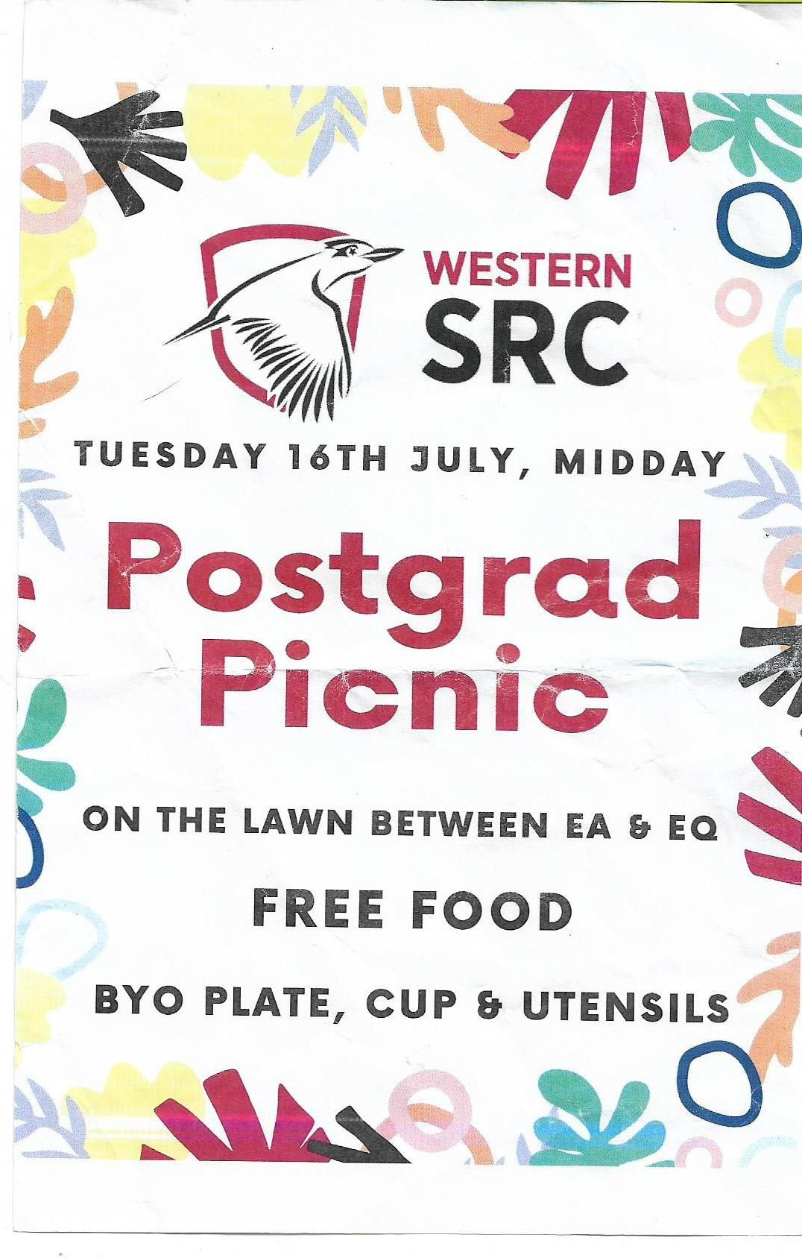
Three SRC Members involved Queer Representative: Erdem Yigiter SRC President Naomi, and I with Master of research students plus others attending, including Professors.

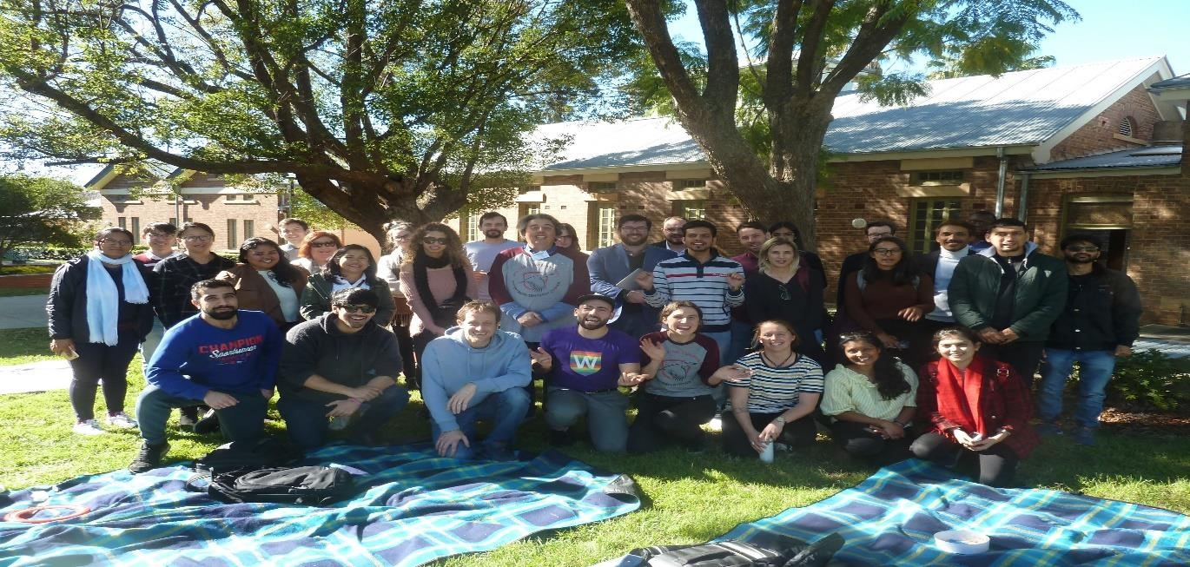

PHOTO Students at the 16th July Postgraduate Picnic.
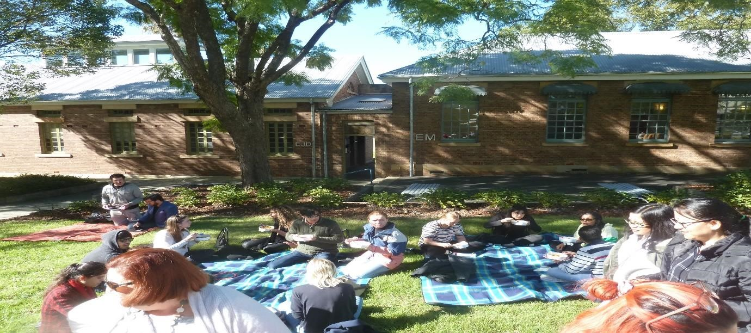
PHOTOS Students eating
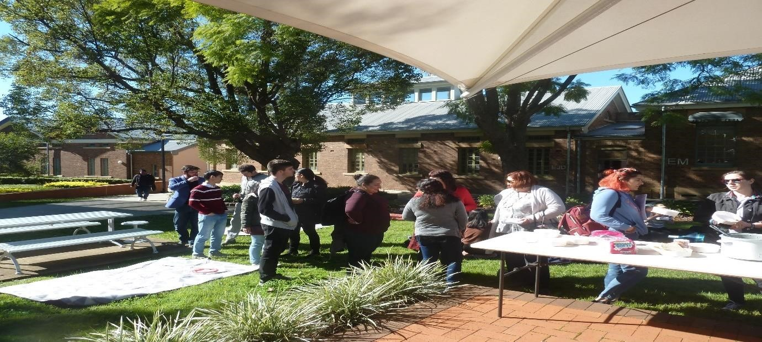
PHOTOS student getting food

- SRC Meeting 17-07-2019 , Monthly full committee meeting, Daniel could not go due to clash with NSW Chapter Australian Institute of building ACM Annual Chapter Meeting.

- Innovation 17-07-2019, total 1 hour, Webinar Timber High rise construction.

- Bush fire 26-07-2019, 9 to 4pm, total 7 hours, Australian Institute of building representative for standards Australia , AS3959 Construction of buildings in bushfire-prone areas, at the meeting I met two Western Sydney University professors Graham Douglas and Collin Wood.

- SRC Meeting 29-07-2019, I went to Parramatta City campus Catch up with Naomi executive meeting, Naomi resigned, meeting was called off.

- Student Welfare Officer, 29-07-2019, 12.30 to 2pm, total 1.5 hours, I went to Parramatta South campus for an appointment about University procedures.

- Student clubs, 29-07-2019, was at Parramatta City campus I called Fred at 3pm I was about to book room, Fred postponed meeting set for 6 to 8pm for CAPS Construction, Architecture Planning Society. I had to contact 6 members including Fred to postpone.

- Student clubs, 29-07-2019, EWB Engineers Without Borders, Blue Mountains Conference Volunteer needed. This is a great opportunity for someone to represent Western Sydney university and be involved with organizing humanitarian engineering conference in the blue mountains this comming September.

- NUS, 30-07-2019, 6 to 8pm, total 2 hours, Special meeting for NUS disaffiliation, chaired by Cheryl previous SRC President, the matter ended with a Motion to have executive Team make KPIs to ensure right reasons for staying, (see Daniels speech on reasons to stay)

- Flying Minutes, 30-07-2019, The flying minute vote collapsed due to lack of response, I personally believe this was the right response as the matter was not clearly detailed. I (Daniel) is on the Remuneration Committee people who did not vote such as myself will have no consequence of there lack of involvement.

- Building Surveying, 31-07-2019, 9am to 5pm, 8 hours, Fire Engineering Design Assessment course commenced DR M.C Hiu, Assignment 1 given FEB.

- SRC Meeting, 1-08-2019, 6.30 to 7.30pm, 1 hour, Vice presidents meeting, Daniel, Matthew, Mandi, Agreement for interim president Daniel let Matthew be interim, Budget and use of orgsync.

- SRC President, 1-08-2019, Email from returning officer President position by EOI, Vice Presidents to do interviews or check applications.

- SRC Meeting, 2-08-2019, 9am to 10.30am, total 1.5 hours, Catch up with Tooba and Grant. Seven people attended, Allen, Keiza, Daniel, Grant, Tooba, Charbel and Mandi.

- Correspondence, June, Many Emails read and responded to over 10 hours.

Aditi Sengupta - Campbelltown Campus Representative

I have worked towards identifying and promoting the interests of all students on my campus, and collaborated with the Student Campus Council and other SRC members. I have spoken to fellow students about Food outlets and prices at the university, Parking and transport, Student services, Clubs and societies, Campus ideas and activities and have encouraged them to engage with the university. I held a stall at Orientation day on the 8th of July with other SRC members at Campbelltown, organised stall and presence for Western Fair at Campbelltown (14th of August), organised CD collection box to collect CDs for Queer Prom,
I attended C3 congress on the 2nd and the 3rd of July, as well as the meeting on communication held amongst SRC members. I attended the zoom meeting on possible communication strategies on the 5th of July, and am currently working towards organising free 2-day gym membership with university gym.
I also attended a meeting via Zoom to organise Campbelltown campus Kitchenette cleaning arrangements last week, and set up CD collection box and created a poster to go with it for Queer Prom. I communicated with Grant on possible ways of creating a student education action group and a student group to discuss university services. I am currently in the process of planning posters and feedback options for students to report any difficulties or concerns regarding university services such as counselling services, shuttle bus service,
I have attended all SRC meetings till date via Zoom and submitted reports before time.

Mandii Carr – Vice President of Activities
· I attended the media law training along with Naomi, Daniel and some editors which was organised by Christina. I found this very interesting and would recommend reps to attend future sessions.
· As many of you are aware, I was a part of C3 congress preparations and assisted in organising C3. I was able to present two breakout sessions on events and marketing. I was also included a panellist with various other reps to discuss how representation had assisted with our leadership skills and how to increase engagement with clubs and reps. I’d like to take this time to thank SR&P for the opportunity to be involved in the event as well as trusting me with the delivery of two presentations.
· I assisted Frederick with his movie screening event at 1PSQ. We received feedback from the students in attendance and I will be implementing the students wishes into the next event alongside Frederick. The projected outcome will be having a movie marathon at Parramatta campus in the hub. I have reached out to Verity Foley to discuss the logistics of such an event and I look forward to bringing a bigger and better movie night for the students.
· I have been in talks with Penrith Rep, Hollie and Environmental Rep, Danielle to promote Penrith’s garden project. This plant potting activity is set to take place at Orientation and I have advised them in events advice in bringing a wholesome and sustainable message for the Penrith students.
· Discussion with Grant in leveraging his and Daniel’s visit to do a pop up event at Westmead this lead to discussion to visit small regional campuses as I feel the regional campuses are seen very little campus life activities.
· Meeting with Grant and Academic Senate reps took place where we discussed how to increase our functionality as a collective group rather than separate entities.
· Winter Wonderland meeting with Chris Youness and his team for Careers involvement. This event has been booked for the 28th August 2019. The event will be held at Stable Square on the Hawkesbury campus. Furthermore, I have asked Cheryl Jendrachowski from The Academy for volunteers and I am urging campus rep JC to join working party (this is a large event and I will take assistance where I can). Site visit booked with Larissa at Hawkesbury on Friday 12th July.
· Requested ballot boxes to be placed on all campus for Queer prom artwork, thus far I believe only Campbelltown have completed this request.
Upcoming events
· NAIDOC event on 17th July 2019 from 10.30am.
· Liverpool Magician and free fairy floss on 31st July 2019 at 11.00am.

Campus visited
[I am attempting to spread my time over various campuses this year to increase SRC visibility and familiarise myself with each campus.]
· Kingswood
· Parramatta South
· 1PSQ
· and Bankstown

Bekker, Frederick W. - General Secretary
I have met all responsibilities and expectations of my role with vigour and stride, in addition to taking the initiative on further actions, and have done all that I can in training for my new role.
I have compiled the minutes and agenda item lists of the second and third SRC scheduled meetings, calling for them via email, and then bringing them together, collating, and formatting them. As per SRC requests I have uploaded all meeting minutes/member reports/agenda item lists online onto the SRC Orgsync for the open access and dissemination for SRC members. Each of these documents spans over 15 pages each, and in addition I have been attended every SRC meeting face to face and diligently providing agenda item lists to participants, and compiling the minutes of the meetings, to be subsequently publishing the aforementioned documents on OrgSync for the dissemination of members.
I have additionally at the meeting been listing apologies, attendance, draft minute, and confidential matters, a per requirement of my role.
I have been busy answering many questions posed to me both via Email and through Facebook messenger, and have been allocating a set time of the week to cover these.
I have attended training pursuant to my role, attending both C3 congress days, and went to workshops relevant to my role in order to best perform my duties, for example learning about minute taking process.
In addition, I have undertaken further initiatives outside of my role description to further the cause of the SRC as a student advocating body. I have organized a movie night event which proved extremely successful amongst the student community, and I have attended and helped out at SRC events, helping set up and run the stalls.

Hastings, Naomi - President

The following report covers my activities in the time since my last written report, that is, June 6th-July 9th, 2019.

Date | Event/Activity | Host/ Chair | Location | Role
6/6 | Academic Freedom of Speech Summit | WSU Chancellory | Level 9, 1PSQ | Attendee with Matthew Bojanic & Daniel Bonatti
12/6 | SRC ‘Craftivism’ Day | SRC & Tooba Anwar | Parramatta South, The Hub | Assistant with screen printing activity
12/6 | Board of Trustees Meeting | WSU Chancellory | Level 9, 1PSQ | Observer
12/6 | ‘Voices of Leadership’ Book Launch | WSU Chancellory | Level 9, 1PSQ | Attendee with Matthew Bojanic, Daniel Bonatti and Frederick Bekker
12/6 | Board of Trustees Dinner | WSU Chancellory | Level 9, 1PSQ | Attendee
13/6 | Board of Trustees Planning & Strategy Day | WSU Chancellory | Level 9, 1PSQ | Participant
24/6 | Council of Australian Postgraduate Associations Board Meeting | Council of Australian Postgraduate Associations President | Zoom | Board member
25/6 | Media Law Training | SR&P - Student Publications | Parramatta South | Participant
25/6 | Meeting with W’SUP editors | SRC | SRC Office | Chair
27/6 | Poster creation & distribution for upcoming SRC events | Myself | Parramatta campuses | Designed, printed and hung up posters for Postgrad Picnic & #WesternWednesday Party
1/7 & 4/7 | Education Conference | National Union of Students | University of Sydney | Attendee and workshop presenter
2/7 | Out There Summit | Western Sydney Leadership Dialogue | Bryan Brown Theatre, Bankstown | Attendee with Matthew Bojanic & Erdem Yigiter
3/7 | C3 Congress | SR&P | Level 9, 1PSQ | Attendee

Board of Trustees
Board of Trustees
Key themes and aspects of the various recent Board of Trustees events:
- Western Growth plans and initiatives: greater discussion about Bankstown CBD, Werrington, Aerotropolis campus (see ‘Flight Path’), Hassall Street campus, future Parramatta North and scope for opening up the green space at Lancer Barracks, Parramatta, for greater access between 1PSQ and Hassall Street.
- Professor Michelle Trudgett, new Pro Vice-Chancellor Aboriginal and Torres Strait Islander Education, presented her plans and vision in her new position. One example: Aboriginal and Torres Strait Islander people currently make up 3.3% of the Australian population, however Aboriginal and Torres Strait Islander WSU staff and students only make up about 1.5% of the total WSU population. Prof. Trudgett aims to increase this percentage to align with the national figure.
- Dr Nicolene Murdoch, the new CEO of The College at WSU, presented her plans to increase collaborative opportunities between The College, TAFE NSW & RTO/Vocational Programs.
- The University’s financial position post-Federal Election: “The university is currently revising its government relations strategy to mitigate the lost funding pledges and re-engage with the returned Coalition government” (VC report, June BOT meeting). The University relies heavily on an increase to Commonwealth Grant Scheme funding, which are currently capped at 2017 levels. The Minister for Education, Dan Tehan, has expressed that increased funding will be provided for tertiary education in regional areas. With that, the university may angle itself to the government as a regional university, in the sense that it caters to the Western Sydney region, a region of significant state and national interest.

Education Conference
Key themes and aspects:
- Preparation and greater cross-university engagement with upcoming National Day of Action, August 19th
- I presented a workshop titled ‘The Dividing Line: Exploring Disparities within Greater Sydney’, based on new findings from the Western Sydney Leadership Diaologue’s ‘Latte Line’ presentation.
- The Safety on Campus Campaign: Significant discussion around ending rape, sexual violence and harrassment on campus and/or involving unviersity community members. This discussion was lead by The NUS Women’s Officer and involved a presentation by Nina Funell of organisation End Rape On Campus, along with disucssion of intiatives at Flinder’s, University, Melbourne University and UNSW.
- Climate Action: in-depth discussion and workshops relating to the NUS’s role as a mobiliser for student rallies and protests on climate change government action.
- A presentation was also lead by the National Tertiary Education Union President, discussing the impacts of the increasing casulation of university staff.

Out There Summit
Education was the central theme of this year’s program. Key aspects of education that were presented included:
- A keynote address by Hon. Sarah Mitchell MLC | NSW Minister for Education and Early Childhood Learning
- The role of schools and training systems in being better connected to the jobs of the future.
- The economic outlook of Greater Western Sydney in terms of the future growth industries, driving factors of growth and increasing number of ‘smart jobs’.
- The impact of population growth on the future of Western Sydney
- Lucy Turnbull AO, Chief Commissioner, Greater Sydney Commission, spoke of the means for defining and governing the Central River City
- A showcase of education infrastructure in Western Sydney, to which our VC and the VC of the University of Sydney presented.
- Greater creativity and active engagement in Western Sydney community centres. The Story Factory was showcased on this theme.
- Eddie Woo, Leader, Mathematics Growth, School Operations and Performance, NSW Department of Education, delivered the 2019 Lachlan Macquarie Lecture.

Bojanic, Matthew - Vice President (Undergraduate)

Since my last submission to the council, I have been busy continuing to pursue a number of initiatives across a broad range of areas, to ensure high-quality student outcomes are maintained at Western. Building upon the activities outlined in the June report, I have been focused on academics, international student affairs, employability and improved socialisation on campus. This report will discuss my activities related to these initiatives over the last month.
General Advocacy
Throughout the last month, I have been actively involved in representing the SRC at a number of events including the Academic Freedom and Freedom of Speech forum on Thursday 6 June, the Voices of Leadership Book Launch on Wednesday 12 June, and the Western Sydney Leadership Dialogue on 2 July. I also attended the Academic Senate meeting on Friday 21 June, which provided a great opportunity to liaise with Alphia Possamai-Inesedy regarding the construction of better communication networks with SAC student representatives, building off my UAAC initiative. This also presented the opportunity to talk with Simon Barrie, PVC Learning Futures, about issues concerning academic integrity, as well as allow us to brainstorm better ways to include students in governance related matters at the University. Finally, I attended C3 Congress, which presented an awesome opportunity for networking with both students and staff alike, as well as enabling us to kick off the development of the SRC’s new Communications Strategy.
Academic Integrity
Academic integrity remains a major focus, with me undertaking a number of meetings concerning this issue over the last month. To help increase my understanding of the University’s current priorities I met with Dr Georgie Avard of the Learning Transformations team on 12 June to discuss the Academic Integrity Module and Strategy. This was a highly productive discussion, that gave me a few ideas for initiatives to reduce incidence of academic misconduct. This meeting was closely followed by my presentation to the incoming cohort of SGSM Students, educating them on academic integrity, their rights and their responsibilities, as well as introducing them to the SRC. This was relatively well received, with 18 students in attendance. The response has since inspired me to begin working on a number of new initiatives to increase student led education on this matter.
Furthermore, to support an evidenced based approach to both International Student Welfare and Academic Integrity, I have since taken on a social work placement student, alongside SoSH, to help conduct research and support the development of initiatives in this area. This was possible through the Mental Health and Wellbeing Ambassador Program, with me meeting with Rowena Saheb and Dr Arianne Reis on 19 June to discuss the project, and subsequently presenting to a group of Social Work student on 24 June. Daniella Johnson subsequently came onboard as a project assistant on 26 June, and has since attended C3 Congress, and begun conducting a literature review into the success, or otherwise, of projects in this area. We will also be meeting with Hannah McClean shortly to discuss Governance Services’ data on this issue, as well as the potential to increase case-based transparency.
My work in this area has also seen me become a member of the National Working Group on Academic Integrity and Contract Cheating as one of the few student representatives alongside Desiree Cai (NUS President) and Lachlan Barker (NUS Education Officer). I will be meeting
over teleconference with the group tomorrow and will fly to the Department of Education offices in Canberra for the first formal meeting of the group on Thursday 18 July.
International and Domestic Employability
I have also continued to pursue the issue of International and Domestic student employability, meeting with Chris Youness on 24 June to discuss SRCs current employability program. I am currently in the process of liaising with Jackie Simpson to continue discussions concerning our International Students, as well as following up with Anthony Mitri, Executive Director of Studies at the College, regarding the development of more vocational training to support International Student Employment (with a focus to be on finding jobs in industries relevant to students’ courses). I have also continued to follow up on the Vocational Training Subsidy Program, with the SoNM and SoSH providing support for the rollout of the first iteration at meetings on 25 June and 28 June respectively. This will ideally see the streamlining of vocational competency training for placement students through the RTO @ the College, with this to once again, be followed up with Anthony.
Furthermore, I have also met with Nicole Brackenreg to discuss Pitch Day 2019 on 26 June, to see what support LEAD could potentially provide the program. I have since applied for Leadership in Practice students to come on board as event managers, to hopefully help streamline the planning process.

Social
I have been following up on a number of initiatives in order to improve the social offerings at Western, building off a number of my projects targeting academics and employability. This has included me continuing to follow up on the upgrade to the Campbelltown Sports Facilities for which I fought last year, with me meeting with Brendan Hoey on 20 June to discuss a new proposal for multipurpose courts, as well as the installation of lights that were promised in the original bid. I brought this to the attention Bill Parasiris who stated the University is in a dialogue with Macarthur FC to secure funding for a full upgrade of the Oval, including lighting, a new amenities block, and potentially returfing, to provide an A-League quality training pitch. Bill also confirmed at our meeting on 5 July that we will be consulting with members of SRC regarding the future of Western Unlimited relatively shortly.
Furthermore, I have been also working with the SCEM Clubs Working Group to deliver new course-based clubs for SCEM students, with 7 students participating in initial discussions which took place on Thursday 27 June. We have since developed the constitution for the Western Association for Computing and Mathematics (WACM), liaised with Joel Brady to help build an improved Engineering Association, and are working with numerous aforementioned partners to deliver Pitch Day 2019, with the intention to use this as a platform to launch the clubs.

Danielle Wolf - Environment Collective Representative

Since the last SRC meeting I have continued organising meetings and contacting external collaborators and stakeholders. I have been putting considerable time into merchandising and advertising materials, as well seeking input from permaculture experts for the Kingswood garden project. In partnership with Tooba we have been working on material (council movement and declaration; advertising material) for the upcoming Climate Strike which the SRC (and hopefully the Uni) can get behind. To further the Enviro Collective’s leverage and visibility within the Uni I have been in discussion with the SDSN Australia, New Zealand & Pacific and Youth Coordinator (located within the Monash Sustainable Development Institute), Michelle Huang to organise Western’s official SDSN Youth alignment as well as implementing an SDG student hub. We are also taking on board a suggestion about SDG training workshops (available to all). We hope this will complement the workshops, food and cultural exchanges, meals and other activities to be held as part of the Kingswood garden initiative. Mandii (VPA) has already come up with a fantastic promotional event to be held in August which I am now working towards aligning the “ground-breaking ceremony” with.
We have recently welcomed three new EC campus officers which has been exciting and makes me feel like we are gaining traction and momentum whom I had the pleasure of meeting at C3 Congress, and one whom I have already partnered with on sustainability-related activities. Having set up a mailing list for general members as well as the core team we are in the process of organising meetings to decide on events, stalls and campaigns such as reducing staff paper consumption, especially during SAC and other meetings, improving signage and introducing green bins on campuses, and a host of other initiatives. The next few weeks will see us finalise merchandising and advertising suppliers and materials and considering workshop formats and content.

Clare Da Silva - Parramatta South Representative

Since the last SRC meeting, I have consulted the main events and for Parramatta South and am in the process for planning them and contacting the relevant bodies. One of the main pieces of feedback I have received was a lack of engagement with students on campus and lack of awareness. I am organising to have events centred around meeting other students and trying to involve clubs into these events (if possible). Another issue I have heard was if students were studying late on campus they didn’t really have many food options and the atmosphere on campus was just that of studying then going home. I am pushing to try and have a food option that can either stay open later (besides just Oliver Brown) as well as potentially a couple options during exam times when the number of students on campus later is at its peak. I am in the middle of drafting up the flyers and organsing the final details for these events. If any other SRC members have any input and would like to be involved in these events, I would love the help.
Also, I was finally able to schedule in a time that suited both Nap and I for a meeting and I hope to work closely with him in order to put these events into action. His availability over the break has been minimal and noting that I also was representing the university in the break at the Australasian debating championships, it has been a challenge to arrange a time that suits us both. The meeting will also be on the morning of the 17th so I should be more informed for the SRC meeting that afternoon. I am also getting into contact with club leaders on the campus in order to try and collaborate with them to find effective mechanisms for promoting them as well as getting their interest and input about the events I am organising. With the recent C3 Congress (that I was, unfortunately, unable to attend due to a clash with my representation of our university at the Australasian Debating Championships), I have spoken to fellow SRC members to catch up as well as looking at the slides Grant sent. Overall, we should see some amazing events on campus soon to better get student engagement.

Hammond, Hollie - Penrith Representative

Since beginning my role as Penrith SRC Rep I’ve been active in a variety of ways. To summarise;
• I’m currently in talks with equity reps, collectives, Matthew Stansfield, Charbel and Grant regarding potentially including a new category of awards at the Student Leader Awards night at the end of the year; this would centre around the collectives and recognising the efforts of students who have been particularly active in these spaces.
• I’ve met with a Project Officer from Penrith City Council who’d like us to come on board with a Women’s Empowerment Project taking place in Kingswood to see how we might be involved. The Officer is also looking at implementing a Committee around this for Council, and I will be involved with this moving forward.
• I’ve attended several additional meetings, including for Student Associations and the Clubs Board. This is particularly relevant to my role, as I hope to work closely with on-campus student clubs for events, as well as an opportunity for further engagement with students on campus.
• I’ve been in discussion with Mandii (VPA) and Danielle Wolfe (Environmental Rep) around the implementation of the on-campus community garden and satellite events surrounding it, including at Western Fair. I will also be working with Mandii to put together some flyers and advertising content for these events (to be held in August) in the hopes it may encourage more students to attend.
• I’ve been in contact with various on-campus stakeholders such as Chaplaincy and Campus Life to discuss campus-specific issues. I hope to set up meetings around this but am currently awaiting responses.
• I have attended a meeting for Academic Senate with another scheduled in the coming weeks. This has been directly relevant to student engagement and the student-centred approach WSU is aiming for.
• I’ve attended Zoom meetings with Grant and other reps to discuss ongoing communication issues among reps which we are working towards solutions on.
• I’m scheduled to attend a meeting with Grant and others this week around changes to WSU’s Orientation events and processes for new students and hope this will also lead to an increase in engagement.
• I attended the Kingswood Orientation event on Thursday 11 July which enabled me to introduce myself to some of the new students commencing in Spring 2019. I was able to give them a variety of information around student representation, campus information and student clubs and collectives. I would like to hold a ‘Meet Your Reps’ type of event in the first half of Spring semester, though this is very preliminary at present.
• I attended both days of C3 Congress along with many other reps and found it to be an interesting and informative experience.
• I’ve been in contact with various other reps including Matthew Bojanic around particular parts of my Role description and look forward to making progress with Facilities Forums etc., as well as working with him on our communication strategies.
• I’ve been added to the invite list for Provost at Kingswood and will be attending the next meeting in the coming weeks. I also intend to attend Board of Trustees meetings as an observer in the coming months.
• I’ve been attending meetings and in communication with Cheryl Jendrachowski in my capacity as the Kingswood Community Advisor for The Academy around several issues and events, including for Kingswood to take the lead on running a Wear It Purple event and how we might best activate The Academy space on campus.
• I’m also tentatively investigating how we might bridge the gap between Schools and undergraduate students, as a consistent theme I have come across is students being entirely unaware of Governance and School structure until they reach post-grad. Opportunities for School-based Forums where students are invited to attend is a priority for me at present. I will also be investigating the potential for mentoring of undergraduate students through this avenue.

Espinas, Jonathan “JC” – Hawksbury Campus Representative

After attending the informal SRC Training session (13/05/2019), I decided that I will take a walk around the whole campus and see if there is any problems to be fixed. Besides the construction happening near memorial hall, I found a minor problem closer to the library. Connected to the library is the community hub where there is a study area and a kitchen. I was glad that the stock supplies (i.e. coffee, tea bags) were always kept up to date but the only tiny problem was the fridge. Not the fact that it needed to be stocked but it was more of it needed to be cleaned. However I took the liberty of cleaning it myself.

On the 29th of May 2019, I attended my first Provost Committee Meeting at Hawkesbury where I met the other staff of that meeting. Although the duration of the meeting was around 30 to 40 minutes, a lot of content was covered. This included a reflection on events that happened earlier this year (i.e. Hawkesbury Show, Round Robin Volleyball). I as a student, before I became an SRC member, attended the Round Robin Volleyball. This social sporting event not only was it so competitive but sparked more of an idea to the Campus Life Officers about the next social sporting event. As of which I am looking forward into working with the Campus Life Officers in their upcoming social sporting event and other events they may propose. Furthermore additional 2 main events will be happening during the Spring Semester of 2019 at the campus which I will be representing the SRC in. These include ‘International Food Fair’ and ‘Hawkesbury Campus R Precinct Opening and 30 Year Anniversary’. For the ‘International Food Fair’, at the moment I am looking for cultural dance groups and that are students from WSU as part of the entertainment. As of which only a few students at Hawkesbury were interested but looking to see if more students will be interested. Both these events I believe will commence somewhere around the first week of August.

Finally SRC Meeting #5 (30/05/2019), which I was able to attend to. Again a lot of content was discussed which included budget allocation, SRC events, SSAF and much more. What interested me during that meeting overall is two things. One is the fact that a budget committee could be created in order to track the SRC finances, which I am looking forward to be part of, if that ever happens. Two is about the SRC meeting dates, which I look forward into hearing/discussing more in the next meeting which is SRC Meeting #6 (11/06/2019).

Cupitt, Sarah - Online Students Representative

Report for July
- Quarterly report for SRC Honorarium Claim (June)
- I attended C3 Congress on behalf of SRC (Online Rep) and P.E.A.C.E Unlimited (Interim Vice President) on 2nd July. I have notes from Day 1 if anyone would like me to upload them to Orgysnc please let me know.
- Participated in the training day for the English Conversation Group on 3rd July and was chosen to facilitate weekly sessions for Spring Semester – enquiring about running two sessions a week – both one on campus and one online for international students
- Emailed Matthew Stansfield regarding the online student’s page for orgsync since info hasn’t been updated since 2017. I’m searching for an effective way to communicate with the online student cohort. I also followed this up with Grant, who provided me with some contacts to whom I can discuss this idea further with and deliver it to online students.
- Currently helping out with the design for a new emerging club at Kingswood which will have online aspects that online students can partake in
- Contributed several articles for the student newspaper W’SUP spring semester edition – also collaborated on a Quiz with an international student who hasn’t previously written in this style before
- Paddl Games WSU 2019 (Best Paddl Profile) - awarded for my impressive profile full of unique experiences and Activity Cards that show how much of a hustler I am!
- Currently discussing with Chanelle about writing an article about the Paddl Games. I connected with the CEO on LinkedIn and such and could make a great story. Also considering writing a piece about the Dog Café at Penrith on 18th July and it’s benefits for students etc.
- Will be attending NOWSA 2019 on behalf of SRC/WoCo
- Registered for UNSW roundtable for August
- Applied for the Jobs on Campus Student Assistant - Student Curriculum Partners on the 21C Project (JOC039/2019)
- I applied to be a volunteer Project Engagement Officer for Project Boost. My application was successful, and I will be attending the “Meet and Greet” session on the 19th July at the Behavioural Insights Team office
- I’m also assisting Asha Chand’ stay in the loop’ in regards to international student news following her newly elected position of Director & Associate Dean International

Members who failed to provide reports

Osborne, Kiara-Lee - Bankstown Representative
Nikibin, Amir - Small & regional Campuses
Renier-Clark, Vicky-Rae - Disabilities Rep
Dunn, Kezia - Women’s Representative
Jha, Vageesh - Residential Students Representative
Chheda, Rohan - International Student Representative
Kathik, Anirudh - Parramatta City Campus Representative

As my term of office with the Board of Trustees did not start until July 1st, my involvement at this meeting and at the Strategy & Planning Day was done so on a voluntary basis.
See footnote 1.
My ticket for this conference was provided as complimentary from the event organisers
Matthew and I received complimentary tickets for this from the event organiser. Erdem received a free ticket from The Academy.

