Student Representative Council
Student Representative member’s reports – March
The following reports are to be provided by all SRC members

Members who failed to provide reports

Anirudh Kathik - Parramatta City Campus Representative
Simon Preuss-Kearney – Penrith Campus Representative
Shayne Miller – First Nations Representative
Vageesh Jha - Residential Representative
Vicky-Rae Renier-Clarke - Disabilities Representative
Cupitt, Sarah - Online Students Representative

Matthew Bojanic – President
Throughout the end of February, and beginning of March, I have been involved with planning, and following up, a number of initiatives and issues relating to the SRC’s activities for the upcoming semester, in order to begin to construct a policy platform for 2020. This activity report will provide an update as to my progress thus far, as well as provide insight into my goals going forward.
CORONAVIRUS
Covid-19 is to present the greatest challenge faced by our students in 2020, not only due to the disruption it will inevitably bring both directly, and indirectly, to their studies, but due to the exacerbation of antisocial behaviours within our University community. There have already been reports of students being targeted and labelled due to their ethnic background, which is completely unacceptable behaviour inconsistent with the values of this institution. As such, it is imperative that we, as the peak student representative body, set an example for our peers, call out xenophobic and racist behaviours, and encourage unity amongst our peers. I am in the process of reaching out to W’SUP to begin coordinating a response to keep our students better informed, and to ensure all of our community understands that we will overcome this disruption through collectively supporting one another.
STUDENT CONSULTATION FOR OUTSOURCED SERVICES
I have reached out to the Office of Estate and Commercial to discuss the ongoing issue of student consultation with regard to services on campus that fall under their area of responsibility. I have received confirmation that the Food and Beverage Services Advisory Committee will be convening for the first time at the end of this month, which is a very welcome development. I will however, be actively following up regarding the terms of reference, which I have not yet received, as well as its composition, on which I am yet to receive a response, other than confirming that the SRC shall have a presence.
I am also additionally awaiting a response regarding developments involving the Co-Op, as well as expanding student representation for Res. I will endeavour to continue to actively follow up with Bill Parasiris and Marion Jones to ensure that we can ensure students remain at the forefront of decision making regarding these vital services, something which has been lately lacking.
ADMIN AND PROCEDURES – CODE OF ETHICS AND VPU HANDOVER
Since the last SRC meeting, I have also been active in the space of administration and procedures, having met with SR+P staff to discuss the resolution of a number of administrative issues, as well as move forward on the Code of Ethics. Due to the nature of the document, and its future relationship with the procedures, Allan Feng (former Ethnocultural Representative) and I, in consultation with the SR+P staff, believe it best to modify two subclauses of the document such that there is no confusion for members in terms of their conduct, and responsibilities, as well as the council’s powers
Frederick W. Bekker – General Secretary

As my primary role as the General Secretary I created/collated the;
- Agenda item list,
- Member reports document,
- Minutes from the previous council meeting
And made these documents available publicly online via the SRC website http://westernsrc.org/ for public dissemination, transparency, and accountability.

Following up on the action Items assigned to me, I sent out all relevant documents within 24 hours after the previous meeting, and created a poll to determine the date of the following meeting.

After a working group chaired by Danielle Wolf the Merchandise Agenda Item has been amended.

I was on hand for a lot of answering of member and student queries through social media and emails, and helped with a lot of administrative tasks within SRC matters.

Finally, I attended a number of events hosted to CampusLife, which I provided SRC representation to.

Finally I attended the Golden Key honour society welcome with Daniel Bonatti, where I met with and talked to a few members of the University executive.

Daniel Bonatti - Vice President Education (Postgraduate)

I write a report greater than 200 words as I am in the Executive of the SRC. I am the Vice President
Education (Postgraduate), & NUS delegate elect, plus CAPA delegate and Budget and Remuneration,
Communication, SSAF Committee member. I am doing a Graduate Diploma in Building Surveying. I am also doing Bachelor of Construction Management, (Honours) majoring in Building Surveying, in the Faculty of Built Environment I am following my role as described in Student Representation Procedures Clause 14 & 15. I easily achieved the required 42 mandatory hours.

- EWB AgriLab Project 28 January 2020 accepted into program for April intake, last student of 49.
- EWB AgriLab real support time project brief
- EWB Project Handbook creative Capacity Building and Co-design 2019 text.
- SRC Budget Committee Meeting, Friday, 31 January 2020 (14:00-15:00)
- SRC Meeting #1 - Friday, 31 January 2020 (15:00-17:00)
- 21 C 1st February Job application 21 C Design Lead wrote draft and submitted via email.
- EWB, Sunday 2nd February 2020 to Tuesday 18th February 2020, Cambodia – Design
summit Study tour to Cambodia with EWB

- EWB CAMBODIA 2 February to 17th February ZOOM IN
I went to Cambodia with Engineers Without Borders, to Humanitarian Design Summit, and Study tour. This was a great inter-university event with strong working with others, networking and engagement opportunities and a chance to fly the flag for WSU as there only student present. I received a Scholarship to go to EWB -Humanitarian Design Summit – Study Tour in Cambodia. This course is worth 80 hours work experience endorsed by Engineers Australia. The course was much longer each day there was Humanitarian Centered Design achieved via community engagement through interviews. The inter-university group was from all over Australia Curtain University, Central Queensland University, Queensland University of Technology, Australian National University, Sydney, UNSW, Adelaide University, Swinburne University, Hobart etc. The Design Summit in Phnon Penh gave us information on Language, Culture, Humanitarian and Community Engagement using Human Centered design, Social technology Strength approach and Case studies. The trip to Koh Preah at a home stay in a remote rural community gave us a chance to us Human Centred Design, with the community, we collated interviews with empathy, to find issues present, discover, developed, ideated, designed, screened and protype. We presented a design and prototype to the community at Kratie this was a mix of the Village Government, Homestay, Carpenter, School principal, elder at a Seminar and then had an expo for questions.
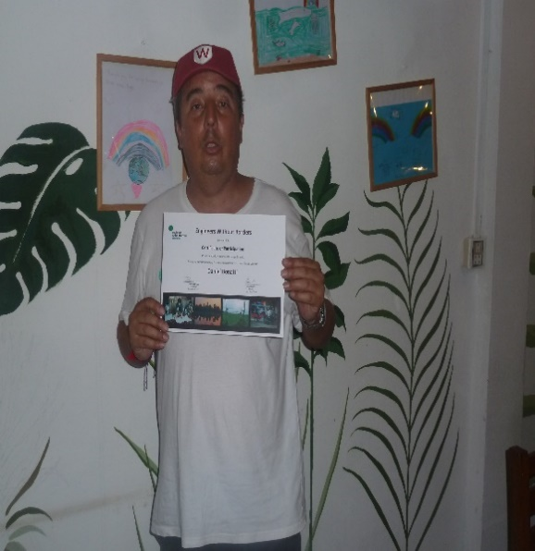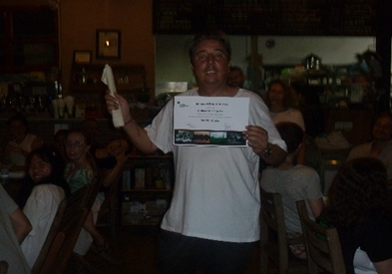
I visited on my travels Singapore with a stop over on the way and back. When in Cambodia we stayed in the capital Phnon Peng, from there we went to a town Kratie for stop over, to proceed to Koh Preah remote rural village on an island. We returned to see Dolphines at Kratie and then back to Phnon Penh for award presentation.
SINGAPORE
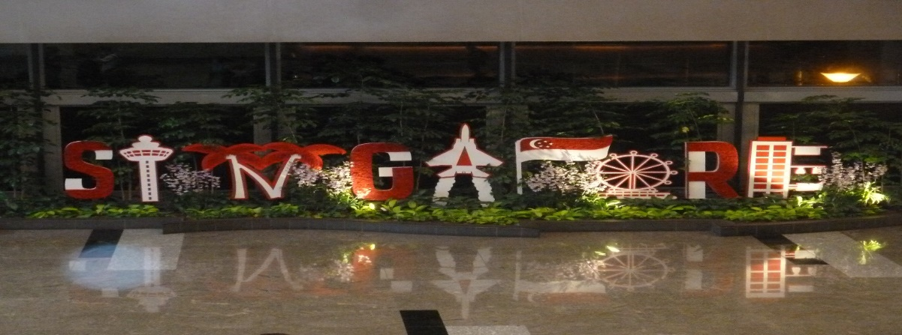
YEAR OF THE RAT
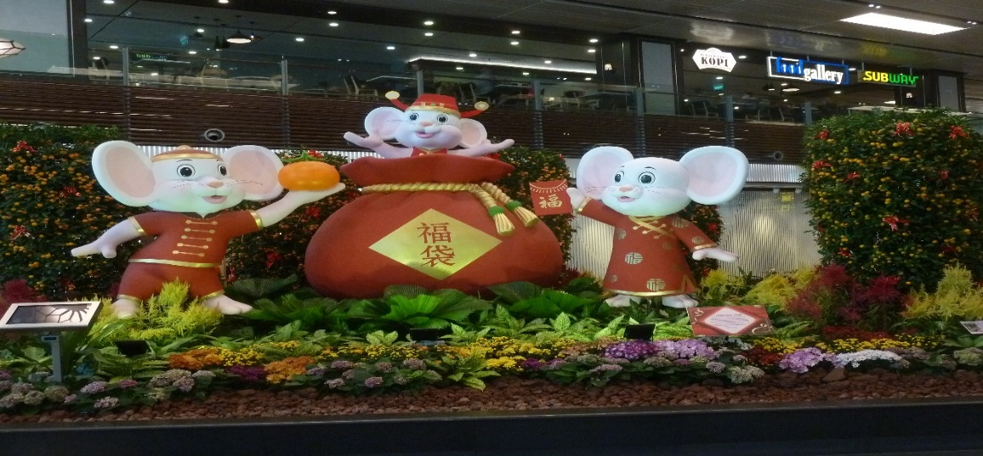

Phnon Penh Cambodia
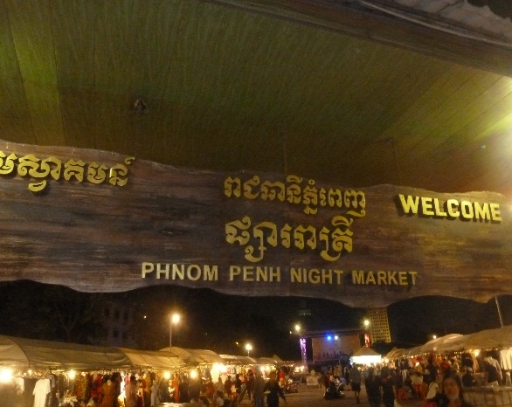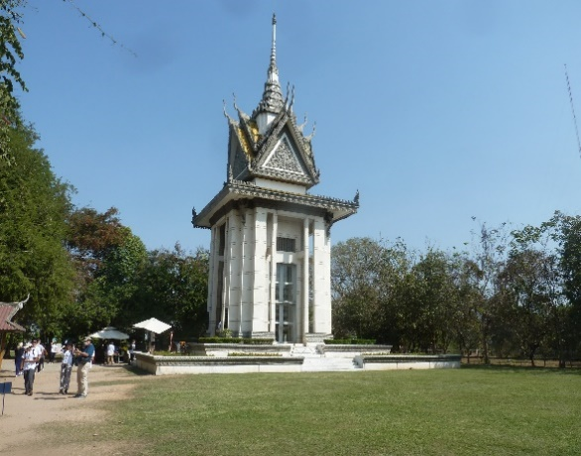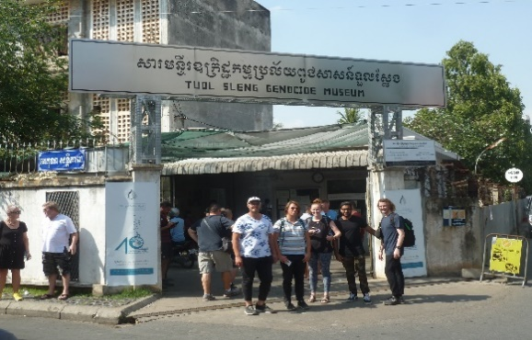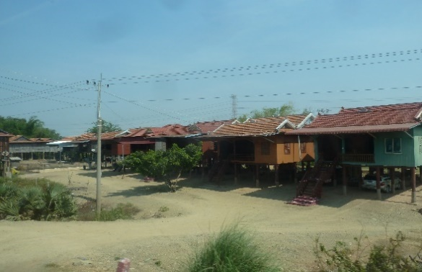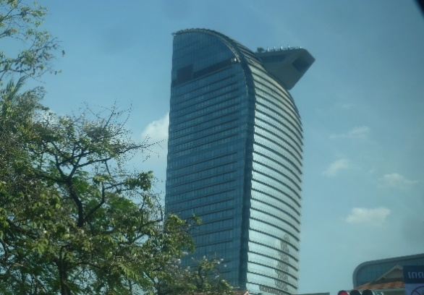

KRATIE
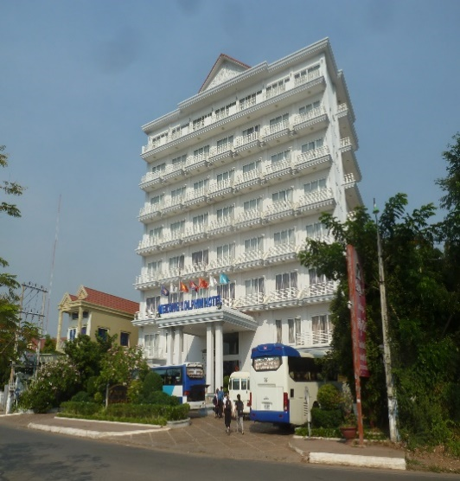
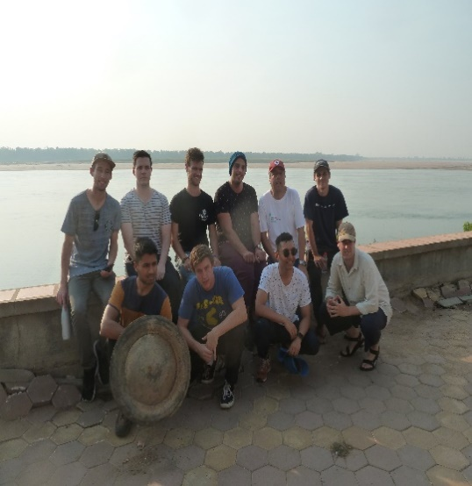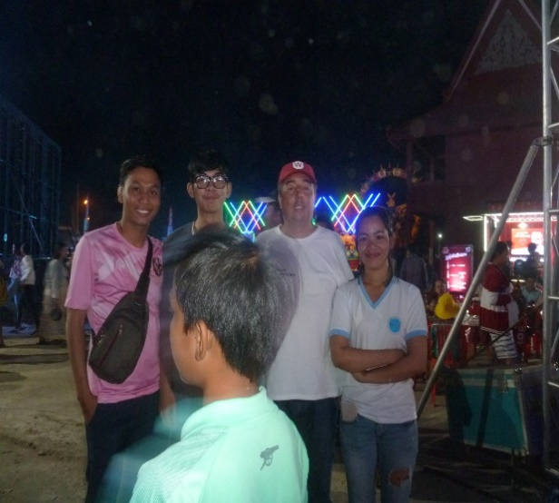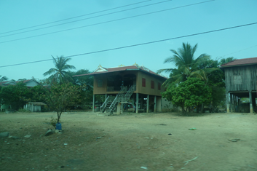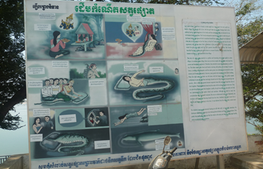

KOH PREAH
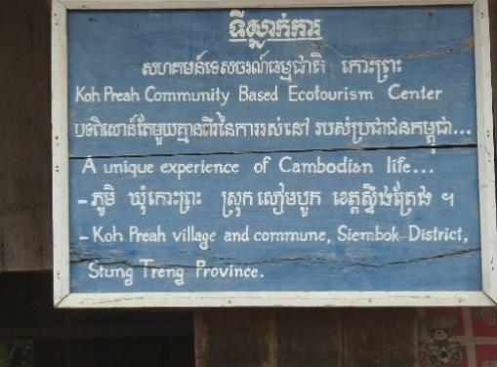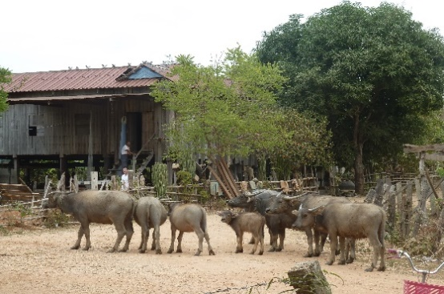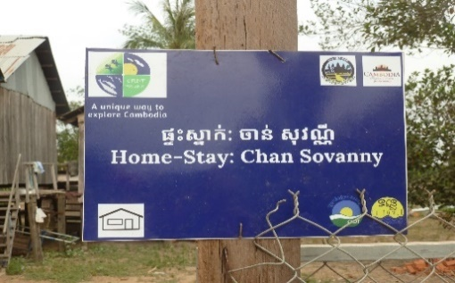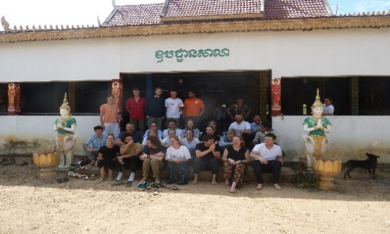
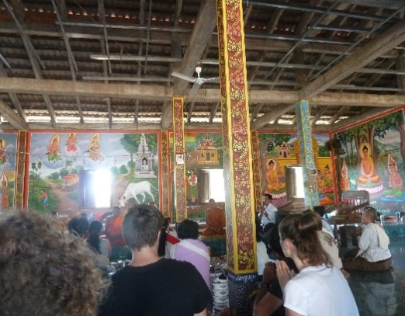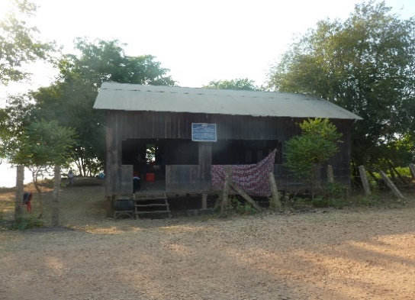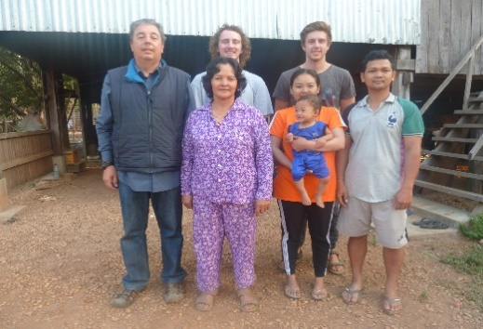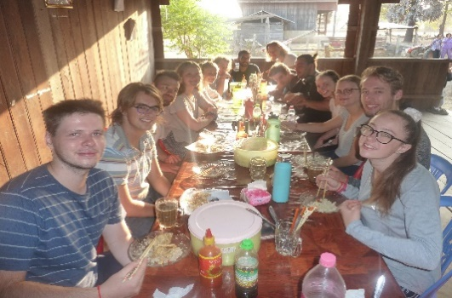

- SRC Meeting - 19th February, jetlagged forgot meeting.
- CLM 20th February 7.30 to 8.30am, total 1 hour, College Leadership & Management Newcastle Division Meeting
- USyd, 20 February 2020, Write up further review summary for academic paper.
- USyd, 20 February 2020, update submission tell Professor commencing from return from Cambodia.
- USyd, 21 February 2020, Research day presentations, not applicable had extension of time.
- Usyd, 21 February 2020, total 7 hours, Continued Write up further review summary for academic paper.
- EWB 21 February 2020, Introduction Graham Andrews to Caleb Amos, to WSU EWB Advisory Panel. I was also invited onto Advisory panel.
- USyd 21 February 2020, total 2.5 hours Diagram what is AI look like?
- USyd, 22 February 2020, 11am to 4pm, total 5 hours, write up further review summary for academic paper.
- SRC 23 February 2020, Remuneration – Honorarium Report merge evidence pdf files.
- AIB 26 February FP-018 Fire Protection Committee 18 meeting Teleconference North Ryde CSIRO.
- USyd, 26 February total 4 hours, updated submission of academic paper for progress review.
- USyd, 27 February Associate Professor Daniel Dias Da Costa change of instructions wrap up, will pay regardless of quality. Scholarship USyd Affiliate WSU- USyd Summer Research Program – CIV2019/13, Prediction of cracking propagation and failure in concrete structures, Academic Paper- Literature review, detecting structural defects in buildings, with UN Sustainability Development Goal 9 Innovation – Using (AI) Artificial Intelligence (Mode of Inquiry Literature Review).
- Parramatta South C21 27 February 2020, 8am to 1pm, total 5 hours, City Challenge and Sydney-water immersion
- Kingswood C21 27 February 2020, 3 to 5pm, Learning Design Student Interns, interview.
- Parramatta South C21 28 February 2020, 9 to 5pm, Ideate, design and prototype, make video, poster and fill in form for judges, design, prototype, and pitch. Chosen as 1 of 5 finalists for project named - Community Micro Grids
- USyd 28,29 and 1st March, total 30 hours, marathon write up further review summary for academic paper, so as to wrap up.
- USyd 2 March, total 6 hours final touch up draft and submitted Scholarship USyd Affiliate WSU- USyd Summer Research Program – CIV2019/13, Prediction of cracking propagation and failure in concrete structures, Academic Paper- Literature review, detecting structural defects in buildings, with UN Sustainability Development Goal 9 Innovation – Using (AI) Artificial Intelligence (Mode of Inquiry Literature Review).
- EWB – AgriLAB, 2 March 2020, EOI to be Lead for project.
- Engineers Australia, 3 March 2020, total 1 hour, Webinar, High Accuracy and Real time indoor positioning technology and applications.
- Engineers Australia, 3 March 2020, total 1 hour, CLM Webinar Creating Exceptional teams.
- EWB, 3 March 2020, Teleconference Meeting president Rohan and Graham Andrews at Kingswood.
- AIB Newcastle University – interuniversity, 4 March 2020, 11am to 1 pm, total 2 hours BBQ with the Boss.
- Engineers Australia, 4 March 2020, 6pm to 8.30pm, total 2.5 hours, Site tour the Res event.
- SRC 5 March 2020, total 4 hours, Remuneration – Honorarium Report write up, new style.
- 21C – 5 March 2020, EOI to be involved in Sustainable House.
- Parramatta South, WSU, 6 March 2020, 3.20 to 4pm, Go Global appointment.
- SRC – Parramatta South Meeting, 6 March 2020, with Fred catch up.
- Golden Key Parramatta South, 6 March 2020, reception and Golden key Chapter of Western Sydney University, new members event presentation at The Ian & Nancy Turbot Auditorium building Awarded Life Member Medallist -The Golden Key International Honour Society Western Sydney University, Chapter, Built Environment, 2019.Graduate of Western Sydney University Chapter, Golden Key International Honour Society, Medal & Certificate, Awarded to the Top 15% of University Students in Australia, 2019. 1000 people present.
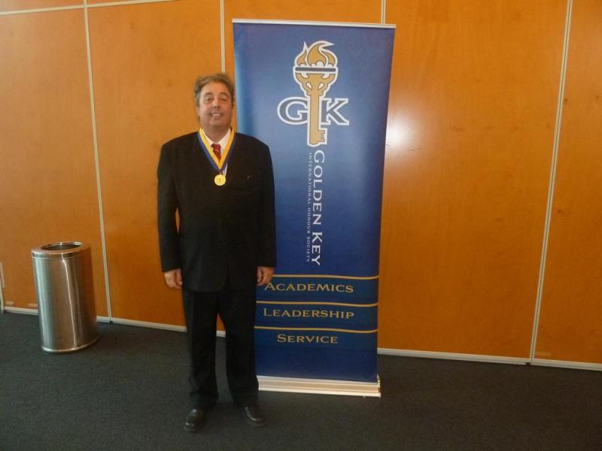
- EWB – 7 March 2020, 9.30am to 2.30pm, total 5 hours UNSW Workshop Schools Outreach Program.
- Newcastle Show- 7 March 2020, 7.30pm to 9.30pm, Community event, Fireworks and displays.
- EWB – 8 March 2020, telephone conference with WSU EWB chapter president Rohan.
- EWB – 8 March 2020, EOI Study tour to Nepal or Timor Lest.
- ACAEDMY – 8 March 2020, application to join WSU Academy.
- LEAD – 9 March 2020, application to join WSU lead engage aspire develop. Accepted Lead Engage Aspire Develop (LEAD) in 2020.
- Kingswood EWB, 10 March 2020, 10 to 2.30pm, total 4.5 hours, stall for Western Fair.
- Engineers Australia, 5.30pm to 7pm, total 1.5 hours Webinar, The state of the art in utility scale energy storage.
- EHA - 11 March 2020, total 2 hours, Engineering Heritage Australia Bi-monthly meeting.
- CLM - 12 March 2020, total 1 hour, College of Leadership and Management meeting.
- CAPS - 13 March 2020, total 2 hours, meeting
- EWB - 13 March 2020, total 2 hours, meeting.
- Engineers Australia - 17 March 2020, 5.30 to 7pm, total 1.5 hours, Webinar - The Ballina Soft soil Field Testing Facility
- EWB Parramatta South - 18 March 2020, 10 to 2.30pm, total 4.5 hours – Western Fair stall for EWB.
- Engineers Australia, - 18 March 2020, 5.30 to 7pm, Webinar Newcastle Focus Lecture Series with Dr Leonard John Hart Smith.
- EWB – 19 March 2020, 6.30 to 7.30pm WSU EWB chapter meeting with Regional.
- SFS – 24 March 2020, 10am to 12pm, total 2 hours, Roundtable SFS with FRNSW.
- SRC – 24 March 2020, 2pm to 4pm, Remuneration Committee meeting.
- AIB – 26 March 2020,9am to 5pm, total 8 hours, FP-22 Meeting Fire Protection Standards Australia Bridge Street Sydney.
- SRC Meeting – TBA

Clare Da Silva - Parramatta South Representative

Since the last meeting, I have worked on various different initiatives to engage and assist students. Events: I have run two speed friending events on parramatta south campus. There was an issue with them not being approved on WesternLife, however, I had had the rooms booked with Nap way in advance. Both of these events equate to roughly $350 combined. There is also the Western’s got talent event coming up, which the SRC, campus life and other clubs are pulling funding for. The flyers were made by campus life and I am sharing them on both Parramatta South and City Western Fair days. Had plans for a traffic light party however, with recent concerns with the coronavirus and small budget, I have decided to postpone these. I am currently working on a video for tips and tricks for students at parramatta south. I have contacted the Nepean Therapy dogs service, as well as counselling service to get therapy dogs on campus. In the future, I will also be running (again), creating your own pot plant event to use up the leftover soil and materials in the SRC office.
Office and emails:
I have created and put up posters about the src around campus. I have been sharing resources such as my speed friending materials and posters with other reps. The western sydney university parramatta south campus groups has over 470 members and I am advertising different campus activities/ groups there. I have been contacted by clubs to also do some printing for their events. I have assisted the filipino student society of western Sydney to print various promotional material for Western fair and to put up around campus.

Leahanne Baker - Nirimba Campus representative

During March, I have recently been in contact with the Nirimba Campus library discussing extended the opening hours of the library and having study hall access during the mid-term and final exam periods. I've also been in contact with them about the air conditioning in the library as they don't work properly and to get it fixed as soon as possible.

Natasha Ferrer - Liverpool Campus representative

General Synopsis and Reflection:
There are many initiatives, events and co-collaborations I have in store for my remaining period as Liverpool Representative. I am enjoying my role very much, however, lately I’ve been starting to feel burnt out from what I’m doing and all the components I have to juggle in my life. I need to manage my time better and “pick up my slack” as soon as possible so I don’t fully burn out.

Experiences:
- I had a meeting with my CLO Nick Dionisopoulos to collaborate on future initiatives and ideas for Liverpool Campus.
- Since the creation of Liverpool Campus Discussion page, I have obtained over 100+ members and I had made Liverpool’s CLO, Women’s Rep, CBM representative and Anthropology club representatives as administrators to provide them with a platform to advertise to students and gain statistics on student wants and needs.
- On the Liverpool Campus Discussion page, I had created events and posts on the Free Mental Health Training based in Liverpool, Liverpool Wester Fair, availabilities for Campus Life’s walking initiative and Westfield’s funded food friending hour to provide the students with an opportunity to become aware and possible attend the event.
- CBM would like to collaborate with SRC through food trolley’s so to progress this initiative I had created a poll on Facebook to determine what the students want for snacks. The top three choices included Up & Go (20 votes), muesli bars (13 votes) and fruit juice (10 votes).
- I had recently reached out to Campus Representatives and Collective members to collect some SRC merchandise in preparation for Western Fair and Future events. The Environmental Collective Representative Danielle Wolf kindly sent SRC branded cups and jugs for me recently.
- In preparation for Western Fair, I’ve noted that I have a suggestion box, Western Life tote bags, SRC mugs and cups and a spinning wheel for my use. I intend on creating a list of what to buy for Western Fair and giving it to my CLO for him to purchase my items.
- In collaboration with my CLO, from the 24th of March to the 21st of June, a booking was made for an entire lecture room (reminding everyone that it is extremely difficult to get a room in Liverpool so this was a miracle). My ‘Relaxation and Study Zone’ initiative runs every Tuesday from 5-7 pm where student are able to have a quiet study or engage in relaxing activities such as origami, colouring books, drawing and lego building. In addition, the bookings went through, however, it still needs to be accepted “So fingers crossed”.
- A keen Student would like to provide a free and more nourishing breakfast for Liverpool students once a week. I’m not sure if I can fund it, however, I will bring it up to provost. I really want to see if I can make this work as the free snack provident the morning for students are extremely sugar-filled which is not healthy.
- As a nursing student and SRC representative, I’ve noticed the needs and concerns of the Nursing cohort and have decided to create a WSU Nursing and Midwifery Students Society. In the past couple of months, I’ve recruited members for most campus/online domains and will have a meeting with them on the 16th of March at 20:00 via zoom.
“The Nursing and Midwifery Students Society purpose is to inspire and connect nursing students and university members alike. It was made by students who want to ensure a positive and beneficial experience for their peers. It is a university-wide initiative located in Liverpool, Parramatta South, Campbelltown, Hawkesbury and Online domains. The society will encompass three main categories: Student Life and events, Education and Employment opportunities and platforming of Student Voice.”

Future Liverpool Campus Initiatives:
- Before the end of my period, I really want to do an open forum for my Campus.
- I’m planning on another Pot-a-Plant event as my students really enjoyed it.
- In my upcoming provost meeting I’m going to address the following items:
- Advocation for student safety in travel to and from the university and starting an initiative on student safety. There are times where WSU classes finish very late (6 pm - the latest I believe) and many students must go home in either the dark or late afternoon. Including Liverpool, many students feel unsafe walking by themselves in the environments around WSU campuses and I believe the university should take action into ensuring their students are out of harm's way during their time as students. I was thinking of advocating for these issues and possibly ordering protective equipment for students university-wide such as rape whistles, alarms and bright flashlights. I was also thinking about possibly creating a map displaying safe routes too and from the university and marking unsafe areas. There could also be voluntary (or paid) walking groups to and from universities. Another keen idea which I have is free (or subsidised) self-defence classes in university and making pacts with surrounding self-defence academies, classes, etc (for subsidies).
- Free proper student breakfast. This is because the provided snacks int the morning is meant to be consumed in the later hours of the day, not before 10 am. Not only will this make students sugar crash but it may potentially impact their health. (Action Item: Post in Liverpool Discussion Page what students would like as breakfast).
- Destressing dog/animal event. My Campus is a very cramped space and many of my students are stressed from assignments and classwork. To help alleviate their stress and provide more life into Liverpool, I would like to initiate this event.

Joshua Newton - Hawkesbury Representative

During this last month I have implemented a number of different initiatives, attended the SRC meeting and the C3 conferences on both days. I attempted to run a speed friending event on the 9th of March, I didnt advertise this very well, as a result the attendance was poor. In the future I will try to emulate the success Clare had with the speed friending event she ran, I feel she advertised alot better then I did and was more organised. During both Orientation Day and Western Fair I organised for Nepean Therapy Dogs to come on campus, this was done in collobaroation with the Counselling team. I feel this initiative was great and I would love to repeat it in the future, lots of students had a chance to both destress and receive an introduction to the counselling team. I have also submited 2 agenda items for the next SRC meeting, I hope to increase the crisis housing avaliable at the university.

Danielle Wolf – Environment Representative

Planning for Western Fairs has taken up a lot of the time between this and my last report, as well as organising the supplies, contacts and collaborators for upcoming initiatives.
Myself, and the other Collective officer, Kathy Nguyen (a force of Nature), have put in significant time collating prize and membership packs, advertising and promotional materials (how tedious is laminating?!), and locking in other events (I have included our working list below).
I have also been working with the Blacktown and District Environment Group re concerns over the future of the Werrington North campus kangaroo mob. We have put together a petition for students and various materials informing them of the situation. Essentially, in the development carve-up of the campus, a small allotment was left for the mob whose numbers would need to be managed over the coming years. The main concerns at this stage is that development runs between the mob and their water source (yes, IKR?), as well as being forced too much into the scrub around the cleared area they pick. While the scrub is great for protection it doesn’t provide a food source. We are collaborating with an ecologist and various other interested parties to explore possible solutions and ways by which we can at least address the water source issue.

Next, the Resilience Roadshows are starting up again with the first at PS campus on the 25th. This is a great opportunity to showcase student initiatives around environmental and broader sustainability, as well as networking with academics and departments around the Uni. The garden of course is ongoing with our relationship and planning with the Farm-It-Forward project still on track. I have also been speaking with Brenda Dobia who is teaching Education for Sustainability about the prospect of including the project in the assessments for the Unit, meaning we may move the ground-breaking to the Sustainability Expo in June.
I have also been focusing on increasing my own knowledge and skills in preparation for designing and managing the garden, as well as planning upskilling offerings for officers and students later in the year.
Finally, Vicky-Rae has introduced me to a group of students who presented an exciting pitch for the recent 21C Challenge at PCC. They have put together something for an EnviroFest and I will be having a meeting with them, Vicky-Rae and the Sustainable Futures team next week.

Planned events:
- Kingswood Campus Wester Fair – Tuesday 10th March
- Parramatta South Campus Western Fair – Wednesday 18th March
- Bankstown Campus Western Fair – Thursday 19th March
- Garden Design Workshop – Saturday in March / April
- Garden Installation – Saturday in April
- Kingswood Campus Beauty and Skincare Workshop – Wednesday 1st April
- Parramatta South Campus Beauty and Skincare Workshop – Friday 3rd April
- Bankstown Campus DIY Workshop – Friday 8th May
- Clothing and Book Swap Day - Wednesday 20th May – TBC Campus
- Parramatta South Campus Stress Less Workshop – TBC June
- Kingswood Campus Stress Less Workshop – TBC June
- Garden Ground-Breaking – TBC June

Photos from Western Fair
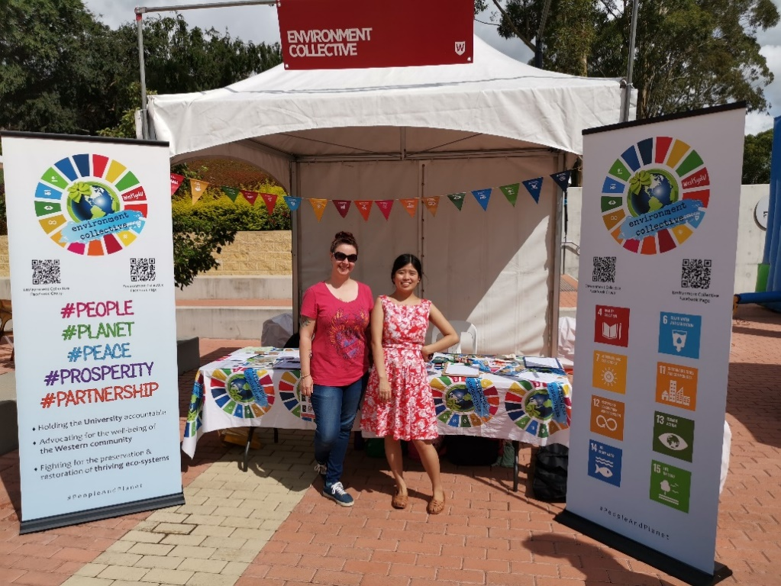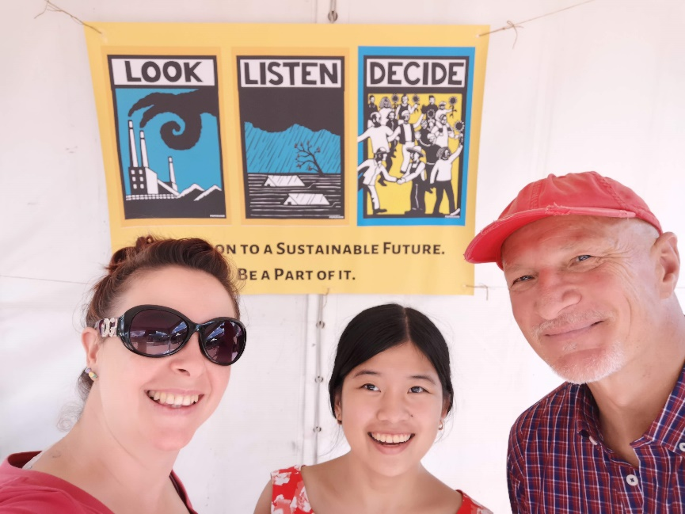

Erdem Yigiter - Queer Representative

At the current moment I am involved in a few upcoming events. Firstly, I am wanting to start holding Queer picnics for the queer collective every 3 weeks. This has taken a little long to set up due to a bit of personal stress and the uncertainty of if it will still be able to continue running once I leave to Taiwan in June. Secondly, I have decided that I would like to try and spearhead the Western Sydney talent show, titled “Western’s Got Talent”. This event was decided with nap and is hosted by about 8 student clubs and collectives. The event is happening on the 15th of May and we have advertising material ready for western fair. I will be on parra south campus for western fair and will be handing out promotional flyers to students.

Lastly, I have decided that the queer collective will hold another event this year for IDAHOBIT. Last year, the queer collective hosted an event called “Western Sydney’s Unhead Voices”. This event gathered 5 amazing queer speakers from diverse backgrounds, and they were asked questions about their families, their upbringing and their lives. The event was held in the female orphan school and had around 50 attendees. I got a full audio recording of the entire night, so I am planning to write a W’SUP article in the lead up to this event.

Sumegha Sehgal – Woman’s Representative

Having begun in February, I am trying to find initiatives and create events for female students.
- Events and current activities and planning
- ONE WEEK ONE STORY
In order to represent every female student at WSU, We have come up with the idea of one story one week where I will be posting about one female every week on Facebook and Western life. (I will try to get details for the Instagram account) and have created a google form for the same to get volunteers. https://forms.gle/C6wEeKtkdcKRU8WA6 That’s the link for the google form.
- The women’s collective is going to collaborate with the international student association where we will be organising CISA Tea talk organised by council of international student Australia, which is a series of events that are run by the CISA Women’s office with the aim of empowering and educating international students especially female. There’s going to be a 30 minute presentation and 60 min group discussion moderated by panel speakers. The event will be held at Parramatta city campus on 24th April, Friday at 11am. The budget has to be allocated since both the societies will be splitting the budget. Event request has been created on westernlife.
- Print the QR code for campuslife and facebook page and make a poster for women’s collective for western fair to engage students during western fair in Parramatta south. Promote women’s collective at Parramatta city campus as well.
- After having a word with Vicky regarding the women’s room in Bankstown campus, we are planning to provide Women's rooms with privacy curtains for breastfeeding on campus in a safe and secluded space.Have to check the current state of rooms in other campuses such as Parramatta, Liverpool ,Campbelltown and Kingswood .
- Attended the collective working group meeting chaired by Allan Fang where the environment collective suggested to collaborate on a few events. Kingswood and Parramatta campus beauty and skincare workshop in the month of April.
- Planning to get sanitary items for various campuses as suggested by the women’s collective officer in Liverpool. Vicky suggested to collaborate on getting female hygiene items through red tent initiatives. Have to check status of item already present in campuses and then order more accordingly.
- Plan visits to other campuses and plan a networking event to have a look at women’s room and see how they are being used and how often they are being used and what are the requirements of the female students. This will be planned for the month of April along with other collective officers for other campuses.
- A Zumba event for females in Parramatta south in the hub by one of the students who is already a Zumba instructor. The event will be planned for the month of April or May depending on the best time and date that suits the students. This event is being planned.
- Being a student leader, I have volunteered to become a member of Student taskforce responsible for updating the university regarding coronavirus and reporting any sorts of misbehaviour or any incidents caused due to the current issue. The taskforce will have online meetings once a week on zoom.
- I have been posting lots of networking opportunities on facebook page and trying to make the women’s collective page more active. I have answered all messages that the collective has received so far as an email or on facebook or western life.
- I assisted during the orientation and tried to promote SRC at Parramatta south campus 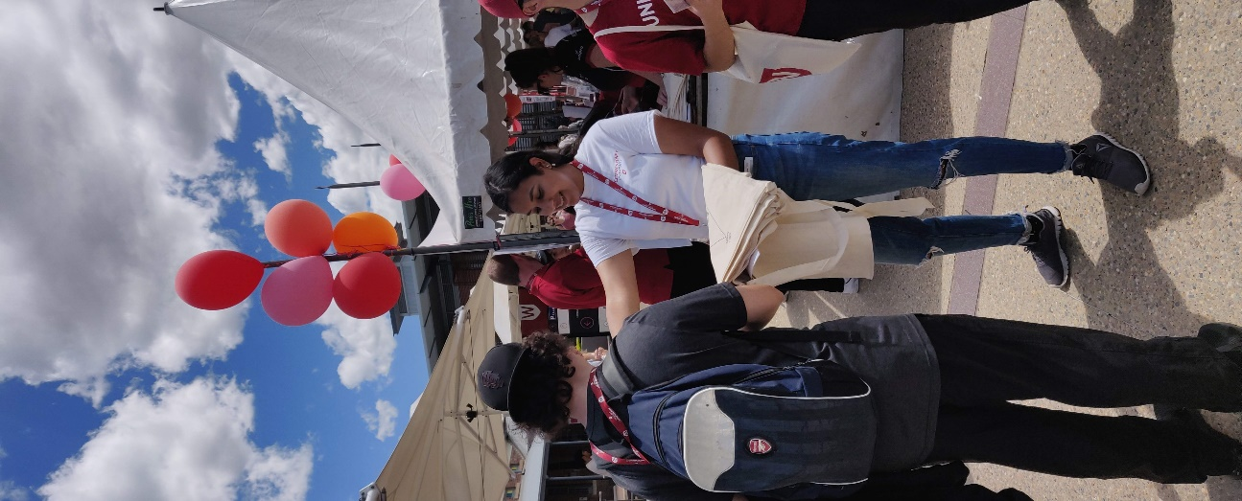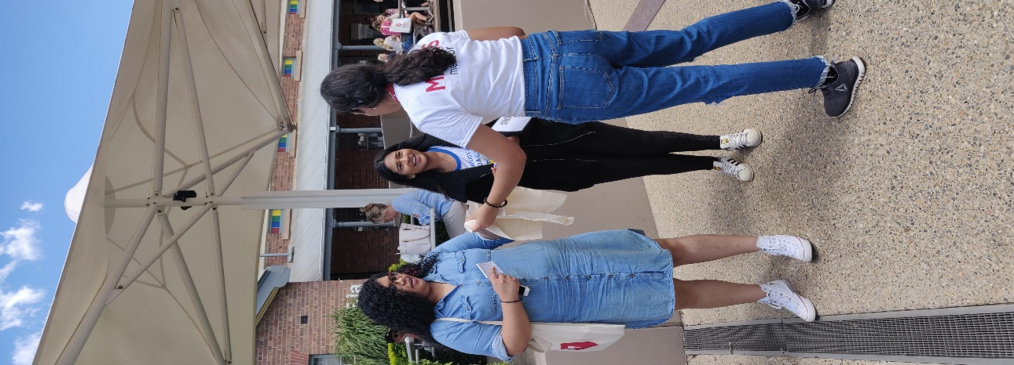 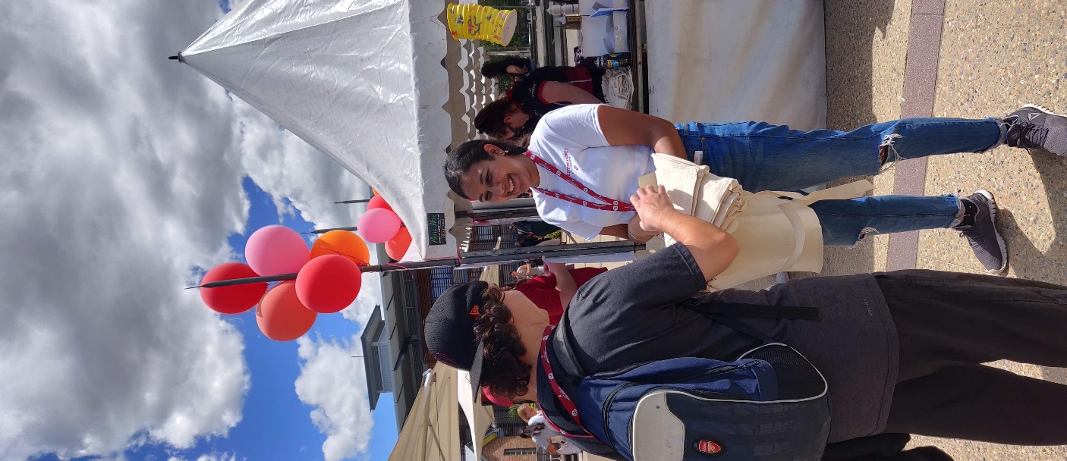

I am trying to work on getting feedback from students and trying ways to engage and see the status of women’s room in other campuses. In the month of March, I will plan visits and try to think of better ways to increase participation and see where the females are having any problems. I look forward to working and delivering my best for the betterment of university and the collective.

